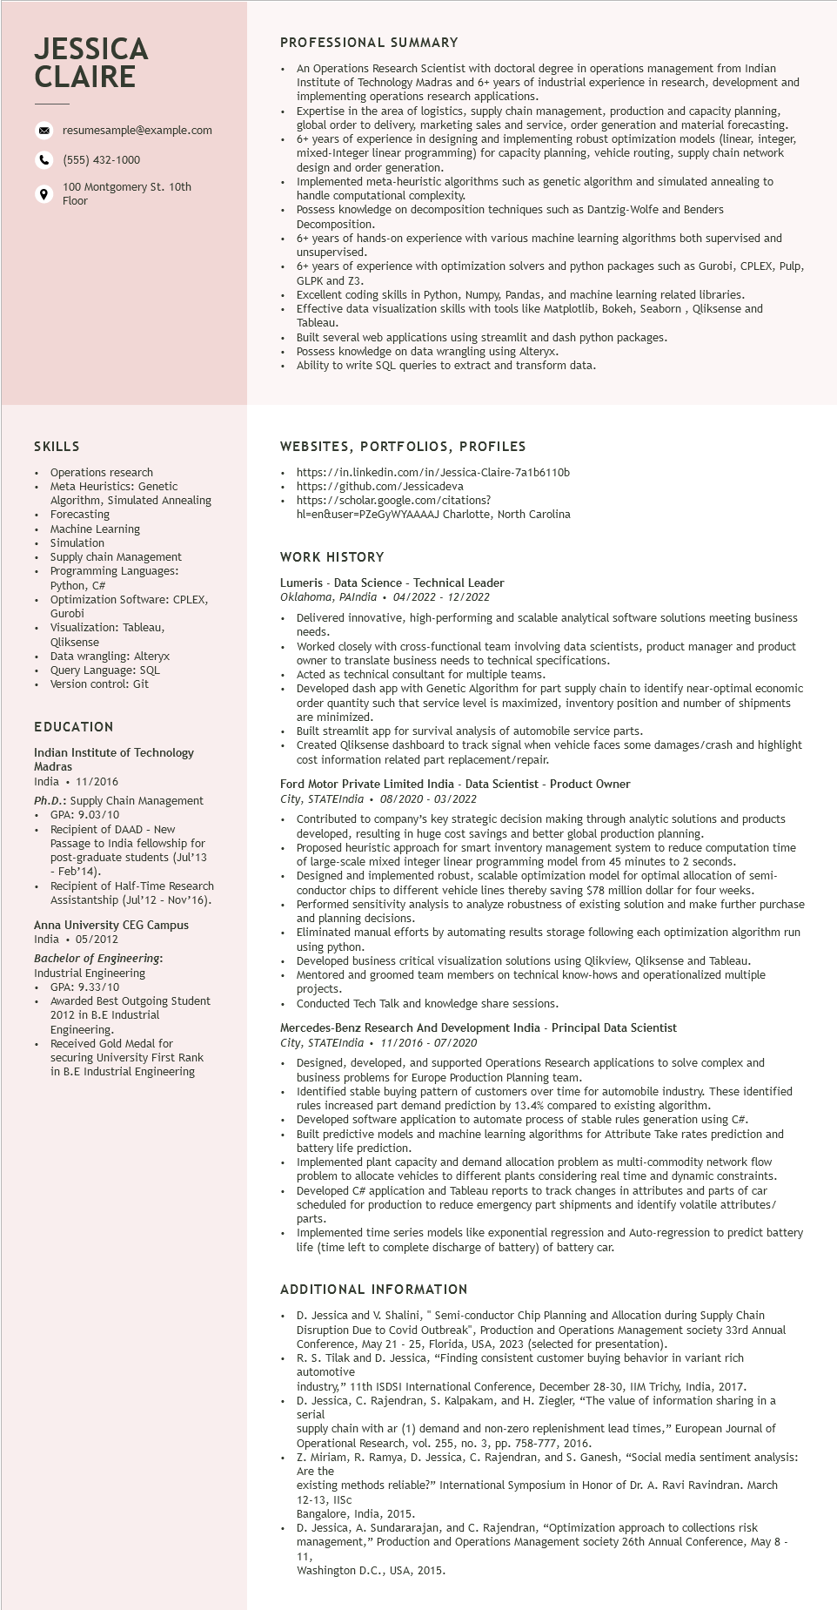

**JESSICA CLAIRE**

resumesample@example.com

(555) 432-1000

100 Montgomery St. 10th Floor

PROFESSIONAL SUMMARY

.

An Operations Research Scientist with doctoral degree in operations management from Indian Institute of Technology Madras and 6+ years of industrial experience in research, development and implementing operations research applications.

Expertise in the area of logistics, supply chain management, production and capacity planning, global order to delivery, marketing sales and service, order generation and material forecasting. 6+ years of experience in designing and implementing robust optimization models (linear, integer, mixed-Integer linear programming) for capacity planning, vehicle routing, supply chain network design and order generation.

Implemented meta-heuristic algorithms such as genetic algorithm and simulated annealing to handle computational complexity.

Possess knowledge on decomposition techniques such as Dantzig-Wolfe and Benders Decomposition.

6+ years of hands-on experience with various machine learning algorithms both supervised and unsupervised.

6+ years of experience with optimization solvers and python packages such as Gurobi, CPLEX, Pulp, GLPK and Z3.

Excellent coding skills in Python, Numpy, Pandas, and machine learning related libraries.

Effective data visualization skills with tools like Matplotlib, Bokeh, Seaborn, Qliksense and Tableau.

Built several web applications using streamlit and dash python packages.

Possess knowledge on data wrangling using Alteryx.

Ability to write SQL queries to extract and transform data.

SKILLS

Operations research

Meta Heuristics: Genetic

Algorithm, Simulated Annealing Forecasting

Machine Learning

Simulation

Supply chain Management

Programming Languages: Python, C#

Optimization Software: CPLEX, Gurobi

Visualization: Tableau, Qliksense

Data wrangling: Alteryx

Query Language: SQL

Version control: Git

EDUCATION

Indian Institute of Technology Madras

India 11/2016

Ph.D.: Supply Chain Management

• GPA: 9.03/10

• Recipient of DAAD - New Passage to India fellowship for post-graduate students (Jul'13 - Feb'14).

• Recipient of Half-Time Research Assistantship (Jul'12 - Nov'16).

Anna University CEG Campus India 05/2012

Bachelor of Engineering:

Industrial Engineering

⚫ GPA: 9.33/10

Awarded Best Outgoing Student 2012 in B.E Industrial Engineering.

Received Gold Medal for securing University First Rank in B.E Industrial Engineering

WEBSITES, PORTFOLIOS, PROFILES

• https://in.linkedin.com/in/Jessica-Claire-7a1b6110b

https://github.com/Jessicadeva https://scholar.google.com/citations?

hl=en&user=PZeGYWYAAAAJ Charlotte, North Carolina

WORK HISTORY

Lumeris - Data Science - Technical Leader

Oklahoma, PAIndia⚫ 04/2022 - 12/2022

Delivered innovative, high-performing and scalable analytical software solutions meeting business needs.

Worked closely with cross-functional team involving data scientists, product manager and product owner to translate business needs to technical specifications.

Acted as technical consultant for multiple teams.

Developed dash app with Genetic Algorithm for part supply chain to identify near-optimal economic order quantity such that service level is maximized, inventory position and number of shipments are minimized.

Built streamlit app for survival analysis of automobile service parts.

Created Qliksense dashboard to track signal when vehicle faces some damages/crash and highlight cost information related part replacement/repair.

Ford Motor Private Limited India - Data Scientist - Product Owner

*City, STATEIndia. 08/2020 - 03/2022*

•

Contributed to company's key strategic decision making through analytic solutions and products developed, resulting in huge cost savings and better global production planning.

Proposed heuristic approach for smart inventory management system to reduce computation time of large-scale mixed integer linear programming model from 45 minutes to 2 seconds. Designed and implemented robust, scalable optimization model for optimal allocation of semi- conductor chips to different vehicle lines thereby saving $78 million dollar for four weeks. Performed sensitivity analysis to analyze robustness of existing solution and make further purchase and planning decisions.

Eliminated manual efforts by automating results storage following each optimization algorithm run using python.

Developed business critical visualization solutions using Qlikview, Qliksense and Tableau. Mentored and groomed team members on technical know-hows and operationalized multiple projects.

Conducted Tech Talk and knowledge share sessions.

Mercedes-Benz Research And Development India - Principal Data Scientist

City, STATEIndia. 11/2016 - 07/2020

Designed, developed, and supported Operations Research applications to solve complex and business problems for Europe Production Planning team.

Identified stable buying pattern of customers over time for automobile industry. These identified rules increased part demand prediction by 13.4% compared to existing algorithm.

• Developed software application to automate process of stable rules generation using C#. Built predictive models and machine learning algorithms for Attribute Take rates prediction and battery life prediction.

Implemented plant capacity and demand allocation problem as multi-commodity network flow problem to allocate vehicles to different plants considering real time and dynamic constraints. Developed C# application and Tableau reports to track changes in attributes and parts of car scheduled for production to reduce emergency part shipments and identify volatile attributes/ parts.

Implemented time series models like exponential regression and Auto-regression to predict battery life (time left to complete discharge of battery) of battery car.

ADDITIONAL INFORMATION

.

.

D. Jessica and V. Shalini, "Semi-conductor Chip Planning and Allocation during Supply Chain Disruption Due to Covid Outbreak", Production and Operations Management society 33rd Annual Conference, May 21 - 25, Florida, USA, 2023 (selected for presentation).

R. S. Tilak and D. Jessica, "Finding consistent customer buying behavior in variant rich automotive

industry," 11th ISDSI International Conference, December 28-30, IIM Trichy, India, 2017.

D. Jessica, C. Rajendran, S. Kalpakam, and H. Ziegler, "The value of information sharing in a serial

supply chain with ar (1) demand and non-zero replenishment lead times," European Journal of Operational Research, vol. 255, no. 3, pp. 758-777, 2016.

Z. Miriam, R. Ramya, D. Jessica, C. Rajendran, and S. Ganesh, "Social media sentiment analysis: Are the

existing methods reliable?" International Symposium in Honor of Dr. A. Ravi Ravindran. March 12-13, IISc

**12.**

Bangalore, India, 2015.

D. Jessica, A. Sundararajan, and C. Rajendran, "Optimization approach to collections risk management," Production and Operations Management society 26th Annual Conference, May 8 -

11,

Washington D.C., USA, 2015.