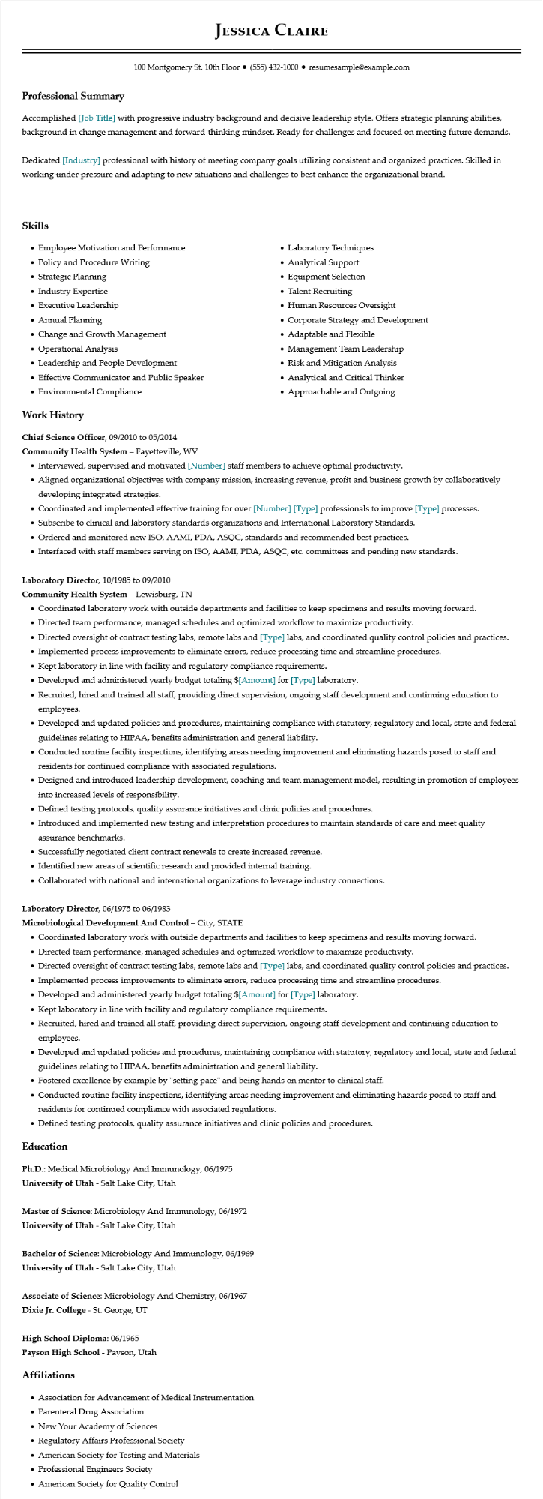

**Professional Summary**

**JESSICA CLAIRE**

100 Montgomery St. 10th Floor⚫ (555) 432-1000⚫ resumesample@example.com

Accomplished [Job Title] with progressive industry background and decisive leadership style. Offers strategic planning abilities, background in change management and forward-thinking mindset. Ready for challenges and focused on meeting future demands.

Dedicated [Industry] professional with history of meeting company goals utilizing consistent and organized practices. Skilled in working under pressure and adapting to new situations and challenges to best enhance the organizational brand.

**Skills**

• Employee Motivation and Performance

• Policy and Procedure Writing

• Strategic Planning

• Industry Expertise

• Executive Leadership

• Annual Planning

• Change and Growth Management

·

Operational Analysis

• Leadership and People Development

• Effective Communicator and Public Speaker

• Environmental Compliance

**Work History**

Chief Science Officer, 09/2010 to 05/2014

**Community Health System - Fayetteville, WV**

• Laboratory Techniques

• Analytical Support

•

Equipment Selection

• Talent Recruiting

• Human Resources Oversight

• Corporate Strategy and Development

• Adaptable and Flexible

.

Management Team Leadership

• Risk and Mitigation Analysis

• Analytical and Critical Thinker

• Approachable and Outgoing

• Interviewed, supervised and motivated [Number] staff members to achieve optimal productivity.

• Aligned organizational objectives with company mission, increasing revenue, profit and business growth by collaboratively developing integrated strategies.

• Coordinated and implemented effective training for over [Number] [Type] professionals to improve [Type] processes.

• Subscribe to clinical and laboratory standards organizations and International Laboratory Standards.

• Ordered and monitored new ISO, AAMI, PDA, ASQC, standards and recommended best practices.

• Interfaced with staff members serving on ISO, AAMI, PDA, ASQC, etc. committees and pending new standards.

**Laboratory Director, 10/1985 to 09/2010**

**Community Health System - Lewisburg, TN**

• Coordinated laboratory work with outside departments and facilities to keep specimens and results moving forward.

• Directed team performance, managed schedules and optimized workflow to maximize productivity.

• Directed oversight of contract testing labs, remote labs and [Type] labs, and coordinated quality control policies and practices.

• Implemented process improvements to eliminate errors, reduce processing time and streamline procedures.

• Kept laboratory in line with facility and regulatory compliance requirements.

• Developed and administered yearly budget totaling $[Amount] for [Type] laboratory.

• Recruited, hired and trained all staff, providing direct supervision, ongoing staff development and continuing education to employees.

• Developed and updated policies and procedures, maintaining compliance with statutory, regulatory and local, state and federal guidelines relating to HIPAA, benefits administration and general liability.

• Conducted routine facility inspections, identifying areas needing improvement and eliminating hazards posed to staff and residents for continued compliance with associated regulations.

• Designed and introduced leadership development, coaching and team management model, resulting in promotion of employees into increased levels of responsibility.

• Defined testing protocols, quality assurance initiatives and clinic policies and procedures.

• Introduced and implemented new testing and interpretation procedures to maintain standards of care and meet quality assurance benchmarks.

• Successfully negotiated client contract renewals to create increased revenue.

• Identified new areas of scientific research and provided internal training.

• Collaborated with national and international organizations to leverage industry connections.

**Laboratory Director, 06/1975 to 06/1983**

**Microbiological Development And Control - City, STATE**

• Coordinated laboratory work with outside departments and facilities to keep specimens and results moving forward.

• Directed team performance, managed schedules and optimized workflow to maximize productivity.

• Directed oversight of contract testing labs, remote labs and [Type] labs, and coordinated quality control policies and practices.

• Implemented process improvements to eliminate errors, reduce processing time and streamline procedures.

• Developed and administered yearly budget totaling $[Amount] for [Type] laboratory.

• Kept laboratory in line with facility and regulatory compliance requirements.

• Recruited, hired and trained all staff, providing direct supervision, ongoing staff development and continuing education to employees.

• Developed and updated policies and procedures, maintaining compliance with statutory, regulatory and local, state and federal guidelines relating to HIPAA, benefits administration and general liability.

• Fostered excellence by example by "setting pace" and being hands on mentor to clinical staff.

• Conducted routine facility inspections, identifying areas needing improvement and eliminating hazards posed to staff and residents for continued compliance with associated regulations.

• Defined testing protocols, quality assurance initiatives and clinic policies and procedures.

**Education**

Ph.D.: Medical Microbiology And Immunology, 06/1975

**University of Utah - Salt Lake City, Utah**

Master of Science: Microbiology And Immunology, 06/1972

**University of Utah - Salt Lake City, Utah**

Bachelor of Science: Microbiology And Immunology, 06/1969 University of Utah - Salt Lake City, Utah

Associate of Science: Microbiology And Chemistry, 06/1967

Dixie Jr. College - St. George, UT

High School Diploma: 06/1965

**Payson High School - Payson, Utah**

**Affiliations**

• Association for Advancement of Medical Instrumentation

• Parenteral Drug Association

• New Your Academy of Sciences

• Regulatory Affairs Professional Society

• American Society for Testing and Materials

• Professional Engineers Society

• American Society for Quality Control