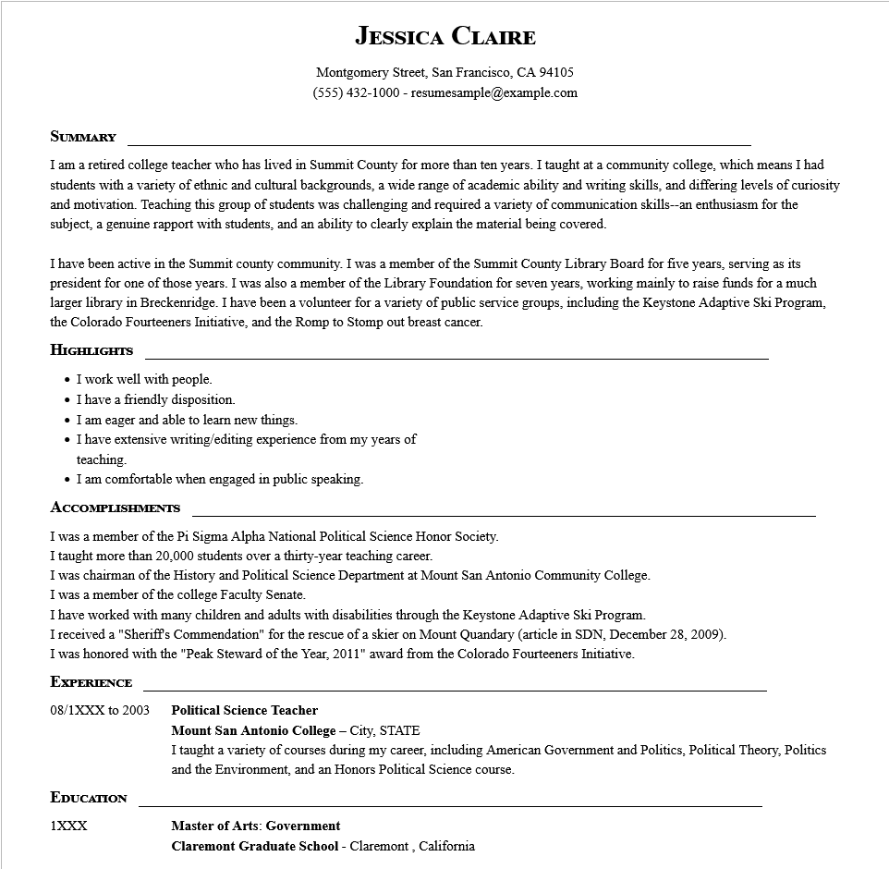

**JESSICA CLAIRE**

Montgomery Street, San Francisco, CA 94105

(555) 432-1000-resumesample@example.com

**SUMMARY**

I am a retired college teacher who has lived in Summit County for more than ten years. I taught at a community college, which means I had students with a variety of ethnic and cultural backgrounds, a wide range of academic ability and writing skills, and differing levels of curiosity and motivation. Teaching this group of students was challenging and required a variety of communication skills--an enthusiasm for the subject, a genuine rapport with students, and an ability to clearly explain the material being covered.

I have been active in the Summit county community. I was a member of the Summit County Library Board for five years, serving as its president for one of those years. I was also a member of the Library Foundation for seven years, working mainly to raise funds for a much larger library in Breckenridge. I have been a volunteer for a variety of public service groups, including the Keystone Adaptive Ski Program, the Colorado Fourteeners Initiative, and the Romp to Stomp out breast cancer.

**HIGHLIGHTS**

• I work well with people.

⚫ I have a friendly disposition.

⚫ I am eager and able to learn new things.

⚫ I have extensive writing/editing experience from my years of

teaching.

⚫ I am comfortable when engaged in public speaking.

**ACCOMPLISHMENTS**

I was a member of the Pi Sigma Alpha National Political Science Honor Society.

I taught more than 20,000 students over a thirty-year teaching career.

I was chairman of the History and Political Science Department at Mount San Antonio Community College.

I was a member of the college Faculty Senate.

I have worked with many children and adults with disabilities through the Keystone Adaptive Ski Program.

I received a "Sheriff's Commendation" for the rescue of a skier on Mount Quandary (article in SDN, December 28, 2009).

I was honored with the "Peak Steward of the Year, 2011" award from the Colorado Fourteeners Initiative.

**EXPERIENCE**

08/1XXX to 2003

**Political Science Teacher**

**Mount San Antonio College - City, STATE**

**EDUCATION**

1XXX

I taught a variety of courses during my career, including American Government and Politics, Political Theory, Politics and the Environment, and an Honors Political Science course.

**Master of Arts: Government**

**Claremont Graduate School - Claremont, California**