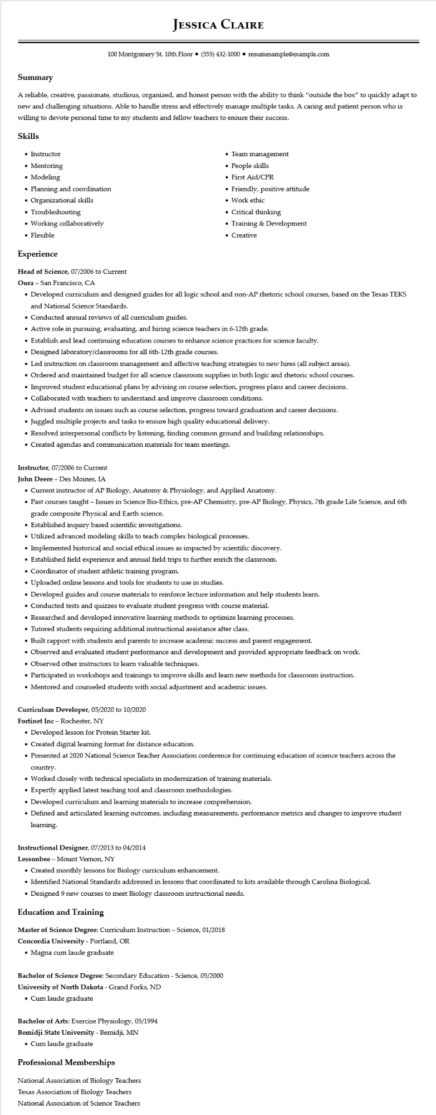

**JESSICA CLAIRE**

100 Montgomery St. 10th Floor⚫ (555) 432-1000⚫ resumesample@example.com

**Summary**

A reliable, creative, passionate, studious, organized, and honest person with the ability to think "outside the box" to quickly adapt to new and challenging situations. Able to handle stress and effectively manage multiple tasks. A caring and patient person who is willing to devote personal time to my students and fellow teachers to ensure their success.

**Skills**

• Instructor

• Mentoring

• Modeling

• Planning and coordination

• Organizational skills

• Troubleshooting

• Working collaboratively

• Flexible

**Experience**

Head of Science, 07/2006 to Current

Oura - San Francisco, CA

• Team management

• People skills

• First Aid/CPR

• Friendly, positive attitude

• Work ethic

• Critical thinking

• Training & Development

• Creative

• Developed curriculum and designed guides for all logic school and non-AP rhetoric school courses, based on the Texas TEKS and National Science Standards.

• Conducted annual reviews of all curriculum guides.

• Active role in pursuing, evaluating, and hiring science teachers in 6-12th grade.

• Establish and lead continuing education courses to enhance science practices for science faculty.

• Designed laboratory/classrooms for all 6th-12th grade courses.

• Led instruction on classroom management and affective teaching strategies to new hires (all subject areas).

• Ordered and maintained budget for all science classroom supplies in both logic and rhetoric school courses.

• Improved student educational plans by advising on course selection, progress plans and career decisions.

• Collaborated with teachers to understand and improve classroom conditions.

• Advised students on issues such as course selection, progress toward graduation and career decisions.

• Juggled multiple projects and tasks to ensure high quality educational delivery.

• Resolved interpersonal conflicts by listening, finding common ground and building relationships.

• Created agendas and communication materials for team meetings.

Instructor, 07/2006 to Current

**John Deere - Des Moines, IA**

• Current instructor of AP Biology, Anatomy & Physiology, and Applied Anatomy.

• Past courses taught – Issues in Science Bio-Ethics, pre-AP Chemistry, pre-AP Biology, Physics, 7th grade Life Science, and 6th grade composite Physical and Earth science.

• Established inquiry based scientific investigations.

• Utilized advanced modeling skills to teach complex biological processes.

• Implemented historical and social ethical issues as impacted by scientific discovery.

• Established field experience and annual field trips to further enrich the classroom.

• Coordinator of student athletic training program.

• Uploaded online lessons and tools for students to use in studies.

• Developed guides and course materials to reinforce lecture information and help students learn.

• Conducted tests and quizzes to evaluate student progress with course material.

• Researched and developed innovative learning methods to optimize learning processes.

• Tutored students requiring additional instructional assistance after class.

• Built rapport with students and parents to increase academic success and parent engagement.

• Observed and evaluated student performance and development and provided appropriate feedback on work.

• Observed other instructors to learn valuable techniques.

• Participated in workshops and trainings to improve skills and learn new methods for classroom instruction.

• Mentored and counseled students with social adjustment and academic issues.

**Curriculum Developer, 05/2020 to 10/2020**

Fortinet Inc - Rochester, NY

• Developed lesson for Protein Starter kit.

• Created digital learning format for distance education.

• Presented at 2020 National Science Teacher Association conference for continuing education of science teachers across the country.

• Worked closely with technical specialists in modernization of training materials.

• Expertly applied latest teaching tool and classroom methodologies.

• Developed curriculum and learning materials to increase comprehension.

• Defined and articulated learning outcomes, including measurements, performance metrics and changes to improve student learning.

**Instructional Designer, 07/2013 to 04/2014**

Lessonbee - Mount Vernon, NY

• Created monthly lessons for Biology curriculum enhancement.

• Identified National Standards addressed in lessons that coordinated to kits available through Carolina Biological.

• Designed 9 new courses to meet Biology classroom instructional needs.

**Education and Training**

Master of Science Degree: Curriculum Instruction - Science, 01/2018 Concordia University - Portland, OR

• Magna cum laude graduate

Bachelor of Science Degree: Secondary Education - Science, 05/2000 University of North Dakota - Grand Forks, ND

• Cum laude graduate

Bachelor of Arts: Exercise Physiology, 05/1994

Bemidji State University - Bemidji, MN

• Cum laude graduate

**Professional Memberships**

National Association of Biology Teachers

Texas Association of Biology Teachers National Association of Science Teachers