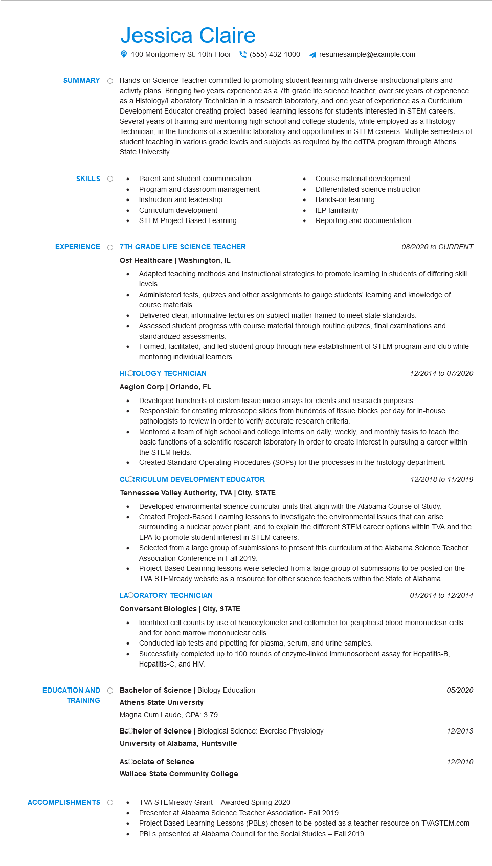

**SUMMARY**

Jessica Claire

100 Montgomery St. 10th Floor(555) 432-1000 ◄ resumesample@example.com

Hands-on Science Teacher committed to promoting student learning with diverse instructional plans and activity plans. Bringing two years experience as a 7th grade life science teacher, over six years of experience as a Histology/Laboratory Technician in a research laboratory, and one year of experience as a Curriculum Development Educator creating project-based learning lessons for students interested in STEM careers. Several years of training and mentoring high school and college students, while employed as a Histology Technician, in the functions of a scientific laboratory and opportunities in STEM careers. Multiple semesters of student teaching in various grade levels and subjects as required by the edTPA program through Athens State University.

**SKILLS**

**EXPERIENCE**

• Parent and student communication Program and classroom management Instruction and leadership

•

Curriculum development

STEM Project-Based Learning

**O 7TH GRADE LIFE SCIENCE TEACHER Osf Healthcare | Washington, IL**

Course material development

Differentiated science instruction

Hands-on learning

•

IEP familiarity

Reporting and documentation

08/2020 to CURRENT

Adapted teaching methods and instructional strategies to promote learning in students of differing skill levels.

Administered tests, quizzes and other assignments to gauge students' learning and knowledge of course materials.

Delivered clear, informative lectures on subject matter framed to meet state standards.

•

•

Assessed student progress with course material through routine quizzes, final examinations and standardized assessments.

Formed, facilitated, and led student group through new establishment of STEM program and club while mentoring individual learners.

**HISTOLOGY TECHNICIAN**

**Aegion Corp | Orlando, FL**

12/2014 to 07/2020

Developed hundreds of custom tissue micro arrays for clients and research purposes.

· Responsible for creating microscope slides from hundreds of tissue blocks per day for in-house pathologists to review in order to verify accurate research criteria.

Mentored a team of high school and college interns on daily, weekly, and monthly tasks to teach the basic functions of a scientific research laboratory in order to create interest in pursuing a career within the STEM fields.

Created Standard Operating Procedures (SOPs) for the processes in the histology department.

**CLORICULUM DEVELOPMENT EDUCATOR**

**Tennessee Valley Authority, TVA | City, STATE**

*12/2018 to 11/2019*

Developed environmental science curricular units that align with the Alabama Course of Study. Created Project-Based Learning lessons to investigate the environmental issues that can arise surrounding a nuclear power plant, and to explain the different STEM career options within TVA and the EPA to promote student interest in STEM careers.

Selected from a large group of submissions to present this curriculum at the Alabama Science Teacher Association Conference in Fall 2019.

Project-Based Learning lessons were selected from a large group of submissions to be posted on the TVA STEMready website as a resource for other science teachers within the State of Alabama.

**LAOORATORY TECHNICIAN**

**Conversant Biologics | City, STATE**

•

*01/2014 to 12/2014*

Identified cell counts by use of hemocytometer and cellometer for peripheral blood mononuclear cells and for bone marrow mononuclear cells.

•

Conducted lab tests and pipetting for plasma, serum, and urine samples.

•

Successfully completed up to 100 rounds of enzyme-linked immunosorbent assay for Hepatitis-B, Hepatitis-C, and HIV.

**EDUCATION AND**

**Bachelor of Science | Biology Education**

05/2020

**TRAINING**

**Athens State University**

Magna Cum Laude, GPA: 3.79

Bachelor of Science | Biological Science: Exercise Physiology

12/2013

**University of Alabama, Huntsville**

AsCociate of Science

12/2010

**Wallace State Community College**

**ACCOMPLISHMENTS**

TVA STEMready Grant - Awarded Spring 2020

Presenter at Alabama Science Teacher Association- Fall 2019

Project Based Learning Lessons (PBLS) chosen to be posted as a teacher resource on TVASTEM.com PBLs presented at Alabama Council for the Social Studies - Fall 2019