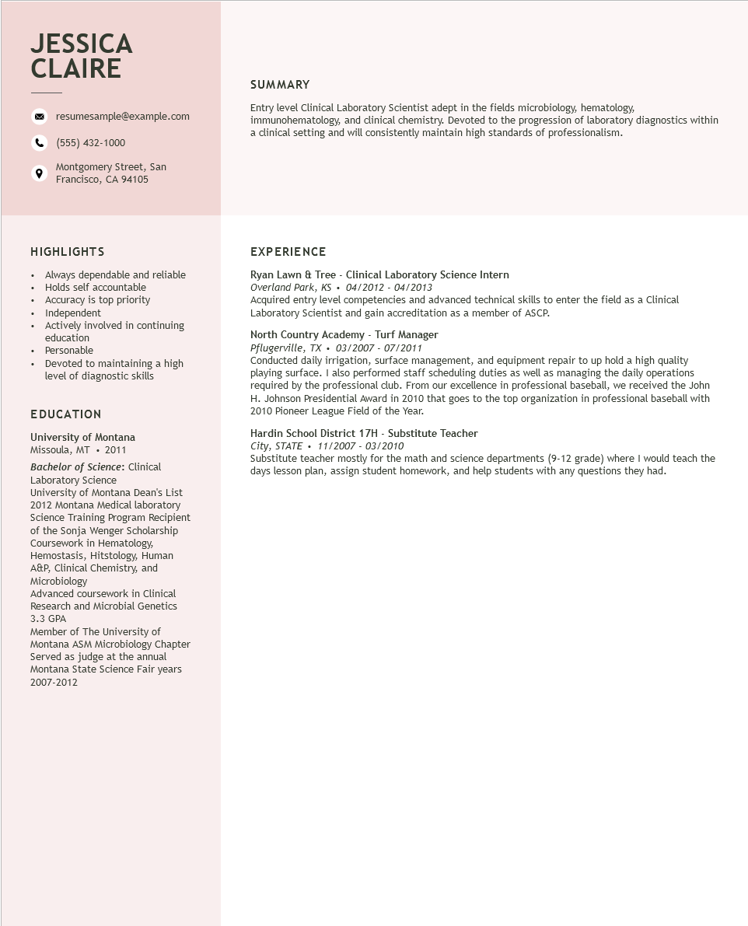

**JESSICA CLAIRE**

resumesample@example.com

(555) 432-1000

Montgomery Street, San

Francisco, CA 94105

SUMMARY

Entry level Clinical Laboratory Scientist adept in the fields microbiology, hematology, immunohematology, and clinical chemistry. Devoted to the progression of laboratory diagnostics within a clinical setting and will consistently maintain high standards of professionalism.

HIGHLIGHTS

Always dependable and reliable

.

•

Holds self accountable

•

•

+

•

Accuracy is top priority Independent

Actively involved in continuing education

Personable

Devoted to maintaining a high

level of diagnostic skills

EDUCATION

University of Montana Missoula, MT. 2011

Bachelor of Science: Clinical Laboratory Science

University of Montana Dean's List 2012 Montana Medical laboratory Science Training Program Recipient of the Sonja Wenger Scholarship Coursework in Hematology, Hemostasis, Hitstology, Human A&P, Clinical Chemistry, and Microbiology

Advanced coursework in Clinical Research and Microbial Genetics 3.3 GPA

Member of The University of

Montana ASM Microbiology Chapter

Served as judge at the annual Montana State Science Fair years 2007-2012

EXPERIENCE

Ryan Lawn & Tree - Clinical Laboratory Science Intern

Overland Park, KS 04/2012 - 04/2013

Acquired entry level competencies and advanced technical skills to enter the field as a Clinical Laboratory Scientist and gain accreditation as a member of ASCP.

North Country Academy - Turf Manager

Pflugerville, TX. 03/2007 - 07/2011

Conducted daily irrigation, surface management, and equipment repair to up hold a high quality playing surface. I also performed staff scheduling duties as well as managing the daily operations required by the professional club. From our excellence in professional baseball, we received the John H. Johnson Presidential Award in 2010 that goes to the top organization in professional baseball with 2010 Pioneer League Field of the Year.

Hardin School District 17H - Substitute Teacher

*City, STATE*

*11/2007-03/2010*

Substitute teacher mostly for the math and science departments (9-12 grade) where I would teach the days lesson plan, assign student homework, and help students with any questions they had.