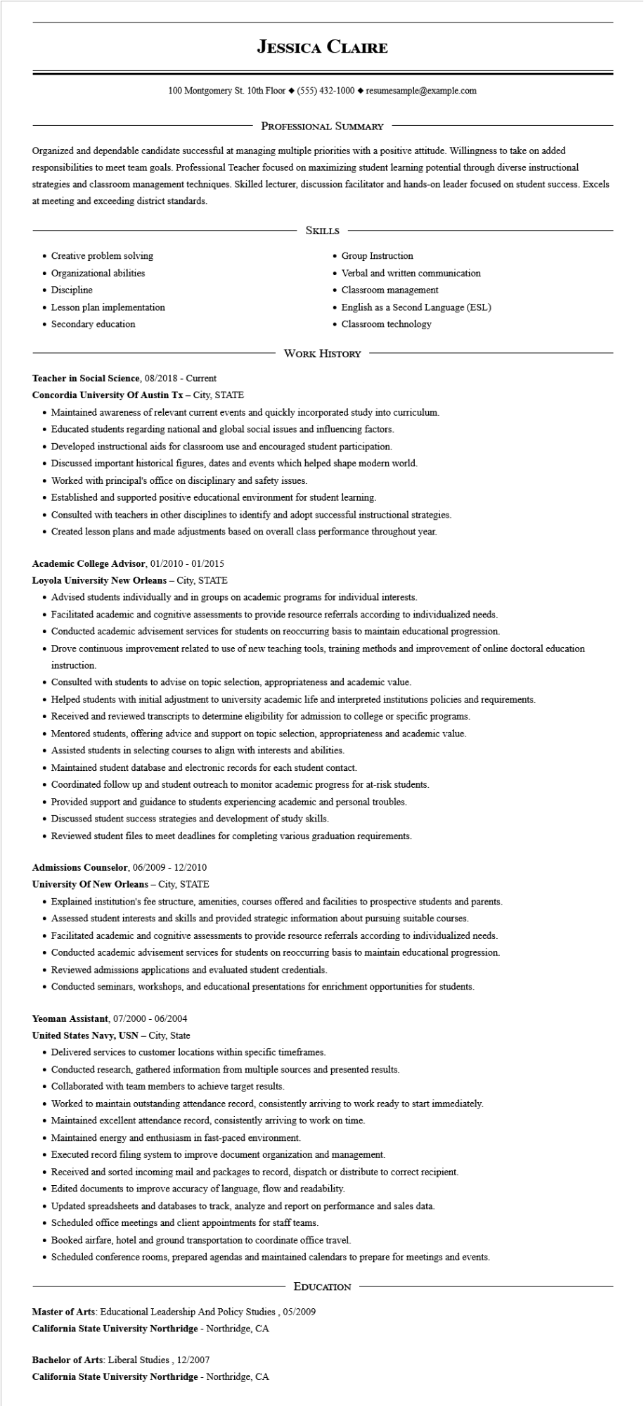

**JESSICA CLAIRE**

100 Montgomery St. 10th Floor (555) 432-1000◆ resumesample@example.com

PROFESSIONAL SUMMARY

Organized and dependable candidate successful at managing multiple priorities with a positive attitude. Willingness to take on added responsibilities to meet team goals. Professional Teacher focused on maximizing student learning potential through diverse instructional strategies and classroom management techniques. Skilled lecturer, discussion facilitator and hands-on leader focused on student success. Excels at meeting and exceeding district standards.

• Creative problem solving

• Organizational abilities

• Discipline

Lesson plan implementation

• Secondary education

SKILLS

• Group Instruction

• Verbal and written communication

• Classroom management

• English as a Second Language (ESL)

• Classroom technology

WORK HISTORY

Teacher in Social Science, 08/2018 - Current

**Concordia University Of Austin Tx - City, STATE**

• Maintained awareness of relevant current events and quickly incorporated study into curriculum.

• Educated students regarding national and global social issues and influencing factors.

• Developed instructional aids for classroom use and encouraged student participation.

• Discussed important historical figures, dates and events which helped shape modern world.

• Worked with principal's office on disciplinary and safety issues.

• Established and supported positive educational environment for student learning.

• Consulted with teachers in other disciplines to identify and adopt successful instructional strategies.

• Created lesson plans and made adjustments based on overall class performance throughout year.

**Academic College Advisor, 01/2010 - 01/2015**

**Loyola University New Orleans - City, STATE**

• Advised students individually and in groups on academic programs for individual interests.

• Facilitated academic and cognitive assessments to provide resource referrals according to individualized needs.

• Conducted academic advisement services for students on reoccurring basis to maintain educational progression.

• Drove continuous improvement related to use of new teaching tools, training methods and improvement of online doctoral education instruction.

• Consulted with students to advise on topic selection, appropriateness and academic value.

• Helped students with initial adjustment to university academic life and interpreted institutions policies and requirements.

• Received and reviewed transcripts to determine eligibility for admission to college or specific programs.

• Mentored students, offering advice and support on topic selection, appropriateness and academic value.

• Assisted students in selecting courses to align with interests and abilities.

• Maintained student database and electronic records for each student contact.

• Coordinated follow up and student outreach to monitor academic progress for at-risk students.

• Provided support and guidance to students experiencing academic and personal troubles.

• Discussed student success strategies and development of study skills.

• Reviewed student files to meet deadlines for completing various graduation requirements.

**Admissions Counselor, 06/2009 - 12/2010**

**University of New Orleans - City, STATE**

• Explained institution's fee structure, amenities, courses offered and facilities to prospective students and parents.

• Assessed student interests and skills and provided strategic information about pursuing suitable courses.

• Facilitated academic and cognitive assessments to provide resource referrals according to individualized needs.

• Conducted academic advisement services for students on reoccurring basis to maintain educational progression.

• Reviewed admissions applications and evaluated student credentials.

• Conducted seminars, workshops, and educational presentations for enrichment opportunities for students.

**Yeoman Assistant, 07/2000 - 06/2004**

**United States Navy, USN - City, State**

• Delivered services to customer locations within specific timeframes.

• Conducted research, gathered information from multiple sources and presented results.

• Collaborated with team members to achieve target results.

• Worked to maintain outstanding attendance record, consistently arriving to work ready to start immediately.

• Maintained excellent attendance record, consistently arriving to work on time.

• Maintained energy and enthusiasm in fast-paced environment.

• Executed record filing system to improve document organization and management.

• Received and sorted incoming mail and packages to record, dispatch or distribute to correct recipient.

• Edited documents to improve accuracy of language, flow and readability.

• Updated spreadsheets and databases to track, analyze and report on performance and sales data.

• Scheduled office meetings and client appointments for staff teams.

• Booked airfare, hotel and ground transportation to coordinate office travel.

• Scheduled conference rooms, prepared agendas and maintained calendars to prepare for meetings and events.

EDUCATION

Master of Arts: Educational Leadership And Policy Studies, 05/2009

**California State University Northridge - Northridge, CA**

**Bachelor of Arts: Liberal Studies, 12/2007**

**California State University Northridge - Northridge, CA**