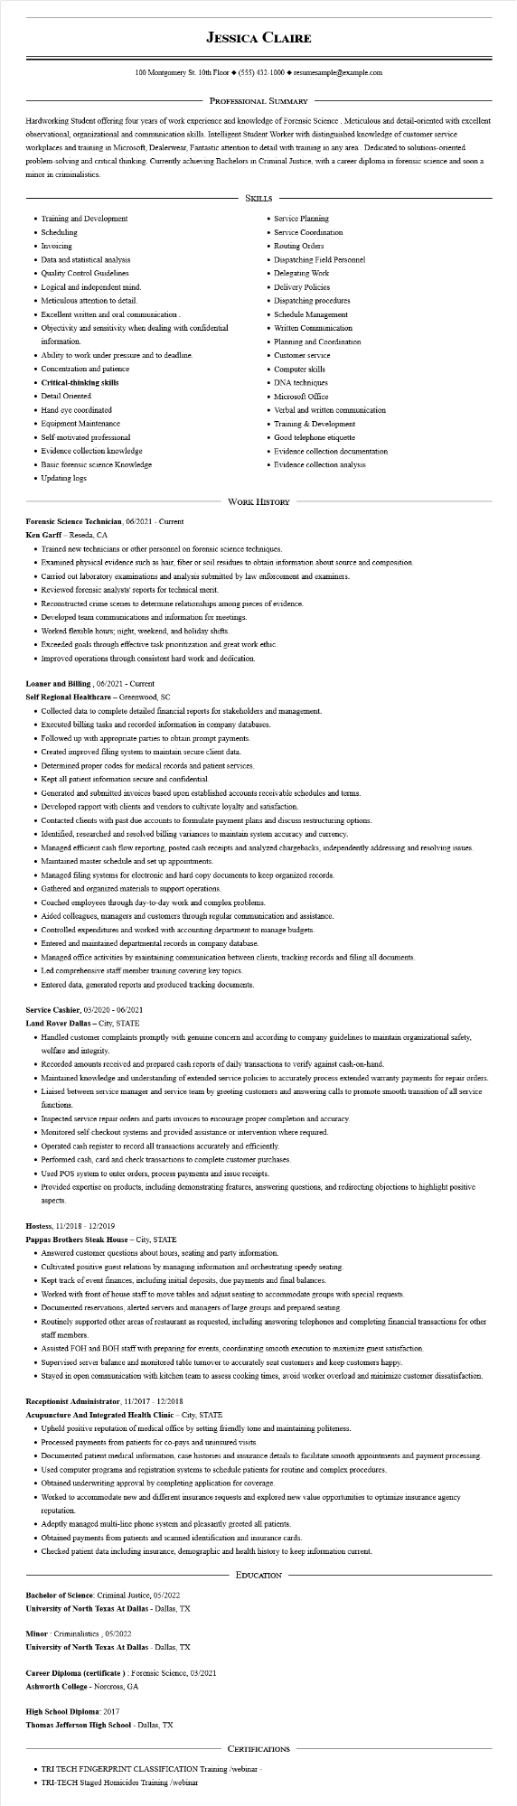

**JESSICA CLAIRE**

100 Montgomery St. 10th Floor (555) 432-1000◆ resumesample@example.com

PROFESSIONAL SUMMARY

Hardworking Student offering four years of work experience and knowledge of Forensic Science . Meticulous and detail-oriented with excellent observational, organizational and communication skills. Intelligent Student Worker with distinguished knowledge of customer service workplaces and training in Microsoft, Dealerwear, Fantastic attention to detail with training in any area. Dedicated to solutions-oriented problem-solving and critical thinking. Currently achieving Bachelors in Criminal Justice, with a career diploma in forensic science and soon a minor in criminalistics.

SKILLS

• Training and Development

• Scheduling

• Invoicing

• Data and statistical analysis

• Quality Control Guidelines

• Logical and independent mind.

• Meticulous attention to detail.

• Excellent written and oral communication.

• Objectivity and sensitivity when dealing with confidential

information.

• Ability to work under pressure and to deadline.

• Concentration and patience

**• Critical-thinking skills**

• Detail Oriented

• Hand eye coordinated

• Equipment Maintenance

• Self-motivated professional

• Evidence collection knowledge

• Basic forensic science Knowledge

• Updating logs

• Service Planning

• Service Coordination

• Routing Orders

• Dispatching Field Personnel

• Delegating Work

• Delivery Policies

• Dispatching procedures

• Schedule Management

• Written Communication

• Planning and Coordination.

• Customer service

• Computer skills

• DNA techniques

• Microsoft Office

• Verbal and written communication

• Training & Development

• Good telephone etiquette

• Evidence collection documentation

• Evidence collection analysis

WORK HISTORY

**Forensic Science Technician, 06/2021 - Current**

Ken Garff - Reseda, CA

• Trained new technicians or other personnel on forensic science techniques.

• Examined physical evidence such as hair, fiber or soil residues to obtain information about source and composition.

• Carried out laboratory examinations and analysis submitted by law enforcement and examiners.

• Reviewed forensic analysts' reports for technical merit.

• Reconstructed crime scenes to determine relationships among pieces of evidence.

• Developed team communications and information for meetings.

• Worked flexible hours; night, weekend, and holiday shifts.

• Exceeded goals through effective task prioritization and great work ethic.

• Improved operations through consistent hard work and dedication.

**Loaner and Billing, 06/2021 - Current**

**Self Regional Healthcare - Greenwood, SC**

• Collected data to complete detailed financial reports for stakeholders and management.

• Executed billing tasks and recorded information in company databases.

• Followed up with appropriate parties to obtain prompt payments.

• Created improved filing system to maintain secure client data.

• Determined proper codes for medical records and patient services.

• Kept all patient information secure and confidential.

• Generated and submitted invoices based upon established accounts receivable schedules and terms.

• Developed rapport with clients and vendors to cultivate loyalty and satisfaction.

• Contacted clients with past due accounts to formulate payment plans and discuss restructuring options.

• Identified, researched and resolved billing variances to maintain system accuracy and currency.

• Managed efficient cash flow reporting, posted cash receipts and analyzed chargebacks, independently addressing and resolving issues.

• Maintained master schedule and set up appointments.

• Managed filing systems for electronic and hard copy documents to keep organized records.

• Gathered and organized materials to support operations.

• Coached employees through day-to-day work and complex problems.

• Aided colleagues, managers and customers through regular communication and assistance.

• Controlled expenditures and worked with accounting department to manage budgets.

• Entered and maintained departmental records in company database.

• Managed office activities by maintaining communication between clients, tracking records and filing all documents.

• Led comprehensive staff member training covering key topics.

• Entered data, generated reports and produced tracking documents.

**Service Cashier, 03/2020 - 06/2021**

**Land Rover Dallas - City, STATE**

• Handled customer complaints promptly with genuine concern and according to company guidelines to maintain organizational safety, welfare and integrity.

• Recorded amounts received and prepared cash reports of daily transactions to verify against cash-on-hand.

• Maintained knowledge and understanding of extended service policies to accurately process extended warranty payments for repair orders.

• Liaised between service manager and service team by greeting customers and answering calls to promote smooth transition of all service functions.

• Inspected service repair orders and parts invoices to encourage proper completion and accuracy.

• Monitored self-checkout systems and provided assistance or intervention where required.

• Operated cash register to record all transactions accurately and efficiently.

• Performed cash, card and check transactions to complete customer purchases.

• Used POS system to enter orders, process payments and issue receipts.

• Provided expertise on products, including demonstrating features, answering questions, and redirecting objections to highlight positive aspects.

Hostess, 11/2018 - 12/2019

**Pappas Brothers Steak House - City, STATE**

• Answered customer questions about hours, seating and party information.

• Cultivated positive guest relations by managing information and orchestrating speedy seating.

• Kept track of event finances, including initial deposits, due payments and final balances.

• Worked with front of house staff to move tables and adjust seating to accommodate groups with special requests.

• Documented reservations, alerted servers and managers of large groups and prepared seating.

• Routinely supported other areas of restaurant as requested, including answering telephones and completing financial transactions for other staff members.

• Assisted FOH and BOH staff with preparing for events, coordinating smooth execution to maximize guest satisfaction.

• Supervised server balance and monitored table turnover to accurately seat customers and keep customers happy.

• Stayed in open communication with kitchen team to assess cooking times, avoid worker overload and minimize customer dissatisfaction.

**Receptionist Administrator, 11/2017 - 12/2018**

**Acupuncture And Integrated Health Clinic - City, STATE**

• Upheld positive reputation of medical office by setting friendly tone and maintaining politeness.

• Processed payments from patients for co-pays and uninsured visits.

• Documented patient medical information, case histories and insurance details to facilitate smooth appointments and payment processing.

• Used computer programs and registration systems to schedule patients for routine and complex procedures.

• Obtained underwriting approval by completing application for coverage.

• Worked to accommodate new and different insurance requests and explored new value opportunities to optimize insurance agency

reputation.

• Adeptly managed multi-line phone system and pleasantly greeted all patients.

• Obtained payments from patients and scanned identification and insurance cards.

• Checked patient data including insurance, demographic and health history to keep information current.

Bachelor of Science: Criminal Justice, 05/2022

**University of North Texas At Dallas - Dallas, TX**

Minor: Criminalistics, 05/2022

**University of North Texas At Dallas - Dallas, TX**

Career Diploma (certificate): Forensic Science, 03/2021

Ashworth College - Norcross, GA

**High School Diploma: 2017**

**Thomas Jefferson High School - Dallas, TX**

**EDUCATION**

CERTIFICATIONS

• TRI TECH FINGERPRINT CLASSIFICATION Training/webinar -

• TRI-TECH Staged Homicides Training /webinar