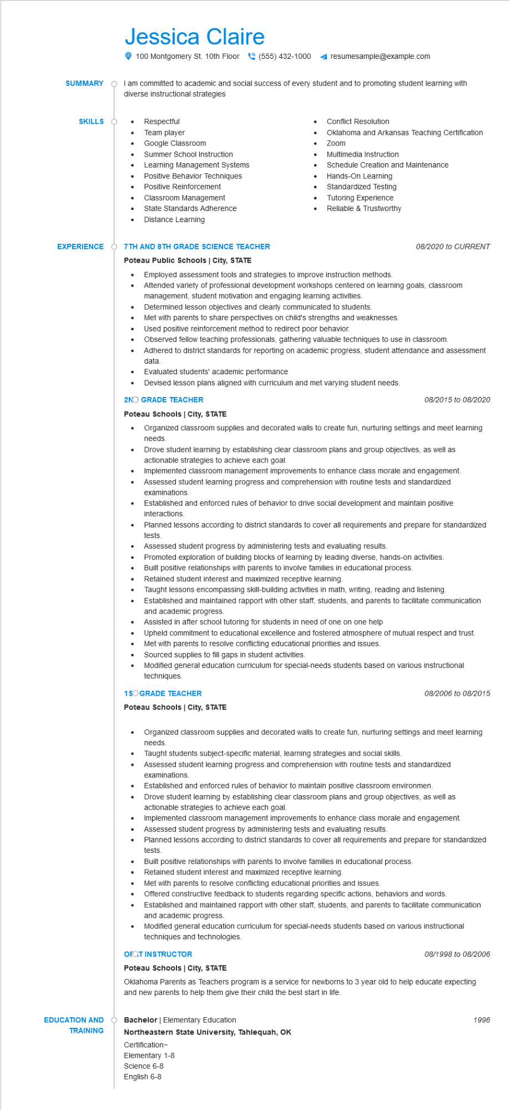

**SUMMARY**

Jessica Claire

100 Montgomery St. 10th Floor(555) 432-1000

resumesample@example.com

I am committed to academic and social success of every student and to promoting student learning with diverse instructional strategies

**SKILLS O**

•

•

Respectful

Team player

Google Classroom

• Summer School Instruction

•

Learning Management Systems

Positive Behavior Techniques

Positive Reinforcement

Classroom Management

• State Standards Adherence

Distance Learning

**EXPERIENCE Ŏ7TH AND 8TH GRADE SCIENCE TEACHER**

**Poteau Public Schools | City, STATE**

•

•

Conflict Resolution

•

•

Zoom

Oklahoma and Arkansas Teaching Certification

Multimedia Instruction

Schedule Creation and Maintenance

Standardized Testing

Tutoring Experience

Reliable & Trustworthy

•

Hands-On Learning

Employed assessment tools and strategies to improve instruction methods.

*08/2020 to CURRENT*

Attended variety of professional development workshops centered on learning goals, classroom

management, student motivation and engaging learning activities.

Determined lesson objectives and clearly communicated to students.

Met with parents to share perspectives on child's strengths and weaknesses.

•

Used positive reinforcement method to redirect poor behavior.

•

Observed fellow teaching professionals, gathering valuable techniques to use in classroom.

Adhered to district standards for reporting on academic progress, student attendance and assessment data.

•

Evaluated students' academic performance

Devised lesson plans aligned with curriculum and met varying student needs.

**2NO GRADE TEACHER**

**Poteau Schools | City, STATE**

•

•

•

•

•

•

*08/2015 to 08/2020*

Organized classroom supplies and decorated walls to create fun, nurturing settings and meet learning needs.

Drove student learning by establishing clear classroom plans and group objectives, as well as actionable strategies to achieve each goal.

Implemented classroom management improvements to enhance class morale and engagement. Assessed student learning progress and comprehension with routine tests and standardized examinations.

Established and enforced rules of behavior to drive social development and maintain positive interactions.

Planned lessons according to district standards to cover all requirements and prepare for standardized tests.

Assessed student progress by administering tests and evaluating results.

Promoted exploration of building blocks of learning by leading diverse, hands-on activities.

Built positive relationships with parents to involve families in educational process.

Retained student interest and maximized receptive learning.

Taught lessons encompassing skill-building activities in math, writing, reading and listening.

Established and maintained rapport with other staff, students, and parents to facilitate communication and academic progress.

Assisted in after school tutoring for students in need of one on one help

Upheld commitment to educational excellence and fostered atmosphere of mutual respect and trust.

Met with parents to resolve conflicting educational priorities and issues.

Sourced supplies to fill gaps in student activities.

Modified general education curriculum for special-needs students based on various instructional techniques.

**1SO GRADE TEACHER**

**Poteau Schools | City, STATE**

08/2006 to 08/2015

• Organized classroom supplies and decorated walls to create fun, nurturing settings and meet learning needs.

•

Taught students subject-specific material, learning strategies and social skills.

Assessed student learning progress and comprehension with routine tests and standardized examinations.

•

Established and enforced rules of behavior to maintain positive classroom environmen.

Drove student learning by establishing clear classroom plans and group objectives, as well as actionable strategies to achieve each goal.

•

Implemented classroom management improvements to enhance class morale and engagement. Assessed student progress by administering tests and evaluating results.

Planned lessons according to district standards to cover all requirements and prepare for standardized tests.

•

Built positive relationships with parents to involve families in educational process.

•

Retained student interest and maximized receptive learning.

Met with parents to resolve conflicting educational priorities and issues.

•

•

Offered constructive feedback to students regarding specific actions, behaviors and words.

Established and maintained rapport with other staff, students, and parents to facilitate communication and academic progress.

Modified general education curriculum for special-needs students based on various instructional techniques and technologies.

**OFQT INSTRUCTOR**

*08/1998 to 08/2006*

**Poteau Schools | City, STATE**

Oklahoma Parents as Teachers program is a service for newborns to 3 year old to help educate expecting and new parents to help them give their child the best start in life.

**EDUCATION AND**

Bachelor | Elementary Education

**TRAINING**

**Northeastern State University, Tahlequah, OK**

Certification~

Elementary 1-8

Science 6-8

English 6-8

1996