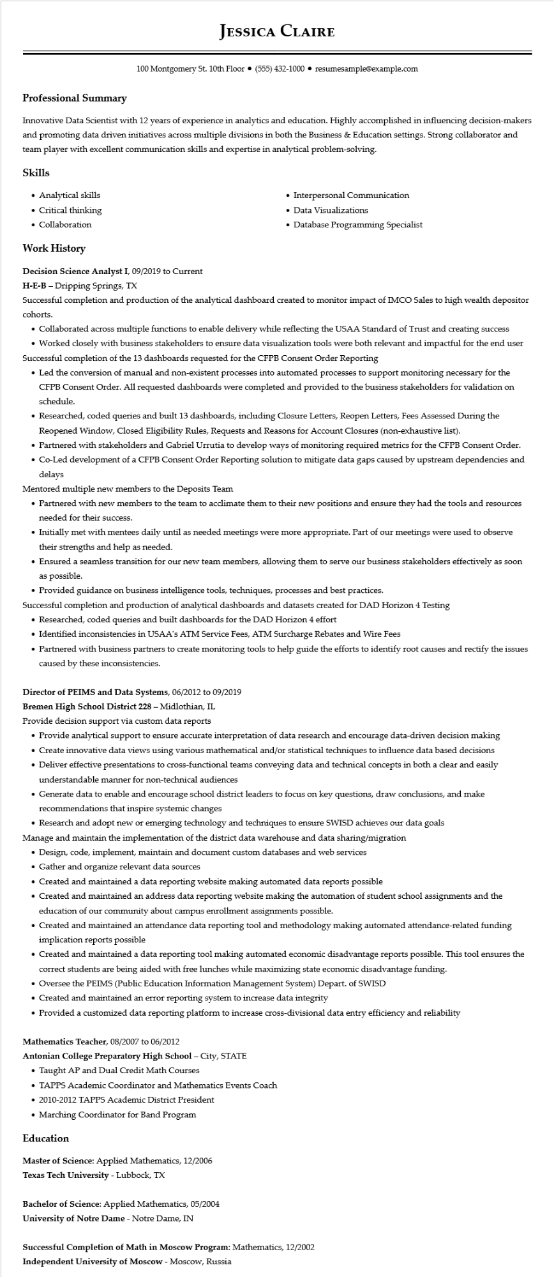

**Professional Summary**

**JESSICA CLAIRE**

100 Montgomery St. 10th Floor⚫ (555) 432-1000⚫ resumesample@example.com

Innovative Data Scientist with 12 years of experience in analytics and education. Highly accomplished in influencing decision-makers and promoting data driven initiatives across multiple divisions in both the Business & Education settings. Strong collaborator and team player with excellent communication skills and expertise in analytical problem-solving.

**Skills**

• Analytical skills

• Critical thinking

• Collaboration

**Work History**

Decision Science Analyst I, 09/2019 to Current

H-E-B - Dripping Springs, TX

• Interpersonal Communication

• Data Visualizations

• Database Programming Specialist

Successful completion and production of the analytical dashboard created to monitor impact of IMCO Sales to high wealth depositor cohorts.

• Collaborated across multiple functions to enable delivery while reflecting the USAA Standard of Trust and creating success

• Worked closely with business stakeholders to ensure data visualization tools were both relevant and impactful for the end user Successful completion of the 13 dashboards requested for the CFPB Consent Order Reporting

• Led the conversion of manual and non-existent processes into automated processes to support monitoring necessary for the CFPB Consent Order. All requested dashboards were completed and provided to the business stakeholders for validation on schedule.

• Researched, coded queries and built 13 dashboards, including Closure Letters, Reopen Letters, Fees Assessed During the Reopened Window, Closed Eligibility Rules, Requests and Reasons for Account Closures (non-exhaustive list).

• Partnered with stakeholders and Gabriel Urrutia to develop ways of monitoring required metrics for the CFPB Consent Order.

• Co-Led development of a CFPB Consent Order Reporting solution to mitigate data gaps caused by upstream dependencies and delays

Mentored multiple new members to the Deposits Team

• Partnered with new members to the team to acclimate them to their new positions and ensure they had the tools and resources needed for their success.

• Initially met with mentees daily until as needed meetings were more appropriate. Part of our meetings were used to observe their strengths and help as needed.

• Ensured a seamless transition for our new team members, allowing them to serve our business stakeholders effectively as soon as possible.

• Provided guidance on business intelligence tools, techniques, processes and best practices.

Successful completion and production of analytical dashboards and datasets created for DAD Horizon 4 Testing

• Researched, coded queries and built dashboards for the DAD Horizon 4 effort

• Identified inconsistencies in USAA's ATM Service Fees, ATM Surcharge Rebates and Wire Fees

• Partnered with business partners to create monitoring tools to help guide the efforts to identify root causes and rectify the issues caused by these inconsistencies.

**Director of PEIMS and Data Systems, 06/2012 to 09/2019**

Bremen High School District 228 - Midlothian, IL

Provide decision support via custom data reports

• Provide analytical support to ensure accurate interpretation of data research and encourage data-driven decision making

• Create innovative data views using various mathematical and/or statistical techniques to influence data based decisions

• Deliver effective presentations to cross-functional teams conveying data and technical concepts in both a clear and easily understandable manner for non-technical audiences

• Generate data to enable and encourage school district leaders to focus on key questions, draw conclusions, and make recommendations that inspire systemic changes

• Research and adopt new or emerging technology and techniques to ensure SWISD achieves our data goals

Manage and maintain the implementation of the district data warehouse and data sharing/migration

• Design, code, implement, maintain and document custom databases and web services

• Gather and organize relevant data sources

• Created and maintained a data reporting website making automated data reports possible

• Created and maintained an address data reporting website making the automation of student school assignments and the education of our community about campus enrollment assignments possible.

• Created and maintained an attendance data reporting tool and methodology making automated attendance-related funding implication reports possible

• Created and maintained a data reporting tool making automated economic disadvantage reports possible. This tool ensures the correct students are being aided with free lunches while maximizing state economic disadvantage funding.

• Oversee the PEIMS (Public Education Information Management System) Depart. of SWISD

• Created and maintained an error reporting system to increase data integrity

• Provided a customized data reporting platform to increase cross-divisional data entry efficiency and reliability

Mathematics Teacher, 08/2007 to 06/2012

**Antonian College Preparatory High School - City, STATE**

• Taught AP and Dual Credit Math Courses

• TAPPS Academic Coordinator and Mathematics Events Coach

2010-2012 TAPPS Academic District President

• Marching Coordinator for Band Program

**Education**

Master of Science: Applied Mathematics, 12/2006

**Texas Tech University - Lubbock, TX**

Bachelor of Science: Applied Mathematics, 05/2004

**University of Notre Dame - Notre Dame, IN**

**Successful Completion of Math in Moscow Program: Mathematics, 12/2002**

Independent University of Moscow - Moscow, Russia