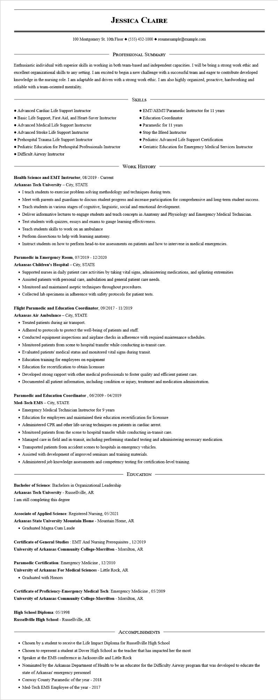

**JESSICA CLAIRE**

100 Montgomery St. 10th Floor (555) 432-1000◆ resumesample@example.com

PROFESSIONAL SUMMARY

Enthusiastic individual with superior skills in working in both team-based and independent capacities. I will be bring a strong work ethic and excellent organizational skills to any setting. I am excited to begin a new challenge with a successful team and eager to contribute developed knowledge in the nursing role. I am adaptable and driven with a strong work ethic. I am also highly organized, proactive, hardworking and reliable with a team-oriented mentality.

• Advanced Cardiac Life Support Instructor

• Basic Life Support, First Aid, and Heart-Saver Instructor

• Advanced Medical Life Support Instructor

• Advanced Stroke Life Support Instructor

• Prehospital Trauma Life Support Instructor

• Pediatric Education for Prehospital Professionals Instructor • Difficult Airway Instructor

SKILLS

• EMT/AEMT/Paramedic Instructor for 11 years

• Education Coordinator

• Paramedic for 11 years

• Stop the Bleed Instructor

• Pediatric Advanced Life Support Certification

• Geriatric Education for Emergency Medical Services Instructor

**Health Science and EMT Instructor, 08/2019 - Current Arkansas Tech University - City, STATE**

WORK HISTORY

• I teach students to exercise problem solving methodology and techniques during tests.

• Meet with parents and guardians to discuss student progress and increase participation for comprehensive and long-term student success.

• Teach students in various stages of cognitive, linguistic, social and emotional development.

• Deliver informative lectures to engage students and teach concepts in Anatomy and Physiology and Emergency Medical Technician.

• Test students with quizzes, essays and exams to gauge learning effectiveness.

• Teach students skills to work on an ambulance

• Perform dissections to help with learning anatomy.

• Instruct students on how to perform head-to-toe assessments on patients and how to intervene in medical emergencies.

**Paramedic in Emergency Room, 07/2019 - 12/2020**

**Arkansas Children's Hospital - City, STATE**

• Supported nurses in daily patient care activities by taking vital signs, administering medications, and splinting extremities

• Assisted patients with personal care, ambulation and general patient care needs.

• Monitored and maintained aseptic techniques throughout procedures.

• Collected lab specimens in adherence with safety protocols for patient tests.

**Flight Paramedic and Education Coordinator, 09/2017 - 11/2019**

**Arkansas Air Ambulance - City, STATE**

• Treated patients during air transport.

• Adhered to protocols to protect the well-being of patients and staff.

• Conducted equipment inspections and airplane checks in adherence with required maintenance schedules.

• Monitored patients from scene to hospital transfer while conducting in-transit care.

• Evaluated patients' medical status and monitored vital signs during transit.

• Education training for employees on equipment

• Education for recertification to obtain licensure

• Developed strong rapport with other medical professionals to foster quality and efficient patient care.

• Documented all patient information, including condition or injury, treatment and medication administration.

**Paramedic and Education Coordinator, 06/2009 - 04/2019**

Med-Tech EMS - City, STATE

• Emergency Medical Technician Instructor for 9 years

• Education for employees and maintained their education recertification for licensure

• Administered CPR and other life-saving techniques on patients in cardiac arrest.

• Monitored patients from the scene to hospital transfer while conducting in-transit care.

• Managed care in field and in-transit, including performing standard testing and administering necessary medication.

• Transported patients from accident scenes to hospitals in emergency vehicles.

• Assisted with development of improved seminars and training materials.

• Administered job knowledge assessments and competency testing for certification-level training.

Bachelor of Science: Bachelors in Organizational Leadership

Arkansas Tech University - Russellville, AR

EDUCATION

I am still completing this degree

Associate of Applied Science: Registered Nursing, 05/2021

Arkansas State University Mountain Home - Mountain Home, AR • Graduated Magna Cum Laude

**Certificate of General Studies: EMT And Nursing Prerequisites, 12/2019 University of Arkansas Community College-Morrilton - Morrilton, AR**

**Paramedic Certification: Emergency Medicine, 12/2010**

**University of Arkansas For Medical Sciences - Little Rock, AR**

• Graduated with Honors

**Certificate of Proficiency-Emergency Medical Tech: Emergency Medicine, 05/2009 University of Arkansas Community College-Morrilton - Morrilton, AR**

**High School Diploma: 05/1998**

**Russellville High School - Russellville, AR**

ACCOMPLISHMENTS

• Chosen by a student to receive the Life Impact Diploma for Russellville High School

• Chosen to represent a student at Dover High School as the teacher that has impacted her the most

• Speaker at the EMS conference in Jacksonville and Little Rock

• Nominated by the Arkansas Department of Health to be an educator for the Difficulty Airway program that was developed to educate the state of Arkansas' emergency personnel

• Conway County Paramedic of the year - 2018

• Med-Tech EMS Employee of the year - 2017