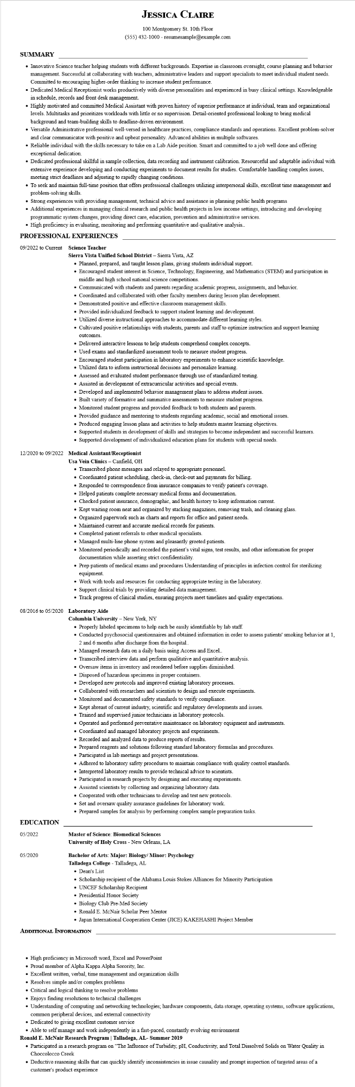

**JESSICA CLAIRE**

100 Montgomery St. 10th Floor (555) 432-1000 - resumesample@example.com

**SUMMARY**

Innovative Science teacher helping students with different backgrounds. Expertise in classroom oversight, course planning and behavior management. Successful at collaborating with teachers, administrative leaders and support specialists to meet individual student needs. Committed to encouraging higher-order thinking to increase student performance.

• Dedicated Medical Receptionist works productively with diverse personalities and experienced in busy clinical settings. Knowledgeable in schedule, records and front desk management.

• Highly motivated and committed Medical Assistant with proven history of superior performance at individual, team and organizational levels. Multitasks and prioritizes workloads with little or no supervision. Detail-oriented professional looking to bring medical

background and team-building skills to deadline-driven environment.

• Versatile Administrative professional well-versed in healthcare practices, compliance standards and operations. Excellent problem-solver and clear communicator with positive and upbeat personality. Advanced abilities in multiple softwares.

• Reliable individual with the skills necessary to take on a Lab Aide position. Smart and committed to a job well done and offering exceptional dedication.

• Dedicated professional skillful in sample collection, data recording and instrument calibration. Resourceful and adaptable individual with extensive experience developing and conducting experiments to document results for studies. Comfortable handling complex issues, meeting strict deadlines and adjusting to rapidly changing conditions.

• To seek and maintain full-time position that offers professional challenges utilizing interpersonal skills, excellent time management and problem-solving skills.

• Strong experiences with providing management, technical advice and assistance in planning public health programs

• Additional experiences in managing clinical research and public health projects in low income settings, introducing and developing

programmatic system changes, providing direct care, education, prevention and administrative services.

• High proficiency in evaluating, monitoring and performing quantitative and qualitative analysis..

**PROFESSIONAL EXPERIENCES**

09/2022 to Current Science Teacher

**Sierra Vista Unified School District - Sierra Vista, AZ**

• Planned, prepared, and taught lesson plans, giving students individual support.

• Encouraged student interest in Science, Technology, Engineering, and Mathematics (STEM) and participation in middle and high school national science competitions.

• Communicated with students and parents regarding academic progress, assignments, and behavior.

• Coordinated and collaborated with other faculty members during lesson plan development.

• Demonstrated positive and effective classroom management skills.

• Provided individualized feedback to support student learning and development.

• Utilized diverse instructional approaches to accommodate different learning styles.

• Cultivated positive relationships with students, parents and staff to optimize instruction and support learning

outcomes.

• Delivered interactive lessons to help students comprehend complex concepts.

• Used exams and standardized assessment tools to measure student progress.

• Encouraged student participation in laboratory experiments to enhance scientific knowledge.

• Utilized data to inform instructional decisions and personalize learning.

• Assessed and evaluated student performance through use of standardized testing.

• Assisted in development of extracurricular activities and special events.

• Developed and implemented behavior management plans to address student issues.

• Built variety of formative and summative assessments to measure student progress.

• Monitored student progress and provided feedback to both students and parents.

• Provided guidance and mentoring to students regarding academic, social and emotional issues.

• Produced engaging lesson plans and activities to help students master learning objectives.

• Supported students in development of skills and strategies to become independent and successful learners.

• Supported development of individualized education plans for students with special needs.

**12/2020 to 09/2022 Medical Assistant/Receptionist**

**Usa Vein Clinics - Canfield, OH**

• Transcribed phone messages and relayed to appropriate personnel.

• Coordinated patient scheduling, check-in, check-out and payments for billing.

• Responded to correspondence from insurance companies to verify patient's coverage.

• Helped patients complete necessary medical forms and documentation.

• Checked patient insurance, demographic, and health history to keep information current.

• Kept waiting room neat and organized by stacking magazines, removing trash, and cleaning glass.

• Organized paperwork such as charts and reports for office and patient needs.

• Maintained current and accurate medical records for patients.

• Completed patient referrals to other medical specialists.

• Managed multi-line phone system and pleasantly greeted patients.

• Monitored periodically and recorded the patient's vital signs, test results, and other information for proper documentation while asserting strict confidentiality.

• Prep patients of medical exams and procedures Understanding of principles in infection control for sterilizing equipment.

• Work with tools and resources for conducting appropriate testing in the laboratory.

• Support clinical trials by providing detailed data management.

• Track progress of clinical studies, ensuring projects meet timelines and quality expectations.

08/2016 to 05/2020 Laboratory Aide

**EDUCATION**

05/2022

05/2020

**Columbia University - New York, NY**

• Properly labeled specimens to help each be easily identifiable by lab staff.

• Conducted psychosocial questionnaires and obtained information in order to assess patients' smoking behavior at 1, 2 and 6 months after discharge from the hospital..

• Managed research data on a daily basis using Access and Excel..

• Transcribed interview data and perform qualitative and quantitative analysis.

• Oversaw items in inventory and reordered before supplies diminished.

• Disposed of hazardous specimens in proper containers.

• Developed new protocols and improved existing laboratory processes.

• Collaborated with researchers and scientists to design and execute experiments.

• Monitored and documented safety standards to verify compliance.

• Kept abreast of current industry, scientific and regulatory developments and issues.

• Trained and supervised junior technicians in laboratory protocols.

• Operated and performed preventative maintenance on laboratory equipment and instruments.

• Coordinated and managed laboratory projects and experiments.

• Recorded and analyzed data to produce reports of results.

• Prepared reagents and solutions following standard laboratory formulas and procedures.

• Participated in lab meetings and project presentations.

• Adhered to laboratory safety procedures to maintain compliance with quality control standards.

• Interpreted laboratory results to provide technical advice to scientists.

• Participated in research projects by designing and executing experiments.

• Assisted scientists by collecting and organizing laboratory data.

• Cooperated with other technicians to develop and test new protocols.

• Set and oversaw quality assurance guidelines for laboratory work.

• Prepared samples for analysis by performing complex sample preparation tasks.

**Master of Science: Biomedical Sciences**

**University of Holy Cross - New Orleans, LA**

**Bachelor of Arts: Major: Biology/Minor: Psychology**

Talladega College - Talladega, AL

• Dean's List

• Scholarship recipient of the Alabama Louis Stokes Alliances for Minority Participation

• UNCEF Scholarship Recipient

• Presidential Honor Society

• Biology Club Pre-Med Society

• Ronald E. McNair Scholar Peer Mentor

• Japan International Cooperation Center (JICE) KAKEHASHI Project Member

**ADDITIONAL INFORMATION**

• High proficiency in Microsoft word, Excel and PowerPoint

• Proud member of Alpha Kappa Alpha Sorority, Inc.

• Excellent written, verbal, time management and organization skills

• Resolves simple and/or complex problems

• Critical and logical thinking to resolve problems

• Enjoys finding resolutions to technical challenges

• Understanding of computing and networking technologies; hardware components, data storage, operating systems, software applications,

common peripheral devices, and external connectivity

• Dedicated to giving excellent customer service

• Able to self manage and work independently in a fast-paced, constantly evolving environment

**Ronald E. McNair Research Program | Talladega, AL- Summer 2019**

• Participated in a research program on "The Influence of Turbidity, pH, Conductivity, and Total Dissolved Solids on Water Quality in Choccolocco Creek

• Deductive reasoning skills that can quickly identify inconsistencies in issue causality and prompt inspection of targeted areas of a customer's product experience