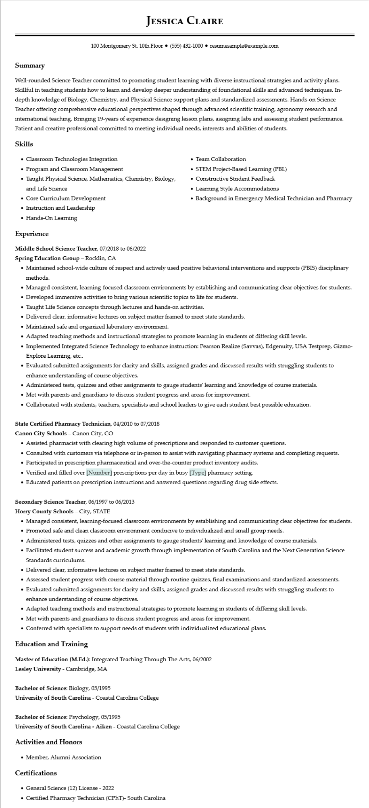

**JESSICA CLAIRE**

100 Montgomery St. 10th Floor⚫ (555) 432-1000⚫ resumesample@example.com

**Summary**

Well-rounded Science Teacher committed to promoting student learning with diverse instructional strategies and activity plans. Skillful in teaching students how to learn and develop deeper understanding of foundational skills and advanced techniques. In- depth knowledge of Biology, Chemistry, and Physical Science support plans and standardized assessments. Hands-on Science Teacher offering comprehensive educational perspectives shaped through advanced scientific training, agronomy research and international teaching. Bringing 19-years of experience designing lesson plans, assigning labs and assessing student performance. Patient and creative professional committed to meeting individual needs, interests and abilities of students.

**Skills**

• Classroom Technologies Integration

• Program and Classroom Management

• Taught Physical Science, Mathematics, Chemistry, Biology, and Life Science

• Team Collaboration

• STEM Project-Based Learning (PBL)

• Constructive Student Feedback

• Learning Style Accommodations

• Background in Emergency Medical Technician and Pharmacy

• Core Curriculum Development

• Instruction and Leadership

• Hands-On Learning

**Experience**

Middle School Science Teacher, 07/2018 to 06/2022

**Spring Education Group - Rocklin, CA**

• Maintained school-wide culture of respect and actively used positive behavioral interventions and supports (PBIS) disciplinary methods.

• Managed consistent, learning-focused classroom environments by establishing and communicating clear objectives for students.

• Developed immersive activities to bring various scientific topics to life for students.

•

Taught Life Science concepts through lectures and hands-on activities.

• Delivered clear, informative lectures on subject matter framed to meet state standards.

• Maintained safe and organized laboratory environment.

• Adapted teaching methods and instructional strategies to promote learning in students of differing skill levels.

• Implemented Integrated Science Technology to enhance instruction: Pearson Realize (Savvas), Edgenuity, USA Testprep, Gizmo- Explore Learning, etc..

• Evaluated submitted assignments for clarity and skills, assigned grades and discussed results with struggling students to enhance understanding of course objectives.

• Administered tests, quizzes and other assignments to gauge students' learning and knowledge of course materials.

• Met with parents and guardians to discuss student progress and areas for improvement.

• Collaborated with students, teachers, specialists and school leaders to give each student best possible education.

State Certified Pharmacy Technician, 04/2010 to 07/2018

**Canon City Schools - Canon City, CO**

• Assisted pharmacist with clearing high volume of prescriptions and responded to customer questions.

• Consulted with customers via telephone or in-person to assist with navigating pharmacy systems and completing requests.

• Participated in prescription pharmaceutical and over-the-counter product inventory audits.

• Verified and filled over [Number] prescriptions per day in busy [Type] pharmacy setting.

• Educated patients on prescription instructions and answered questions regarding drug side effects.

Secondary Science Teacher, 06/1997 to 06/2013

**Horry County Schools - City, STATE**

• Managed consistent, learning-focused classroom environments by establishing and communicating clear objectives for students.

• Promoted safe and clean classroom environment conducive to individualized and small group needs.

• Administered tests, quizzes and other assignments to gauge students' learning and knowledge of course materials.

• Facilitated student success and academic growth through implementation of South Carolina and the Next Generation Science Standards curriculums.

• Delivered clear, informative lectures on subject matter framed to meet state standards.

• Assessed student progress with course material through routine quizzes, final examinations and standardized assessments.

• Evaluated submitted assignments for clarity and skills, assigned grades and discussed results with struggling students to enhance understanding of course objectives.

• Adapted teaching methods and instructional strategies to promote learning in students of differing skill levels.

• Met with parents and guardians to discuss student progress and areas for improvement.

• Conferred with specialists to support needs of students with individualized educational plans.

**Education and Training**

Master of Education (M.Ed.): Integrated Teaching Through The Arts, 06/2002

**Lesley University - Cambridge, MA**

Bachelor of Science: Biology, 05/1995

**University of South Carolina - Coastal Carolina College**

**Bachelor of Science: Psychology, 05/1995**

University of South Carolina - Aiken - Coastal Carolina College

**Activities and Honors**

• Member, Alumni Association

**Certifications**

• General Science (12) License - 2022

• Certified Pharmacy Technician (CPhT)- South Carolina