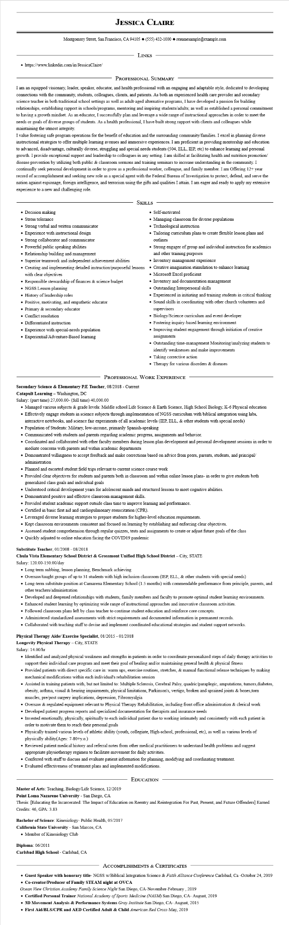

**JESSICA CLAIRE**

Montgomery Street, San Francisco, CA 94105 ♦ (555) 432-1000 resumesample@example.com

• https://www.linkedin.com/in/JessicaClaire/

LINKS

PROFESSIONAL SUMMARY

I am an equipped visionary, leader, speaker, educator, and health professional with an engaging and adaptable style, dedicated to developing connections with the community, students, colleagues, clients, and patients. As both an experienced health care provider and secondary science teacher in both traditional school settings as well as adult-aged alternative programs, I have developed a passion for building relationships, establishing rapport in schools/programs, mentoring and inspiring students/adults; as well as established a personal commitment to having a growth mindset. As an educator, I successfully plan and leverage a wide range of instructional approaches in order to meet the needs or goals of diverse groups of students. As a health professional, I have built strong rapport with clients and colleagues while maintaining the utmost integrity.

I value fostering safe program operations for the benefit of education and the surrounding community/families. I excel in planning diverse instructional strategies to offer multiple learning avenues and immersive experiences. I am proficient in providing mentorship and education to advanced, disadvantage, culturally diverse, struggling and special needs students (504, ELL, IEP, etc) to enhance learning and personal growth. I provide exceptional support and leadership to colleagues in any setting. I am skilled at facilitating health and nutrition promotion/ disease prevention by utilizing both public & classroom sermons and training seminars to increase understanding in the community. I continually seek personal development in order to grow as a professional worker, colleague, and family member. I am Offering 12+ year record of accomplishment and seeking new role as a special agent with the Federal Bureau of Investigation to protect, defend, and serve the nation against espionage, foreign intelligence, and terrorism using the gifts and qualities I attain. I am eager and ready to apply my extensive experience to a new and challenging role.

• Decision making

• Stress tolerance

• Strong verbal and written communicator

• Experience with instructional design

• Strong collaborator and communicator

• Powerful public speaking abilities

• Relationship building and management

• Superior teamwork and independent achievement abilities

SKILLS

• Creating and implementing detailed instruction/purposeful lessons with clear objectives

• Responsible stewardship of finances & science budget

• NGSS Lesson planning

• History of leadership roles

• Positive, motivating, and empathetic educator

• Primary & secondary educator

• Conflict resolution

• Differentiated instruction

• Experience with special-needs population

• Experiential/Adventure-Based learning

• Self-motivated

• Managing classroom for diverse populations

• Technological instruction

• Tailoring curriculum plans to create flexible lesson plans and outlines

• Strong engager of group and individual instruction for academics and other training purposes

• Inventory management experience

• Creative imagination stimulation to enhance learning

• Microsoft Excel proficient

• Inventory and documentation management

• Outstanding Interpersonal skills

Experienced in initiating and training students in critical thinking

• Sound skills in coordinating with other church volunteers and supervisors

• Biology/Science curriculum and event developer

• Fostering inquiry-based learning environment

• Improving student engagement through initiation of creative assignments

• Outstanding time-management Monitoring/analyzing students to identify weaknesses and make improvements

• Taking corrective action

• Therapy for various disorders & diseases

PROFESSIONAL WORK EXPERIENCE

**Secondary Science & Elementary P.E Teacher, 08/2018 - Current**

Catapult Learning - Washington, DC

Salary: (part time) 27,000.00- (full time) 40,000.00

• Managed various subjects & grade levels: Middle school Life Science & Earth Science, High School Biology, K-6 Physical education

• Effectively engage students in science subjects through implementation of NGSS curriculum with biblical integration using labs,

interactive notebooks, and science fair experiments of all academic levels (IEP, ELL, & other students with special needs)

• Population of Students: Military, low-income, primarily Spanish-speaking

• Communicated with students and parents regarding academic progress, assignments and behavior.

• Coordinated and collaborated with other faculty members during lesson plan development and personal development sessions in order to mediate concerns with parents and within academic departments

• Demonstrated willingness to accept feedback and make corrections based on advice from peers, parents, students, and principal/ administration

Planned and escorted student field trips relevant to current science course work

• Provided clear objectives for students and parents both in classroom and within online lesson plans- in order to give students both generalized class goals and individual goals

• Understood critical development years for adolescent minds and structured lessons to meet cognitive abilities.

• Demonstrated positive and effective classroom management skills.

• Provided student academic support outside class time to improve learning and performance.

• Certified in basic first aid and cardiopulmonary resuscitation (CPR).

• Leveraged diverse learning strategies to prepare students for higher-level education requirements.

• Kept classroom environments consistent and focused on learning by establishing and enforcing clear objectives.

• Assessed student comprehension through regular quizzes, tests and assignments to create or adjust future goals of the class

• Quickly adjusted to online education facing the COVID19 pandemic

**Substitute Teacher, 01/2008 - 08/2018**

**Chula Vista Elementary School District & Grossmont Unified High School District - City, STATE**

Salary: 120.00-150.00/day

• Long term subbing, lesson planning, Benchmark achieving

• Oversaw/taught groups of up to 31 students with high inclusion classroom (IEP, ELL, & other students with special needs)

• Long-term substitute position at Camarena Elementary School (1.5 months) with commendable performance from principle, parents, and other teachers/administration

• Developed and deepened relationships with students, family members and faculty to promote optimal student learning environments.

• Enhanced student learning by optimizing wide range of instructional approaches and innovative classroom activities.

• Followed classroom plans left by class teacher to continue student education and reinforce core concepts.

• Administered standardized assessments with strict requirements and documented information in permanent records.

• Collaborated with teaching staff to devise and implement coordinated educational strategies and student support networks.

**Physical Therapy Aide/ Exercise Specialist, 01/2015 - 01/2018**

**Longevity Physical Therapy - City, STATE**

Salary: 14.00/hr

• Identified and analyzed physical weakness and strengths in patients in order to coordinate personalized steps of daily therapy activities to support their individual care program and meet their goal of healing and/or maintaining general health & physical fitness

• Provided patients with direct specific care in: warm ups, exercise routines, stretches, & manual functional release techniques by making mechanical modifications within each individual's rehabilitation session

• Assisted in training patients with, but not limited to: Multiple Sclerosis, Cerebral Palsy, quadric/paraplegic, amputations, tumors, diabetes, obesity, asthma, visual & hearing impairments, physical limitations, Parkinson's, vertigo, broken and sprained joints & bones,torn muscles, pre/post surgery implications, depression, Fibromyalgia

• Oversaw & regulated equipment relevant to Physical Therapy Rehabilitation, including front office administration & clerical work

• Developed patient progress reports and specialized documentation for therapists and insurance needs

• Invested emotionally, physically, spiritually to each individual patient due to working intimately and consistently with each patient in order to motivate them to reach their personal goals

• Physically trained various levels of athletic ability (youth, collegiate, High-school, professional, etc), as well as various levels of physically ability(Ages: 7-80+y.o.)

• Reviewed patient medical history and referral notes from other medical practitioners to understand health problems and suggest appropriate physiotherapy regimen to facilitate movement for daily activities.

• Conferred with staff to discuss and evaluate patient information for planning, modifying and coordinating treatment.

• Evaluated effectiveness of treatment plans and implemented modifications.

EDUCATION

Master of Arts: Teaching, Biology/Life Science, 12/2019

**Point Loma Nazarene University - San Diego, CA**

Thesis: [Educating the Incarcerated: The Impact of Education on Reentry and Reintegration For Past, Present, and Future Offenders] Earned Credits: 46, GPA: 3.83

**Bachelor of Science: Kinesiology- Public Health, 05/2017**

**California State University - San Marcos, CA**

• Member of Kinesiology Club

**Diploma: 06/2011**

**Carlsbad High School - Carlsbad, CA**

ACCOMPLISHMENTS & CERTIFICATES

**• Guest Speaker with honorary title- NGSS w/Biblical Integration Science & Faith Alliance Conference Carlsbad, Ca -October 24, 2019**

**• Co-creator/Producer of Family STEAM night at OVCA**

Ocean View Christian Academy Family Science Night San Diego, CA-November-February, 2019

*• Certified Personal Trainer National Academy of Sports Medicine (NASM) San Diego, CA- August, 2019*

**• 3D Movement Analysis & Performance Systems Gray Institute San Diego, CA- August, 2015**

**• First Aid/BLS/CPR and AED Certified Adult & Child American Red Cross-May, 2019**