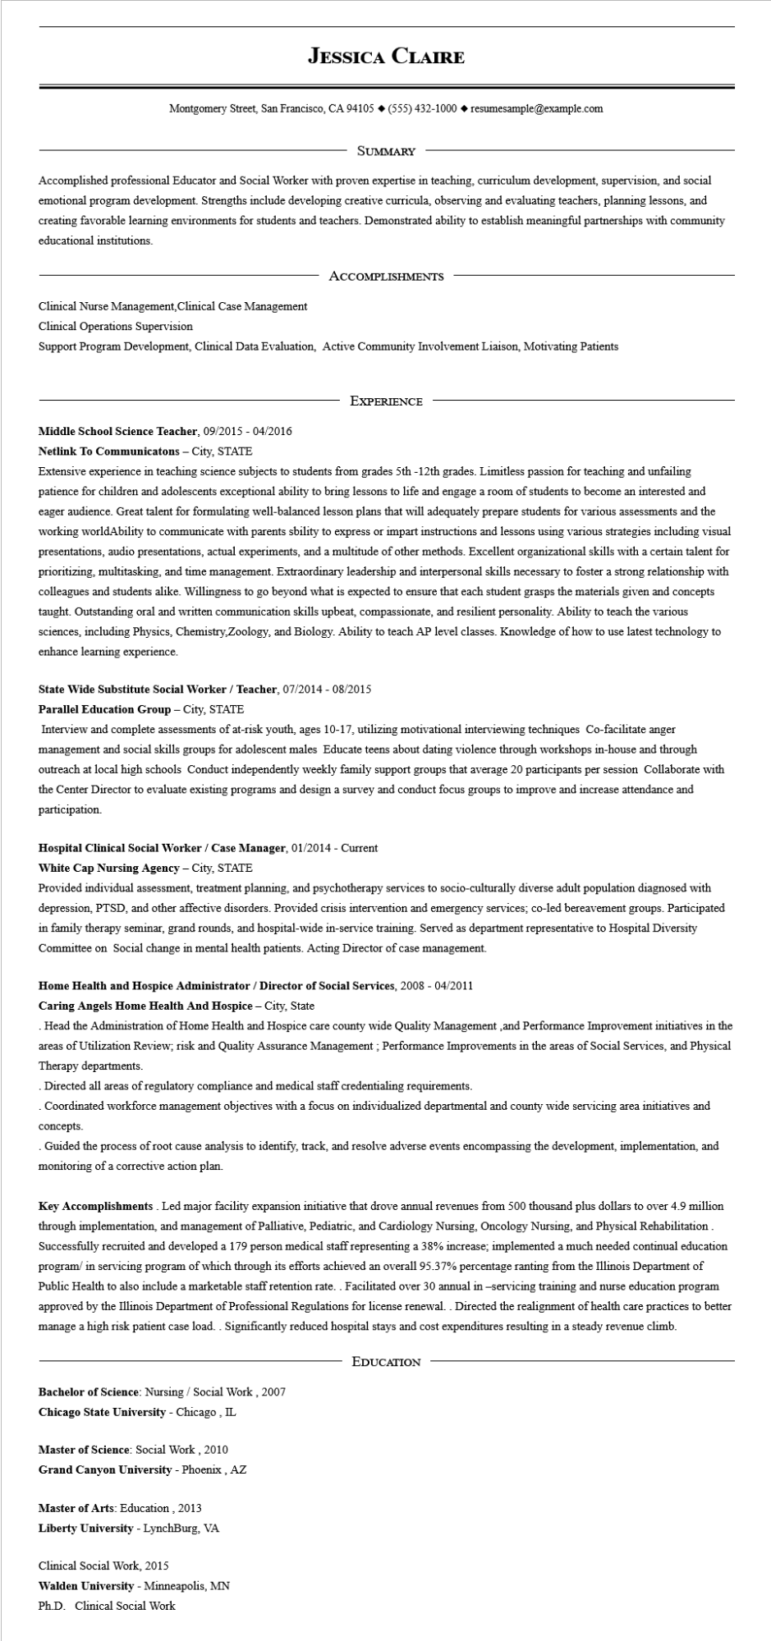

**JESSICA CLAIRE**

Montgomery Street, San Francisco, CA 94105 ♦ (555) 432-1000 resumesample@example.com

SUMMARY

Accomplished professional Educator and Social Worker with proven expertise in teaching, curriculum development, supervision, and social emotional program development. Strengths include developing creative curricula, observing and evaluating teachers, planning lessons, and creating favorable learning environments for students and teachers. Demonstrated ability to establish meaningful partnerships with community educational institutions.

ACCOMPLISHMENTS

Clinical Nurse Management, Clinical Case Management

Clinical Operations Supervision

Support Program Development, Clinical Data Evaluation, Active Community Involvement Liaison, Motivating Patients

EXPERIENCE

**Middle School Science Teacher, 09/2015 - 04/2016 Netlink To Communicatons - City, STATE**

Extensive experience in teaching science subjects to students from grades 5th-12th grades. Limitless passion for teaching and unfailing patience for children and adolescents exceptional ability to bring lessons to life and engage a room of students to become an interested and eager audience. Great talent for formulating well-balanced lesson plans that will adequately prepare students for various assessments and the working worldAbility to communicate with parents sbility to express or impart instructions and lessons using various strategies including visual presentations, audio presentations, actual experiments, and a multitude of other methods. Excellent organizational skills with a certain talent for prioritizing, multitasking, and time management. Extraordinary leadership and interpersonal skills necessary to foster a strong relationship with colleagues and students alike. Willingness to go beyond what is expected to ensure that each student grasps the materials given and concepts taught. Outstanding oral and written communication skills upbeat, compassionate, and resilient personality. Ability to teach the various sciences, including Physics, Chemistry, Zoology, and Biology. Ability to teach AP level classes. Knowledge of how to use latest technology to enhance learning experience.

**State Wide Substitute Social Worker / Teacher, 07/2014 - 08/2015**

**Parallel Education Group - City, STATE**

Interview and complete assessments of at-risk youth, ages 10-17, utilizing motivational interviewing techniques Co-facilitate anger management and social skills groups for adolescent males Educate teens about dating violence through workshops in-house and through outreach at local high schools Conduct independently weekly family support groups that average 20 participants per session Collaborate with the Center Director to evaluate existing programs and design a survey and conduct focus groups to improve and increase attendance and participation.

**Hospital Clinical Social Worker / Case Manager, 01/2014 - Current**

**White Cap Nursing Agency - City, STATE**

Provided individual assessment, treatment planning, and psychotherapy services to socio-culturally diverse adult population diagnosed with depression, PTSD, and other affective disorders. Provided crisis intervention and emergency services; co-led bereavement groups. Participated in family therapy seminar, grand rounds, and hospital-wide in-service training. Served as department representative to Hospital Diversity Committee on Social change in mental health patients. Acting Director of case management.

**Home Health and Hospice Administrator/Director of Social Services, 2008 - 04/2011**

**Caring Angels Home Health And Hospice - City, State**

. Head the Administration of Home Health and Hospice care county wide Quality Management, and Performance Improvement initiatives in the areas of Utilization Review; risk and Quality Assurance Management; Performance Improvements in the areas of Social Services, and Physical Therapy departments.

Directed all areas of regulatory compliance and medical staff credentialing requirements.

Coordinated workforce management objectives with a focus on individualized departmental and county wide servicing area initiatives and concepts.

Guided the process of root cause analysis to identify, track, and resolve adverse events encompassing the development, implementation, and monitoring of a corrective action plan.

Key Accomplishments. Led major facility expansion initiative that drove annual revenues from 500 thousand plus dollars to over 4.9 million through implementation, and management of Palliative, Pediatric, and Cardiology Nursing, Oncology Nursing, and Physical Rehabilitation. Successfully recruited and developed a 179 person medical staff representing a 38% increase; implemented a much needed continual education program/ in servicing program of which through its efforts achieved an overall 95.37% percentage ranting from the Illinois Department of Public Health to also include a marketable staff retention rate.. Facilitated over 30 annual in-servicing training and nurse education program approved by the Illinois Department of Professional Regulations for license renewal. . Directed the realignment of health care practices to better manage a high risk patient case load. . Significantly reduced hospital stays and cost expenditures resulting in a steady revenue climb.

**Bachelor of Science: Nursing/Social Work, 2007**

**Chicago State University - Chicago, IL**

Master of Science: Social Work, 2010

**Grand Canyon University - Phoenix, AZ**

Master of Arts: Education, 2013

Liberty University - Lynchburg, VA

Clinical Social Work, 2015

**Walden University - Minneapolis, MN**

Ph.D. Clinical Social Work

**EDUCATION**