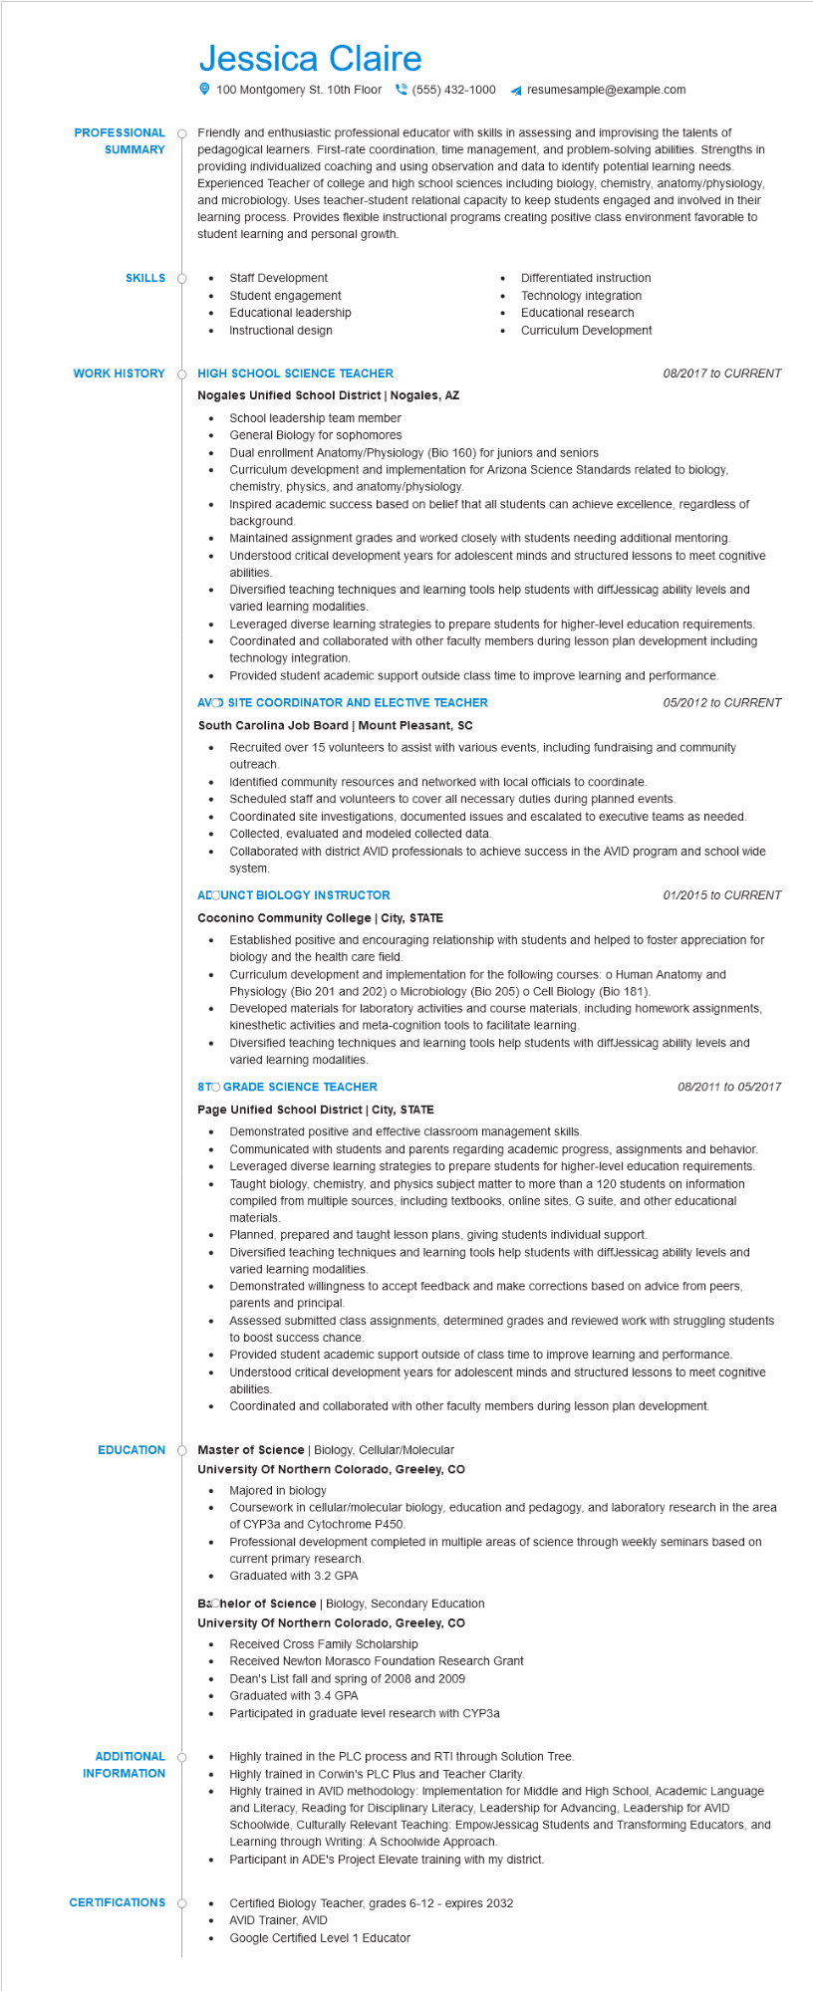

**PROFESSIONAL SUMMARY**

Jessica Claire

100 Montgomery St. 10th Floor (555) 432-1000 4 resumesample@example.com

Friendly and enthusiastic professional educator with skills in assessing and improvising the talents of pedagogical learners. First-rate coordination, time management, and problem-solving abilities. Strengths in providing individualized coaching and using observation and data to identify potential learning needs. Experienced Teacher of college and high school sciences including biology, chemistry, anatomy/physiology, and microbiology. Uses teacher-student relational capacity to keep students engaged and involved in their learning process. Provides flexible instructional programs creating positive class environment favorable to student learning and personal growth.

**SKILLS**

•

Staff Development

Student engagement

•

Educational leadership

•

Instructional design

•

Differentiated instruction Technology integration Educational research Curriculum Development

**WORK HISTORY**

**HIGH SCHOOL SCIENCE TEACHER**

*08/2017 to CURRENT*

**Nogales Unified School District | Nogales, AZ**

•

School leadership team member

General Biology for sophomores

Dual enrollment Anatomy/Physiology (Bio 160) for juniors and seniors

Curriculum development and implementation for Arizona Science Standards related to biology, chemistry, physics, and anatomy/physiology.

Inspired academic success based on belief that all students can achieve excellence, regardless of background.

Maintained assignment grades and worked closely with students needing additional mentoring. Understood critical development years for adolescent minds and structured lessons to meet cognitive abilities

Diversified teaching techniques and learning tools help students with diffJessicag ability levels and varied learning modalities.

Leveraged diverse learning strategies to prepare students for higher-level education requirements. Coordinated and collaborated with other faculty members during lesson plan development including technology integration.

Provided student academic support outside class time to improve learning and performance.

**AVO SITE COORDINATOR AND ELECTIVE TEACHER**

**South Carolina Job Board | Mount Pleasant, SC**

*05/2012 to CURRENT*

• Recruited over 15 volunteers to assist with various events, including fundraising and community outreach.

•

Identified community resources and networked with local officials to coordinate.

• Scheduled staff and volunteers to cover all necessary duties during planned events.

Coordinated site investigations, documented issues and escalated to executive teams as needed.

• Collected, evaluated and modeled collected data.

Collaborated with district AVID professionals to achieve success in the AVID program and school wide system.

**ACOUNCT BIOLOGY INSTRUCTOR**

**Coconino Community College | City, STATE**

•

01/2015 to CURRENT

Established positive and encouraging relationship with students and helped to foster appreciation for biology and the health care field.

Curriculum development and implementation for the following courses: o Human Anatomy and Physiology (Bio 201 and 202) o Microbiology (Bio 205) o Cell Biology (Bio 181).

•

Developed materials for laboratory activities and course materials, including homework assignments, kinesthetic activities and meta-cognition tools to facilitate learning.

Diversified teaching techniques and learning tools help students with diffJessicag ability levels and varied learning modalities.

**8TO GRADE SCIENCE TEACHER**

**Page Unified School District | City, STATE**

•

•

•

•

Demonstrated positive and effective classroom management skills.

08/2011 to 05/2017

Communicated with students and parents regarding academic progress, assignments and behavior. Leveraged diverse learning strategies to prepare students for higher-level education requirements. Taught biology, chemistry, and physics subject matter to more than a 120 students on information compiled from multiple sources, including textbooks, online sites, G suite, and other educational materials.

Planned, prepared and taught lesson plans, giving students individual support.

Diversified teaching techniques and learning tools help students with diffJessicag ability levels and varied learning modalities.

Demonstrated willingness to accept feedback and make corrections based on advice from peers, parents and principal.

Assessed submitted class assignments, determined grades and reviewed work with struggling students to boost success chance.

Provided student academic support outside of class time to improve learning and performance. Understood critical development years for adolescent minds and structured lessons to meet cognitive abilities.

Coordinated and collaborated with other faculty members during lesson plan development.

EDUCATION Master of Science | Biology, Cellular/Molecular

**University Of Northern Colorado, Greeley, CO**

·

Majored in biology

Coursework in cellular/molecular biology, education and pedagogy, and laboratory research in the area of CYP3a and Cytochrome P450.

Professional development completed in multiple areas of science through weekly seminars based on current primary research.

Graduated with 3.2 GPA

Bachelor of Science | Biology, Secondary Education

**University of Northern Colorado, Greeley, CO**

**ADDITIONAL INFORMATION**

**CERTIFICATIONS**

•

Received Cross Family Scholarship

Received Newton Morasco Foundation Research Grant

•

Dean's List fall and spring of 2008 and 2009

Graduated with 3.4 GPA

• Participated in graduate level research with CYP3a

Highly trained in the PLC process and RTI through Solution Tree. Highly trained in Corwin's PLC Plus and Teacher Clarity.

Highly trained in AVID methodology: Implementation for Middle and High School, Academic Language and Literacy, Reading for Disciplinary Literacy, Leadership for Advancing, Leadership for AVID Schoolwide, Culturally Relevant Teaching: EmpowJessicag Students and Transforming Educators, and Learning through Writing: A Schoolwide Approach.

•

Participant in ADE's Project Elevate training with my district.

Certified Biology Teacher, grades 6-12 - expires 2032

AVID Trainer, AVID

Google Certified Level 1 Educator