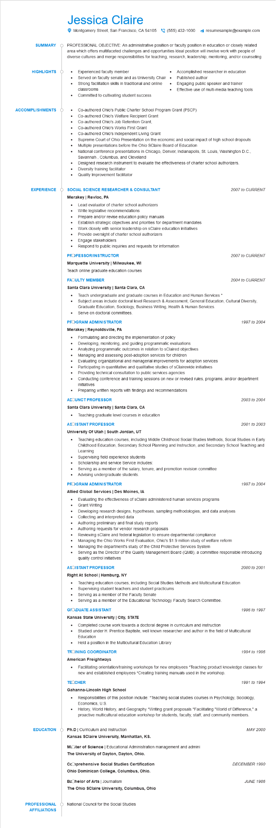

**SUMMARY**

Jessica Claire

Montgomery Street, San Francisco, CA 94105 (555) 432-1000

resumesample@example.com

PROFESSIONAL OBJECTIVE: An administrative position or faculty position in education or closely related area which offers multifaceted challenges and opportunities Ideal position will involve work with people of diverse cultures and merge responsibilities for teaching, research, leadership, mentoring, and/or counseling

Experienced faculty member

Served on faculty senate and as University Chair

•

Strong facilitation skills in traditional and online classrooms

•

Accomplished researcher in education Published author

Engaging public speaker and trainer Effective use of multi-media teaching tools

**HIGHLIGHTS**

•

**ACCOMPLISHMENTS**

**EXPERIENCE**

. Committed to cultivating student success

Co-authored Ohio's Public Charter School Program Grant (PSCP)

Co-authored Ohio's Welfare Recipient Grant

Co-authored Ohio's Job Retention Grant,

• Co-authored Ohio's Works First Grant

.

•

•

Co-authored Ohio's Independent Living Grant

Supreme Court of Ohio Presentation on the economic and social impact of high school dropouts Multiple presentations before the Ohio SClaire Board of Education

National conference presentations in Chicago, Denver, Indianapolis, St. Louis, Washington D.C., Savannah, Columbus, and Cleveland

Designed research instrument to evaluate the effectiveness of charter school authorizers. Diversity training facilitator

Quality Improvement facilitator

**SOCIAL SCIENCE RESEARCHER & CONSULTANT**

Merakey | Revloc, PA

Lead evaluator of charter school authorizers

•

Write legislative recommendations

Prepare and/or revise education policy manuals

Establish strategic objectives and priorities for department mandates

Work closely with senior leadership on sClaire education initiatives

Provide oversight of charter school authorizers

• Engage stakeholders

Respond to public inquiries and requests for information

**PROFESSOR/INSTRUCTOR**

**Marquette University | Milwaukee, WI**

Teach online graduate education courses

**FAOULTY MEMBER**

**Santa Clara University | Santa Clara, CA**

*2007 to CURRENT*

2007 to CURRENT

*2004 to CURRENT*

• Teach undergraduate and graduate courses in Education and Human Services *

• Subject areas include doctoral level Research & Assessment, General Education, Cultural Diversity, Graduate Education, Sociology, Business Writing, Health & Human Services.

Serve on doctoral committees.

**PROGRAM ADMINISTRATOR**

**Merakey | Reynoldsville, PA**

• Formulating and directing the implementation of policy

•

Developing, monitoring, and guiding programmatic evaluations

·

Analyzing programmatic outcomes in relation to sClaired objectives

Managing and assessing post-adoption services for children

•

Evaluating organizational and managerial improvements for adoption services Participating in quantitative and qualitative studies of sClairewide initiatives

Providing technical consultation to public services agencies

1997 to 2004

Conducting conference and training sessions on new or revised rules, programs, and/or department initiatives

• Preparing written reports with findings and recommendations

**ACOUNCT PROFESSOR**

**Santa Clara University | Santa Clara, CA**

2003 to 2004

• Teaching graduate level courses in education

**ASOISTANT PROFESSOR**

**University Of Utah | South Jordan, UT**

*2001 to 2003*

Teaching education courses, including Middle Childhood Social Studies Methods, Social Studies in Early Childhood Education, Secondary School Planning and Instruction, and Secondary School Teaching and Learning

Supervising field experience students

Scholarship and service Service includes:

Serving as a member of the salary, tenure, and promotion revision committee

Advising undergraduate students.

**PROGRAM ADMINISTRATOR**

**Allied Global Services | Des Moines, IA**

Evaluating the effectiveness of sClaire administered human services programs

•

Grant Writing

Developing research designs, hypotheses, sampling methodologies, and data analyses Collecting and interpreted data

•

Authoring preliminary and final study reports

•

Authoring requests for vendor research proposals

Reviewing sClaire and federal legislation to ensure departmental compliance

Managing the Ohio Works First Evaluation, Ohio's $1.9 million study of welfare reform

•

Managing the department's study of the Child Protective Services System

1997 to 2004

• Serving as the Director of the Quality Management Board (QMB), a committee responsible introducing quality control initiatives

**ASOISTANT PROFESSOR**

2000 to 2001

**Right At School | Hamburg, NY**

•

Teaching education courses, including Social Studies Methods and Multicultural Education

•

Supervising student teachers and student practicums

· Serving as a member of the Faculty Senate

Serving as a member of the Educational Technology Faculty Search Committee.

**GRADUATE ASSISTANT**

1996 to 1997

**Kansas State University | City, STATE**

Completed course work towards a doctoral degree in curriculum and instruction Studied under H. Prentice Baptiste, well known researcher and author in the field of Multicultural Education

•

Held a position in the Multicultural Education Library

**TROINING COORDINATOR**

1994 to 1996

**American Freightways**

• Facilitating orientation/training workshops for new employees *Teaching product knowledge classes for new and established employees *Creating training manuals used in the workshop.

**TECCHER**

**Gahanna-Lincoln High School**

*1991 to 1994*

Responsibilities of this position include: *Teaching social studies courses in Psychology, Sociology, Economics, U.S.

History, World History, and Geography *Writing grant proposals *Facilitating "World of Difference," a proactive multicultural education workshop for students, faculty, staff, and community members.

**EDUCATION**

Ph.D | Curriculum and Instruction

Kansas SClaire University, Manhattan, KS.

MOOter of Science | Educational Administration management and admini

**The University of Dayton, Dayton, Ohio.**

**CcOprehensive Social Studies Certification**

**Ohio Dominican College, Columbus, Ohio.**

Bachelor of Arts | Journalism

**The Ohio SClaire University, Columbus, Ohio**

PROFESSIONAL O National Council for the Social Studies AFFILIATIONS

*MAY 2000*

*DECEMBER 1990*

*JUNE 1986*