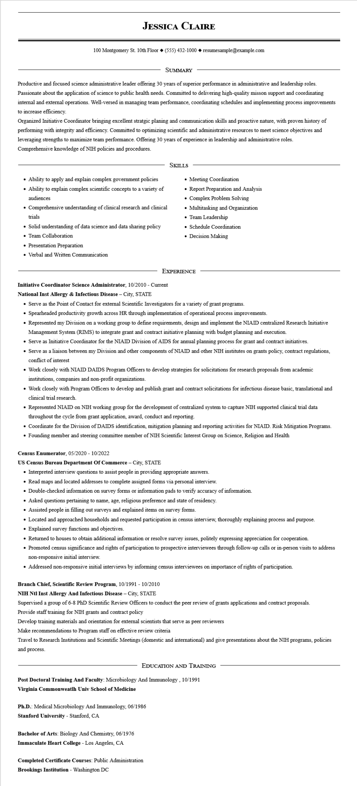

**JESSICA CLAIRE**

100 Montgomery St. 10th Floor (555) 432-1000◆ resumesample@example.com

SUMMARY

Productive and focused science administrative leader offering 30 years of superior performance in administrative and leadership roles. Passionate about the application of science to public health needs. Committed to delivering high-quality misson support and coordinating internal and external operations. Well-versed in managing team performance, coordinating schedules and implementing process improvements to increase efficiency.

Organized Initiative Coordinator bringing excellent stratgic planing and communication skills and proactive nature, with proven history of performing with integrity and efficiency. Committed to optimizing scientific and administrative resources to meet science objectives and leveraging strengths to maximize team performance. Offering 30 years of experience in leadership and administrative roles. Comprehensive knowledge of NIH policies and procedures.

• Ability to apply and explain complex government policies

• Ability to explain complex scientific concepts to a variety of audiences

• Comprehensive understanding of clinical research and clinical trials

• Solid understanding of data science and data sharing policy

• Team Collaboration

• Presentation Preparation

• Verbal and Written Communication

SKILLS

• Meeting Coordination

• Report Preparation and Analysis Complex Problem Solving

• Multitasking and Organization

• Team Leadership

• Schedule Coordination

• Decision Making

EXPERIENCE

**Initiative Coordinator Science Administrator, 10/2010 - Current**

**National Inst Allergy & Infectious Disease - City, STATE**

• Serve as the Point of Contact for external Scientific Investigators for a variety of grant programs.

•

Spearheaded productivity growth across HR through implementation of operational process improvements.

• Represented my Division on a working group to define requirements, design and implement the NIAID centralized Research Initiative

Management System (RIMS) to integrate grant and contract initiative planning with budget planning and execution.

• Serve as Initiative Coordinator for the NIAID Division of AIDS for annual planning process for grant and contract initiatives.

• Serve as a liaison between my Division and other components of NIAID and other NIH institutes on grants policy, contract regulations, conflict of interest

• Work closely with NIAID DAIDS Program Officers to develop strategies for solicitations for research proposals from academic institutions, companies and non-profit organizations.

• Work closely with Program Officers to develop and publish grant and contract solicitations for infectious disease basic, translational and clinical trial research.

• Represented NIAID on NIH working group for the development of centralized system to capture NIH supported clinical trial data throughout the cycle from grant application, award, conduct and reporting.

• Coordinate for the Division of DAIDS identification, mitigation planning and reporting activities for NIAID. Risk Mitigation Programs.

• Founding member and steering committee member of NIH Scientific Interest Group on Science, Religion and Health

Census Enumerator, 05/2020 - 10/2022

**US Census Bureau Department Of Commerce - City, STATE**

• Interpreted interview questions to assist people in providing appropriate answers.

• Read maps and located addresses to complete assigned forms via personal interview.

• Double-checked information on survey forms or information pads to verify accuracy of information.

• Asked questions pertaining to name, age, religious preference and state of residency.

• Assisted people in filling out surveys and explained items on survey forms.

• Located and approached households and requested participation in census interview, thoroughly explaining process and purpose.

• Explained survey functions and objectives.

• Returned to houses to obtain additional information or resolve survey issues, politely expressing appreciation for cooperation.

• Promoted census significance and rights of participation to prospective interviewees through follow-up calls or in-person visits to address non-responsive initial interview.

• Addressed non-responsive initial interviews by informing census interviewees on importance of rights of participation.

**Branch Chief, Scientific Review Program, 10/1991 - 10/2010**

**NIH Ntl Inst Allergy And Infectious Disease - City, STATE**

Supervised a group of 6-8 PhD Scientific Review Officers to conduct the peer review of grants applications and contract proposals.

Provide staff training for NIH grants and contract policy

Develop training materials and orientation for external scientists that serve as peer reviewers

Make recommendations to Program staff on effective review criteria

Travel to Research Institutions and Scientific Meetings (domestic and international) and give presentations about the NIH programs, policies and process.

**EDUCATION AND TRAINING**

**Post Doctoral Training And Faculty: Microbiology And Immunology, 10/1991**

**Virginia Commonweatlh Univ School of Medicine**

Ph.D.: Medical Microbiology And Immunology, 06/1986

**Stanford University - Stanford, CA**

**Bachelor of Arts: Biology And Chemistry, 06/1976**

Immaculate Heart College - Los Angeles, CA

**Completed Certificate Courses: Public Administration Brookings Institution - Washington DC**