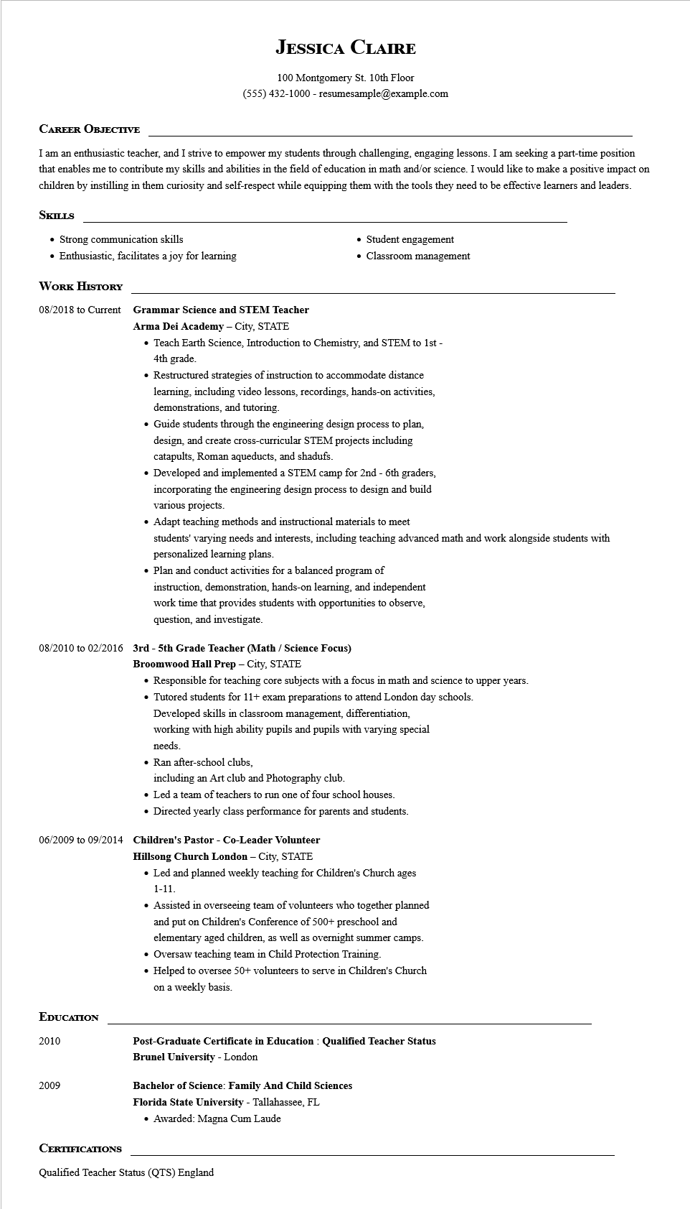

**JESSICA CLAIRE**

100 Montgomery St. 10th Floor (555) 432-1000 - resumesample@example.com

**CAREER OBJECTIVE**

I am an enthusiastic teacher, and I strive to empower my students through challenging, engaging lessons. I am seeking a part-time position that enables me to contribute my skills and abilities in the field of education in math and/or science. I would like to make a positive impact on children by instilling in them curiosity and self-respect while equipping them with the tools they need to be effective learners and leaders.

**SKILLS**

• Strong communication skills

• Enthusiastic, facilitates a joy for learning

**WORK HISTORY**

• Student engagement

• Classroom management

08/2018 to Current

**Grammar Science and STEM Teacher**

**Arma Dei Academy - City, STATE**

• Teach Earth Science, Introduction to Chemistry, and STEM to 1st - 4th grade.

• Restructured strategies of instruction to accommodate distance learning, including video lessons, recordings, hands-on activities, demonstrations, and tutoring.

• Guide students through the engineering design process to plan, design, and create cross-curricular STEM projects including catapults, Roman aqueducts, and shadufs.

• Developed and implemented a STEM camp for 2nd - 6th graders, incorporating the engineering design process to design and build various projects.

• Adapt teaching methods and instructional materials to meet

students' varying needs and interests, including teaching advanced math and work alongside students with personalized learning plans.

• Plan and conduct activities for a balanced program of

instruction, demonstration, hands-on learning, and independent

work time that provides students with opportunities to observe, question, and investigate.

**08/2010 to 02/2016 3rd-5th Grade Teacher (Math / Science Focus)**

**Broomwood Hall Prep - City, STATE**

• Responsible for teaching core subjects with a focus in math and science to upper years.

• Tutored students for 11+ exam preparations to attend London day schools.

Developed skills in classroom management, differentiation,

working with high ability pupils and pupils with varying special

needs.

• Ran after-school clubs,

including an Art club and Photography club.

• Led a team of teachers to run one of four school houses.

• Directed yearly class performance for parents and students.

**06/2009 to 09/2014 Children's Pastor - Co-Leader Volunteer Hillsong Church London - City, STATE**

• Led and planned weekly teaching for Children's Church ages 1-11.

• Assisted in overseeing team of volunteers who together planned and put on Children's Conference of 500+ preschool and elementary aged children, as well as overnight summer camps.

• Oversaw teaching team in Child Protection Training.

• Helped to oversee 50+ volunteers to serve in Children's Church on a weekly basis.

**EDUCATION**

2010

2009

**CERTIFICATIONS**

**Post-Graduate Certificate in Education: Qualified Teacher Status Brunel University - London**

**Bachelor of Science: Family And Child Sciences**

**Florida State University - Tallahassee, FL**

• Awarded: Magna Cum Laude

Qualified Teacher Status (QTS) England