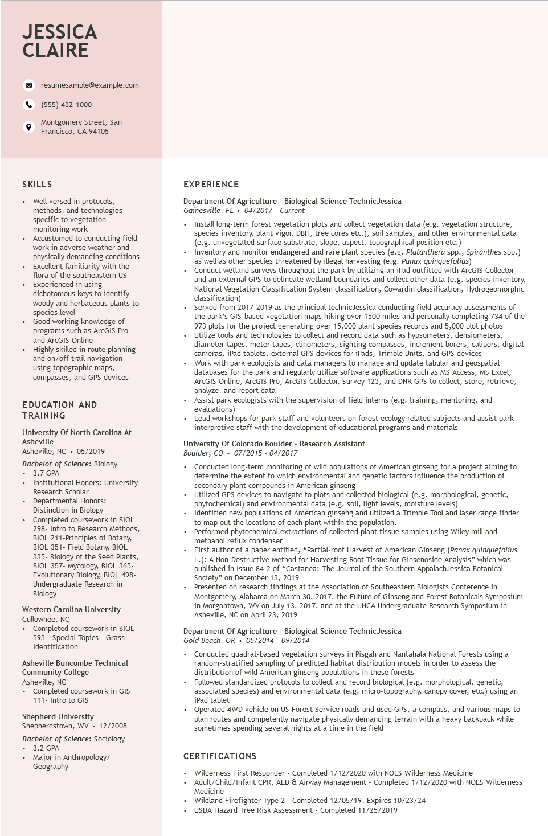

**JESSICA CLAIRE**

resumesample@example.com

(555) 432-1000

Montgomery Street, San Francisco, CA 94105

SKILLS

• Well versed in protocols,

methods, and technologies specific to vegetation monitoring work

• Accustomed to conducting field work in adverse weather and physically demanding conditions Excellent familiarity with the flora of the southeastern US Experienced in using dichotomous keys to identify woody and herbaceous plants to species level

• Good working knowledge of programs such as ArcGIS Pro and ArcGIS Online

Highly skilled in route planning and on/off trail navigation using topographic maps, compasses, and GPS devices

EDUCATION AND TRAINING

University of North Carolina At Asheville

Asheville, NC

05/2019

Bachelor of Science: Biology

• 3.7 GPA

·

•

Institutional Honors: University Research Scholar

Departmental Honors:

Distinction in Biology

Completed coursework in BIOL

298- Intro to Research Methods, BIOL 211-Principles of Botany, BIOL 351- Field Botany, BIOL 335- Biology of the Seed Plants, BIOL 357- Mycology, BIOL 365- Evolutionary Biology, BIOL 498- Undergraduate Research in Biology

Western Carolina University Cullowhee, NC

• Completed coursework in BIOL

593 - Special Topics - Grass Identification

Asheville Buncombe Technical Community College Asheville, NC

• Completed coursework in GIS 111- Intro to GIS

Shepherd University Shepherdstown, WV. 12/2008

Bachelor of Science: Sociology

• 3.2 GPA

•

Major in Anthropology/ Geography

EXPERIENCE

Department of Agriculture - Biological Science Technic Jessica Gainesville, FL. 04/2017 - Current

• Install long-term forest vegetation plots and collect vegetation data (e.g. vegetation structure, species inventory, plant vigor, DBH, tree cores etc.), soil samples, and other environmental data (e.g. unvegetated surface substrate, slope, aspect, topographical position etc.)

• Inventory and monitor endangered and rare plant species (e.g. Platanthera spp., Spiranthes spp.) as well as other species threatened by illegal harvesting (e.g. Panax quinquefolius)

• Conduct wetland surveys throughout the park by utilizing an iPad outfitted with ArcGIS Collector and an external GPS to delineate wetland boundaries and collect other data (e.g. species inventory, National Vegetation Classification System classification, Cowardin classification, Hydrogeomorphic classification)

Served from 2017-2019 as the principal technicJessica conducting field accuracy assessments of the park's GIS-based vegetation maps hiking over 1500 miles and personally completing 734 of the 973 plots for the project generating over 15,000 plant species records and 5,000 plot photos • Utilize tools and technologies to collect and record data such as hypsometers, densiometers, diameter tapes, meter tapes, clinometers, sighting compasses, increment borers, calipers, digital cameras, iPad tablets, external GPS devices for iPads, Trimble Units, and GPS devices

• Work with park ecologists and data managers to manage and update tabular and geospatial databases for the park and regularly utilize software applications such as MS Access, MS Excel, ArcGIS Online, ArcGIS Pro, ArcGIS Collector, Survey 123, and DNR GPS to collect, store, retrieve, analyze, and report data

Assist park ecologists with the supervision of field interns (e.g. training, mentoring, and evaluations)

• Lead workshops for park staff and volunteers on forest ecology related subjects and assist park interpretive staff with the development of educational programs and materials

University Of Colorado Boulder - Research Assistant

*Boulder, CO⚫ 07/2015 - 04/2017*

• Conducted long-term monitoring of wild populations of American ginseng for a project aiming to determine the extent to which environmental and genetic factors influence the production of secondary plant compounds in American ginseng

Utilized GPS devices to navigate to plots and collected biological (e.g. morphological, genetic, phytochemical) and environmental data (e.g. soil, light levels, moisture levels)

• Identified new populations of American ginseng and utilized a Trimble Tool and laser range finder to map out the locations of each plant within the population.

• Performed phytochemical extractions of collected plant tissue samples using Wiley mill and methanol reflux condenser

• First author of a paper entitled, "Partial-root Harvest of American Ginseng (Panax quinquefolius L.): A Non-Destructive Method for Harvesting Root Tissue for Ginsenoside Analysis" which was published in Issue 84-2 of "Castanea; The Journal of the Southern AppalachJessica Botanical Society" on December 13, 2019

Presented on research findings at the Association of Southeastern Biologists Conference in Montgomery, Alabama on March 30, 2017, the Future of Ginseng and Forest Botanicals Symposium in Morgantown, WV on July 13, 2017, and at the UNCA Undergraduate Research Symposium in Asheville, NC on April 23, 2019

Department of Agriculture - Biological Science Technic Jessica

Gold Beach, OR⚫ 05/2014 - 09/2014

.

• Conducted quadrat-based vegetation surveys in Pisgah and Nantahala National Forests using a random-stratified sampling of predicted habitat distribution models in order to assess the distribution of wild American ginseng populations in these forests

• Followed standardized protocols to collect and record biological (e.g. morphological, genetic, associated species) and environmental data (e.g. micro-topography, canopy cover, etc.) using an iPad tablet

Operated 4WD vehicle on US Forest Service roads and used GPS, a compass, and various maps to plan routes and competently navigate physically demanding terrain with a heavy backpack while sometimes spending several nights at a time in the field

**CERTIFICATIONS**

• Wilderness First Responder - Completed 1/12/2020 with NOLS Wilderness Medicine

• Adult/Child/Infant CPR, AED & Airway Management - Completed 1/12/2020 with NOLS Wilderness Medicine

Wildland Firefighter Type 2 - Completed 12/05/19, Expires 10/23/24

.

USDA Hazard Tree Risk Assessment - Completed 11/25/2019