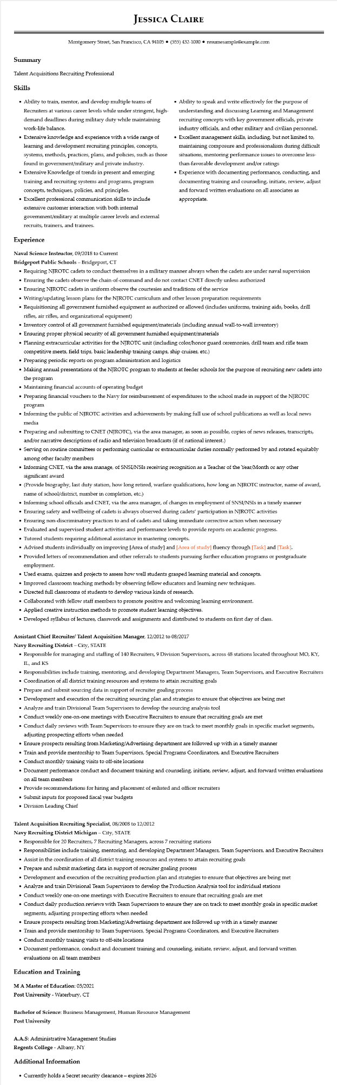

**JESSICA CLAIRE**

Montgomery Street, San Francisco, CA 94105 ⚫ (555) 432-1000⚫ resumesample@example.com

Summary

Talent Acquisitions Recruiting Professional

Skills

• Ability to train, mentor, and develop multiple teams of Recruiters at various career levels while under stringent, high- demand deadlines during military duty while maintaining

work-life balance.

• Extensive knowledge and experience with a wide range of learning and development recruiting principles, concepts, systems, methods, practices, plans, and policies, such as those found in government/military and private industry. • Extensive Knowledge of trends in present and emerging training and recruiting systems and programs, program concepts, techniques, policies, and principles.

• Excellent professional communication skills to include extensive customer interaction with both internal government/military at multiple career levels and external recruits, trainers, and trainees.

**Experience**

Naval Science Instructor, 09/2018 to Current

Bridgeport Public Schools - Bridgeport, CT

• Ability to speak and write effectively for the purpose of understanding and discussing Learning and Management recruiting concepts with key government officials, private industry officials, and other military and civilian personnel. • Excellent management skills, including, but not limited to, maintaining composure and professionalism during difficult situations, mentoring performance issues to overcome less- than-favorable development and/or ratings

• Experience with documenting performance, conducting, and documenting training and counseling, initiate, review, adjust and forward written evaluations on all associates as appropriate.

• Requiring NJROTC cadets to conduct themselves in a military manner always when the cadets are under naval supervision

• Ensuring the cadets observe the chain-of-command and do not contact CNET directly unless authorized

• Ensuring NJROTC cadets in uniform observe the courtesies and traditions of the service

• Writing/updating lesson plans for the NJROTC curriculum and other lesson preparation requirements

• Requisitioning all government furnished equipment as authorized or allowed (includes uniforms, training aids, books, drill rifles, air rifles, and organizational equipment)

• Inventory control of all government furnished equipment/materials (including annual wall-to-wall inventory)

• Ensuring proper physical security of all government furnished equipment/materials

• Planning extracurricular activities for the NJROTC unit (including color/honor guard ceremonies, drill team and rifle team competitive meets, field trips, basic leadership training camps, ship cruises, etc.)

• Preparing periodic reports on program administration and logistics

• Making annual presentations of the NJROTC program to students at feeder schools for the purpose of recruiting new cadets into the program

• Maintaining financial accounts of operating budget

• Preparing financial vouchers to the Navy for reimbursement of expenditures to the school made in support of the NJROTC program

• Informing the public of NJROTC activities and achievements by making full use of school publications as well as local news media

• Preparing and submitting to CNET (NJROTC), via the area manager, as soon as possible, copies of news releases, transcripts, and/or narrative descriptions of radio and television broadcasts (if of national interest.)

• Serving on routine committees or performing curricular or extracurricular duties normally performed by and rotated equitably among other faculty members

• Informing CNET, via the area manage, of SNSI/NSIs receiving recognition as a Teacher of the Year/Month or any other significant award

• (Provide biography, last duty station, how long retired, warfare qualifications, how long an NJROTC instructor, name of award, name of school/district, number in completion, etc.)

• Informing school officials and CNET, via the area manager, of changes in employment of SNSI/NSIS in a timely manner

• Ensuring safety and wellbeing of cadets is always observed during cadets' participation in NJROTC activities

• Ensuring non-discriminatory practices to and of cadets and taking immediate corrective action when necessary

• Evaluated and supervised student activities and performance levels to provide reports on academic progress.

• Tutored students requiring additional assistance in mastering concepts.

• Advised students individually on improving [Area of study] and [Area of study] fluency through [Task] and [Task].

• Provided letters of recommendation and other referrals to students pursuing further education programs or postgraduate employment.

• Used exams, quizzes and projects to assess how well students grasped learning material and concepts.

• Improved classroom teaching methods by observing fellow educators and learning new techniques.

• Directed full classrooms of students to develop various kinds of research.

• Collaborated with fellow staff members to promote positive and welcoming learning environment.

• Applied creative instruction methods to promote student learning objectives.

• Developed syllabus of lectures, classwork and assignments and distributed to students on first day of class.

**Assistant Chief Recruiter/ Talent Acquisition Manager, 12/2012 to 08/2017**

Navy Recruiting District - City, STATE

• Responsible for managing and staffing of 140 Recruiters, 9 Division Supervisors, across 48 stations located throughout MO, KY, IL, and KS

• Responsibilities include training, mentoring, and developing Department Managers, Team Supervisors, and Executive Recruiters

• Coordination of all district training resources and systems to attain recruiting goals

• Prepare and submit sourcing data in support of recruiter goaling process

• Development and execution of the recruiting sourcing plan and strategies to ensure that objectives are being met

·

Analyze and train Divisional Team Supervisors to develop the sourcing analysis tool

• Conduct weekly one-on-one meetings with Executive Recruiters to ensure that recruiting goals are met

• Conduct daily reviews with Team Supervisors to ensure they are on track to meet monthly goals in specific market segments, adjusting prospecting efforts when needed

• Ensure prospects resulting from Marketing/Advertising department are followed up with in a timely manner

• Train and provide mentorship to Team Supervisors, Special Programs Coordinators, and Executive Recruiters

• Conduct monthly training visits to off-site locations

• Document performance conduct and document training and counseling, initiate, review, adjust, and forward written evaluations on all team members

• Provide recommendations for hiring and placement of enlisted and officer recruiters

• Submit inputs for proposed fiscal year budgets

• Division Leading Chief

**Talent Acquisition Recruiting Specialist, 08/2008 to 12/2012**

Navy Recruiting District Michigan - City, STATE

• Responsible for 20 Recruiters, 7 Recruiting Managers, across 7 recruiting stations

• Responsibilities include training, mentoring, and developing Department Managers, Team Supervisors, and Executive Recruiters

• Assist in the coordination of all district training resources and systems to attain recruiting goals

• Prepare and submit marketing data in support of recruiter goaling process

• Development and execution of the recruiting production plan and strategies to ensure that objectives are being met

• Analyze and train Divisional Team Supervisors to develop the Production Analysis tool for individual stations

• Conduct weekly one-on-one meetings with Executive Recruiters to ensure that recruiting goals are met

• Conduct daily production reviews with Team Supervisors to ensure they are on track to meet monthly goals in specific market segments, adjusting prospecting efforts when needed

• Ensure prospects resulting from Marketing/Advertising department are followed up with in a timely manner

• Train and provide mentorship to Team Supervisors, Special Programs Coordinators, and Executive Recruiters

• Conduct monthly training visits to off-site locations

• Document performance, conduct and document training and counseling, initiate, review, adjust, and forward written evaluations on all team members

**Education and Training**

**M A Master of Education: 05/2021**

Post University - Waterbury, CT

Bachelor of Science: Business Management, Human Resource Management

Post University

A.A.S: Administrative Management Studies

**Regents College - Albany, NY**

Additional Information

• Currently holds a Secret security clearance - expires 2026