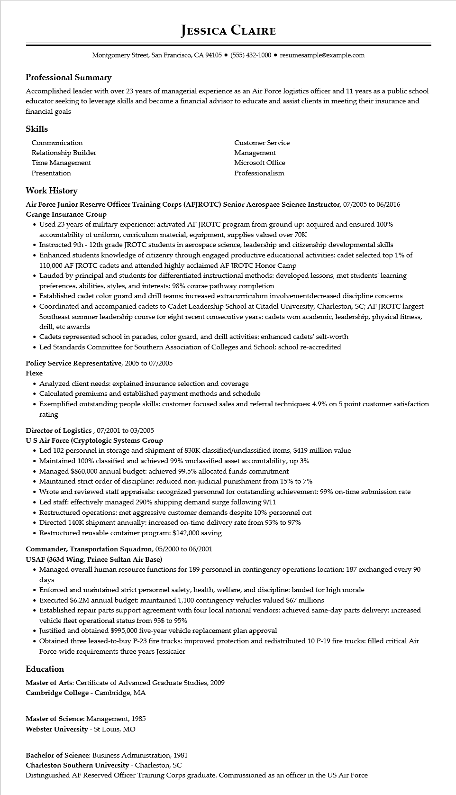

**JESSICA CLAIRE**

Montgomery Street, San Francisco, CA 94105 (555) 432-1000 resumesample@example.com

**Professional Summary**

Accomplished leader with over 23 years of managerial experience as an Air Force logistics officer and 11 years as a public school educator seeking to leverage skills and become a financial advisor to educate and assist clients in meeting their insurance and financial goals

Skills

Communication

Relationship Builder

Time Management

Presentation

Customer Service Management Microsoft Office Professionalism

**Work History**

**Air Force Junior Reserve Officer Training Corps (AFJROTC) Senior Aerospace Science Instructor, 07/2005 to 06/2016 Grange Insurance Group**

• Used 23 years of military experience: activated AF JROTC program from ground up: acquired and ensured 100% accountability of uniform, curriculum material, equipment, supplies valued over 70K

• Instructed 9th - 12th grade JROTC students in aerospace science, leadership and citizenship developmental skills

• Enhanced students knowledge of citizenry through engaged productive educational activities: cadet selected top 1% of 110,000 AF JROTC cadets and attended highly acclaimed AF JROTC Honor Camp

• Lauded by principal and students for differentiated instructional methods: developed lessons, met students' learning preferences, abilities, styles, and interests: 98% course pathway completion

• Established cadet color guard and drill teams: increased extracurriculum involvementdecreased discipline concerns

• Coordinated and accompanied cadets to Cadet Leadership School at Citadel University, Charleston, SC; AF JROTC largest Southeast summer leadership course for eight recent consecutive years: cadets won academic, leadership, physical fitness, drill, etc awards

• Cadets represented school in parades, color guard, and drill activities: enhanced cadets' self-worth

• Led Standards Committee for Southern Association of Colleges and School: school re-accredited

Policy Service Representative, 2005 to 07/2005

Flexe

• Analyzed client needs: explained insurance selection and coverage

• Calculated premiums and established payment methods and schedule

• Exemplified outstanding people skills: customer focused sales and referral techniques: 4.9% on 5 point customer satisfaction rating

**Director of Logistics, 07/2001 to 03/2005**

**US Air Force (Cryptologic Systems Group**

• Led 102 personnel in storage and shipment of 830K classified/unclassified items, $419 million value

• Maintained 100% classified and achieved 99% unclassified asset accountability, up 3%

• Managed $860,000 annual budget: achieved 99.5% allocated funds commitment

• Maintained strict order of discipline: reduced non-judicial punishment from 15% to 7%

• Wrote and reviewed staff appraisals: recognized personnel for outstanding achievement: 99% on-time submission rate

• Led staff: effectively managed 290% shipping demand surge following 9/11

• Restructured operations: met aggressive customer demands despite 10% personnel cut

• Directed 140K shipment annually: increased on-time delivery rate from 93% to 97%

• Restructured reusable container program: $142,000 saving

**Commander, Transportation Squadron, 05/2000 to 06/2001**

**USAF (363d Wing, Prince Sultan Air Base)**

• Managed overall human resource functions for 189 personnel in contingency operations location; 187 exchanged every 90 days

• Enforced and maintained strict personnel safety, health, welfare, and discipline: lauded for high morale

• Executed $6.2M annual budget: maintained 1,100 contingency vehicles valued $67 millions

• Established repair parts support agreement with four local national vendors: achieved same-day parts delivery: increased vehicle fleet operational status from 93$ to 95%

• Justified and obtained $995,000 five-year vehicle replacement plan approval

• Obtained three leased-to-buy P-23 fire trucks: improved protection and redistributed 10 P-19 fire trucks: filled critical Air Force-wide requirements three years Jessicaier

**Education**

Master of Arts: Certificate of Advanced Graduate Studies, 2009

**Cambridge College - Cambridge, MA**

Master of Science: Management, 1985

**Webster University - St Louis, MO**

Bachelor of Science: Business Administration, 1981

Charleston Southern University - Charleston, SC

Distinguished AF Reserved Officer Training Corps graduate. Commissioned as an officer in the US Air Force