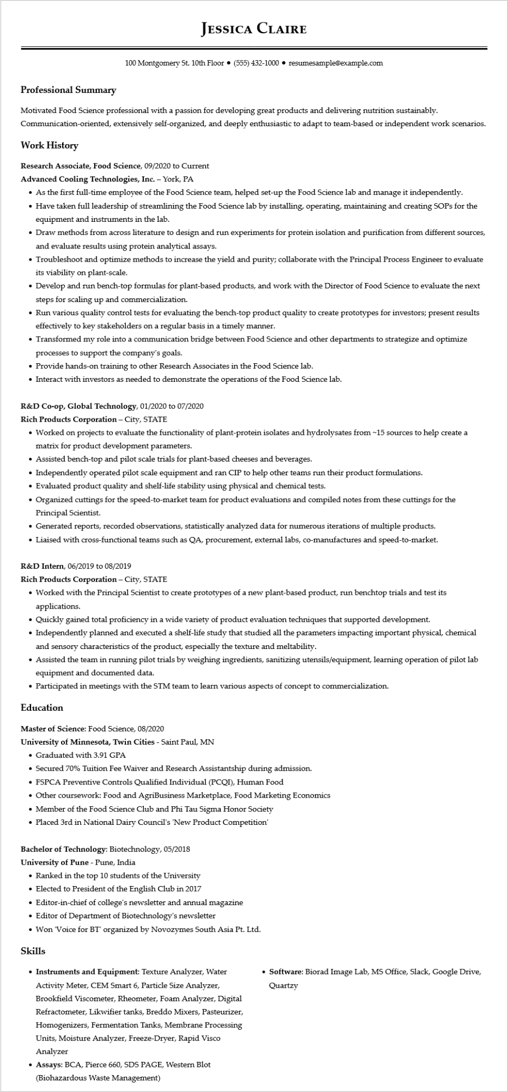

**Professional Summary**

**JESSICA CLAIRE**

100 Montgomery St. 10th Floor⚫ (555) 432-1000⚫ resumesample@example.com

Motivated Food Science professional with a passion for developing great products and delivering nutrition sustainably. Communication-oriented, extensively self-organized, and deeply enthusiastic to adapt to team-based or independent work scenarios.

Work History

**Research Associate, Food Science, 09/2020 to Current**

**Advanced Cooling Technologies, Inc. - York, PA**

• As the first full-time employee of the Food Science team, helped set-up the Food Science lab and manage it independently.

• Have taken full leadership of streamlining the Food Science lab by installing, operating, maintaining and creating SOPs for the equipment and instruments in the lab.

• Draw methods from across literature to design and run experiments for protein isolation and purification from different sources, and evaluate results using protein analytical assays.

• Troubleshoot and optimize methods to increase the yield and purity; collaborate with the Principal Process Engineer to evaluate its viability on plant-scale.

• Develop and run bench-top formulas for plant-based products, and work with the Director of Food Science to evaluate the next steps for scaling up and commercialization.

• Run various quality control tests for evaluating the bench-top product quality to create prototypes for investors; present results effectively to key stakeholders on a regular basis in a timely manner.

• Transformed my role into a communication bridge between Food Science and other departments to strategize and optimize processes to support the company's goals.

• Provide hands-on training to other Research Associates in the Food Science lab.

• Interact with investors as needed to demonstrate the operations of the Food Science lab.

**R&D Co-op, Global Technology, 01/2020 to 07/2020**

**Rich Products Corporation - City, STATE**

• Worked on projects to evaluate the functionality of plant-protein isolates and hydrolysates from ~15 sources to help create a matrix for product development parameters.

• Assisted bench-top and pilot scale trials for plant-based cheeses and beverages.

• Independently operated pilot scale equipment and ran CIP to help other teams run their product formulations.

• Evaluated product quality and shelf-life stability using physical and chemical tests.

• Organized cuttings for the speed-to-market team for product evaluations and compiled notes from these cuttings for the Principal Scientist.

• Generated reports, recorded observations, statistically analyzed data for numerous iterations of multiple products.

• Liaised with cross-functional teams such as QA, procurement, external labs, co-manufactures and speed-to-market.

R&D Intern, 06/2019 to 08/2019

**Rich Products Corporation - City, STATE**

• Worked with the Principal Scientist to create prototypes of a new plant-based product, run benchtop trials and test its applications.

• Quickly gained total proficiency in a wide variety of product evaluation techniques that supported development.

• Independently planned and executed a shelf-life study that studied all the parameters impacting important physical, chemical and sensory characteristics of the product, especially the texture and meltability.

• Assisted the team in running pilot trials by weighing ingredients, sanitizing utensils/equipment, learning operation of pilot lab equipment and documented data.

• Participated in meetings with the STM team to learn various aspects of concept to commercialization.

**Education**

Master of Science: Food Science, 08/2020

University of Minnesota, Twin Cities - Saint Paul, MN

• Graduated with 3.91 GPA

• Secured 70% Tuition Fee Waiver and Research Assistantship during admission.

• FSPCA Preventive Controls Qualified Individual (PCQI), Human Food

• Other coursework: Food and AgriBusiness Marketplace, Food Marketing Economics

• Member of the Food Science Club and Phi Tau Sigma Honor Society

• Placed 3rd in National Dairy Council's 'New Product Competition'

Bachelor of Technology: Biotechnology, 05/2018

**University of Pune - Pune, India**

• Ranked in the top 10 students of the University

• Elected to President of the English Club in 2017

• Editor-in-chief of college's newsletter and annual magazine

• Editor of Department of Biotechnology's newsletter

• Won 'Voice for BT' organized by Novozymes South Asia Pt. Ltd.

**Skills**

• Instruments and Equipment: Texture Analyzer, Water Activity Meter, CEM Smart 6, Particle Size Analyzer, Brookfield Viscometer, Rheometer, Foam Analyzer, Digital Refractometer, Likwifier tanks, Breddo Mixers, Pasteurizer, Homogenizers, Fermentation Tanks, Membrane Processing Units, Moisture Analyzer, Freeze-Dryer, Rapid Visco Analyzer

• Assays: BCA, Pierce 660, SDS PAGE, Western Blot

(Biohazardous Waste Management)

• Software: Biorad Image Lab, MS Office, Slack, Google Drive, Quartzy