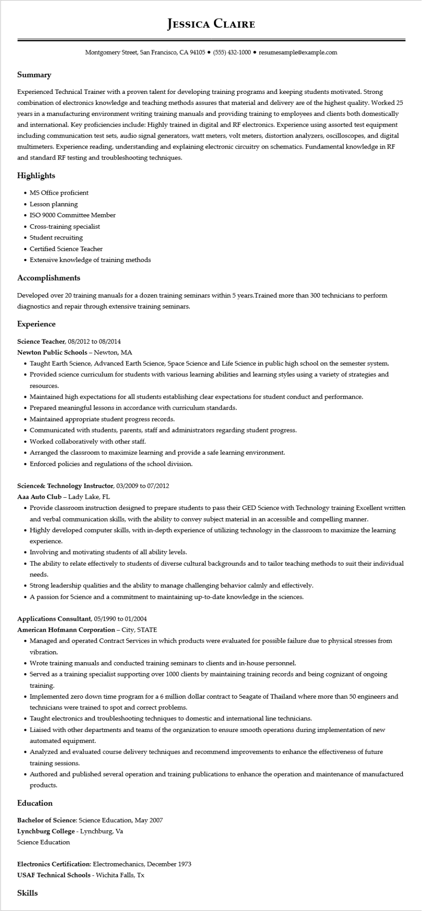

**JESSICA CLAIRE**

Montgomery Street, San Francisco, CA 94105⚫ (555) 432-1000⚫ resumesample@example.com

**Summary**

Experienced Technical Trainer with a proven talent for developing training programs and keeping students motivated. Strong combination of electronics knowledge and teaching methods assures that material and delivery are of the highest quality. Worked 25 years in a manufacturing environment writing training manuals and providing training to employees and clients both domestically and international. Key proficiencies include: Highly trained in digital and RF electronics. Experience using assorted test equipment including communication test sets, audio signal generators, watt meters, volt meters, distortion analyzers, oscilloscopes, and digital multimeters. Experience reading, understanding and explaining electronic circuitry on schematics. Fundamental knowledge in RF and standard RF testing and troubleshooting techniques.

**Highlights**

• MS Office proficient

• Lesson planning

• ISO 9000 Committee Member

• Cross-training specialist

• Student recruiting

• Certified Science Teacher

• Extensive knowledge of training methods

**Accomplishments**

Developed over 20 training manuals for a dozen training seminars within 5 years. Trained more than 300 technicians to perform diagnostics and repair through extensive training seminars.

**Experience**

Science Teacher, 08/2012 to 08/2014

**Newton Public Schools - Newton, MA**

• Taught Earth Science, Advanced Earth Science, Space Science and Life Science in public high school on the semester system.

• Provided science curriculum for students with various learning abilities and learning styles using a variety of strategies and

resources.

• Maintained high expectations for all students establishing clear expectations for student conduct and performance.

• Prepared meaningful lessons in accordance with curriculum standards.

• Maintained appropriate student progress records.

• Communicated with students, parents, staff and administrators regarding student progress.

• Worked collaboratively with other staff.

• Arranged the classroom to maximize learning and provide a safe learning environment.

• Enforced policies and regulations of the school division.

**Science & Technology Instructor, 03/2009 to 07/2012**

Aaa Auto Club - Lady Lake, FL

• Provide classroom instruction designed to prepare students to pass their GED Science with Technology training Excellent written and verbal communication skills, with the ability to convey subject material in an accessible and compelling manner.

• Highly developed computer skills, with in-depth experience of utilizing technology in the classroom to maximize the learning experience.

• Involving and motivating students of all ability levels.

• The ability to relate effectively to students of diverse cultural backgrounds and to tailor teaching methods to suit their individual needs.

• Strong leadership qualities and the ability to manage challenging behavior calmly and effectively.

• A passion for Science and a commitment to maintaining up-to-date knowledge in the sciences.

Applications Consultant, 05/1990 to 01/2004

American Hofmann Corporation - City, STATE

• Managed and operated Contract Services in which products were evaluated for possible failure due to physical stresses from vibration.

• Wrote training manuals and conducted training seminars to clients and in-house personnel.

• Served as a training specialist supporting over 1000 clients by maintaining training records and being cognizant of ongoing training.

• Implemented zero down time program for a 6 million dollar contract to Seagate of Thailand where more than 50 engineers and technicians were trained to spot and correct problems.

• Taught electronics and troubleshooting techniques to domestic and international line technicians.

• Liaised with other departments and teams of the organization to ensure smooth operations during implementation of new automated equipment.

• Analyzed and evaluated course delivery techniques and recommend improvements to enhance the effectiveness of future training sessions.

• Authored and published several operation and training publications to enhance the operation and maintenance of manufactured products.

**Education**

Bachelor of Science: Science Education, May 2007

**Lynchburg College - Lynchburg, Va**

Science Education

Electronics Certification: Electromechanics, December 1973

USAF Technical Schools - Wichita Falls, Tx

Skills