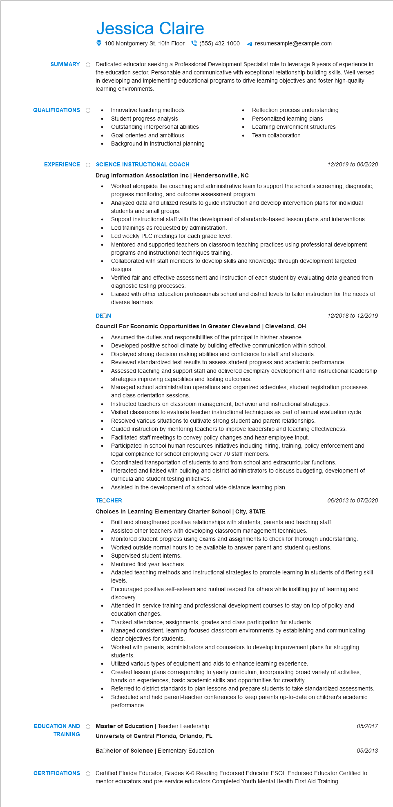

**SUMMARY**

Jessica Claire

100 Montgomery St. 10th Floor(555) 432-1000

resumesample@example.com

Dedicated educator seeking a Professional Development Specialist role to leverage 9 years of experience in the education sector. Personable and communicative with exceptional relationship building skills. Well-versed in developing and implementing educational programs to drive learning objectives and foster high-quality learning environments.

**QUALIFICATIONS**

•

Innovative teaching methods Student progress analysis

Outstanding interpersonal abilities

• Goal-oriented and ambitious

•

Background in instructional planning

Reflection process understanding Personalized learning plans

Learning environment structures Team collaboration

**EXPERIENCE**

**SCIENCE INSTRUCTIONAL COACH**

**Drug Information Association Inc | Hendersonville, NC**

•

•

DEON

*12/2019 to 06/2020*

Worked alongside the coaching and administrative team to support the school's screening, diagnostic, progress monitoring, and outcome assessment program.

Analyzed data and utilized results to guide instruction and develop intervention plans for individual students and small groups.

Support instructional staff with the development of standards-based lesson plans and interventions. Led trainings as requested by administration.

Led weekly PLC meetings for each grade level.

Mentored and supported teachers on classroom teaching practices using professional development programs and instructional techniques training.

Collaborated with staff members to develop skills and knowledge through development targeted designs.

Verified fair and effective assessment and instruction of each student by evaluating data gleaned from diagnostic testing processes.

Liaised with other education professionals school and district levels to tailor instruction for the needs of diverse learners.

*12/2018 to 12/2019*

**Council For Economic Opportunities In Greater Cleveland | Cleveland, OH**

• Assumed the duties and responsibilities of the principal in his/her absence.

Developed positive school climate by building effective communication within school.

Reviewed standardized test results to assess student progress and academic performance.

•

• Displayed strong decision making abilities and confidence to staff and students.

•

•

.....

Assessed teaching and support staff and delivered exemplary development and instructional leadership strategies improving capabilities and testing outcomes.

Managed school administration operations and organized schedules, student registration processes and class orientation sessions.

Instructed teachers on classroom management, behavior and instructional strategies.

Visited classrooms to evaluate teacher instructional techniques as part of annual evaluation cycle.

Resolved various situations to cultivate strong student and parent relationships.

Guided instruction by mentoring teachers to improve leadership and teaching effectiveness. Facilitated staff meetings to convey policy changes and hear employee input.

Participated in school human resources initiatives including hiring, training, policy enforcement and legal compliance for school employing over 70 staff members.

Coordinated transportation of students to and from school and extracurricular functions. Interacted and liaised with building and district administrators to discuss budgeting, development of curricula and student testing initiatives.

Assisted in the development of a school-wide distance learning plan.

**TEOCHER**

**Choices In Learning Elementary Charter School | City, STATE**

*06/2013 to 07/2020*

• Built and strengthened positive relationships with students, parents and teaching staff. Assisted other teachers with developing classroom management techniques.

•

Monitored student progress using exams and assignments to check for thorough understanding.

•

Worked outside normal hours to be available to answer parent and student questions. Supervised student interns.

•

Mentored first year teachers.

Adapted teaching methods and instructional strategies to promote learning in students of differing skill levels.

Encouraged positive self-esteem and mutual respect for others while instilling joy of learning and discovery.

Attended in-service training and professional development courses to stay on top of policy and education changes.

Tracked attendance, assignments, grades and class participation for students.

Managed consistent, learning-focused classroom environments by establishing and communicating clear objectives for students.

Worked with parents, administrators and counselors to develop improvement plans for struggling students

Utilized various types of equipment and aids to enhance learning experience.

Created lesson plans corresponding to yearly curriculum, incorporating broad variety of activities, hands-on experiences, basic academic skills and opportunities for creativity.

Referred to district standards to plan lessons and prepare students to take standardized assessments. Scheduled and held parent-teacher conferences to keep parents up-to-date on children's academic performance.

**EDUCATION AND TRAINING**

**Master of Education | Teacher Leadership**

05/2017

**University of Central Florida, Orlando, FL**

Bachelor of Science | Elementary Education

05/2013

**CERTIFICATIONS**

Certified Florida Educator, Grades K-6 Reading Endorsed Educator ESOL Endorsed Educator Certified to mentor educators and pre-service educators Completed Youth Mental Health First Aid Training