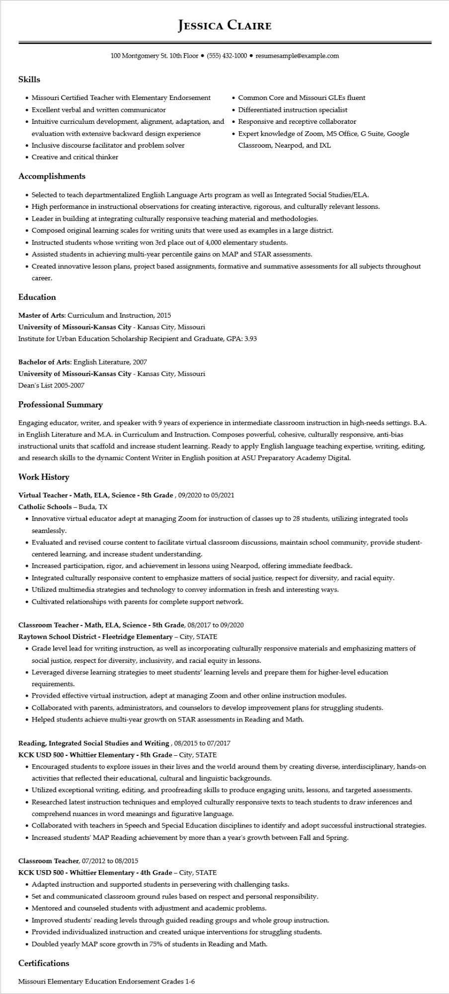

**JESSICA CLAIRE**

100 Montgomery St. 10th Floor⚫ (555) 432-1000⚫ resumesample@example.com

Skills

• Missouri Certified Teacher with Elementary Endorsement

• Excellent verbal and written communicator

• Intuitive curriculum development, alignment, adaptation, and evaluation with extensive backward design experience

• Inclusive discourse facilitator and problem solver

• Creative and critical thinker

**Accomplishments**

• Common Core and Missouri GLEs fluent

• Differentiated instruction specialist

• Responsive and receptive collaborator

Expert knowledge of Zoom, MS Office, G Suite, Google Classroom, Nearpod, and IXL

• Selected to teach departmentalized English Language Arts program as well as Integrated Social Studies/ELA.

• High performance in instructional observations for creating interactive, rigorous, and culturally relevant lessons.

• Leader in building at integrating culturally responsive teaching material and methodologies.

• Composed original learning scales for writing units that were used as examples in a large district.

• Instructed students whose writing won 3rd place out of 4,000 elementary students.

• Assisted students in achieving multi-year percentile gains on MAP and STAR assessments.

• Created innovative lesson plans, project based assignments, formative and summative assessments for all subjects throughout

career.

**Education**

Master of Arts: Curriculum and Instruction, 2015

**University of Missouri-Kansas City - Kansas City, Missouri**

Institute for Urban Education Scholarship Recipient and Graduate, GPA: 3.93

Bachelor of Arts: English Literature, 2007

**University of Missouri-Kansas City - Kansas City, Missouri**

Dean's List 2005-2007

**Professional Summary**

Engaging educator, writer, and speaker with 9 years of experience in intermediate classroom instruction in high-needs settings. B.A. in English Literature and M.A. in Curriculum and Instruction. Composes powerful, cohesive, culturally responsive, anti-bias instructional units that scaffold and increase student learning. Ready to apply English language teaching expertise, writing, editing, and research skills to the dynamic Content Writer in English position at ASU Preparatory Academy Digital.

**Work History**

**Virtual Teacher - Math, ELA, Science - 5th Grade, 09/2020 to 05/2021**

Catholic Schools - Buda, TX

• Innovative virtual educator adept at managing Zoom for instruction of classes up to 28 students, utilizing integrated tools seamlessly.

• Evaluated and revised course content to facilitate virtual classroom discussions, maintain school community, provide student- centered learning, and increase student understanding.

• Increased participation, rigor, and achievement in lessons using Nearpod, offering immediate feedback.

• Integrated culturally responsive content to emphasize matters of social justice, respect for diversity, and racial equity.

• Utilized multimedia strategies and technology to convey information in fresh and interesting ways.

• Cultivated relationships with parents for complete support network.

**Classroom Teacher - Math, ELA, Science - 5th Grade, 08/2017 to 09/2020**

Raytown School District - Fleetridge Elementary - City, STATE

• Grade level lead for writing instruction, as well as incorporating culturally responsive materials and emphasizing matters of social justice, respect for diversity, inclusivity, and racial equity in lessons.

• Leveraged diverse learning strategies to meet students' learning levels and prepare them for higher-level education requirements.

• Provided effective virtual instruction, adept at managing Zoom and other online instruction modules.

• Collaborated with parents, administrators, and counselors to develop improvement plans for struggling students.

• Helped students achieve multi-year growth on STAR assessments in Reading and Math.

**Reading, Integrated Social Studies and Writing, 08/2015 to 07/2017**

**KCK USD 500 - Whittier Elementary - 5th Grade - City, STATE**

• Encouraged students to explore issues in their lives and the world around them by creating diverse, interdisciplinary, hands-on activities that reflected their educational, cultural and linguistic backgrounds.

• Utilized exceptional writing, editing, and proofreading skills to produce engaging units, lessons, and targeted assessments.

• Researched latest instruction techniques and employed culturally responsive texts to teach students to draw inferences and comprehend nuances in word meanings and figurative language.

• Collaborated with teachers in Speech and Special Education disciplines to identify and adopt successful instructional strategies.

• Increased students' MAP Reading achievement by more than a year's growth between Fall and Spring.

**Classroom Teacher, 07/2012 to 08/2015**

**KCK USD 500 - Whittier Elementary - 4th Grade - City, STATE**

• Adapted instruction and supported students in persevering with challenging tasks.

• Set and communicated classroom ground rules based on respect and personal responsibility.

• Mentored and counseled students with adjustment and academic problems.

• Improved students' reading levels through guided reading groups and whole group instruction.

• Provided individualized instruction and created unique interventions for struggling students.

• Doubled yearly MAP score growth in 75% of students in Reading and Math.

Certifications

Missouri Elementary Education Endorsement Grades 1-6