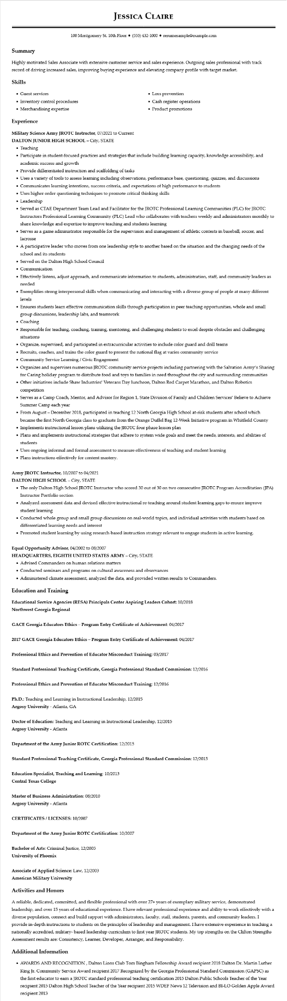

**JESSICA CLAIRE**

100 Montgomery St. 10th Floor⚫ (555) 432-1000⚫ resumesample@example.com

**Summary**

Highly motivated Sales Associate with extensive customer service and sales experience. Outgoing sales professional with track record of driving increased sales, improving buying experience and elevating company profile with target market.

**Skills**

• Guest services

• Inventory control procedures

• Merchandising expertise

**Experience**

Military Science Army JROTC Instructor, 07/2021 to Current

**DALTON JUNIOR HIGH SCHOOL - City, STATE**

• Teaching

• Loss prevention

• Cash register operations

• Product promotions

• Participate in student-focused practices and strategies that include building learning capacity, knowledge accessibility, and academic success and growth

• Provide differentiated instruction and scaffolding of tasks

• Uses a variety of tools to assess learning including observations, performance base, questioning, quizzes, and discussions

• Communicates learning intentions, success criteria, and expectations of high performance to students

• Uses higher order questioning techniques to promote critical thinking skills

• Leadership

• Served as CTAE Department Team Lead and Facilitator for the JROTC Professional Learning Communities (PLC) for JROTC Instructors Professional Learning Community (PLC) Lead who collaborates with teachers weekly and administrators monthly to share knowledge and expertise to improve teaching and students learning

• Serves as a game administrator responsible for the supervision and management of athletic contests in baseball, soccer, and lacrosse

• A participative leader who moves from one leadership style to another based on the situation and the changing needs of the school and its students

• Served on the Dalton High School Council

• Communication

• Effectively listens, adjust approach, and communicate information to students, administration, staff, and community leaders as needed

• Exemplifies strong interpersonal skills when communicating and interacting with a diverse group of people at many different levels

• Ensures students learn effective communication skills through participation in peer teaching opportunities, whole and small group discussions, leadership labs, and teamwork

• Coaching

• Responsible for teaching, coaching, training, mentoring, and challenging students to excel despite obstacles and challenging situations

• Organize, supervised, and participated in extracurricular activities to include color guard and drill teams

• Recruits, coaches, and trains the color guard to present the national flag at varies community service

• Community Service Learning / Civic Engagement

• Organizes and supervises numerous JROTC community service projects including partnering with the Salvation Army's Sharing for Caring holiday program to distribute food and toys to families in need throughout the city and surrounding communities

• Other initiatives include Shaw Industries' Veterans Day luncheon, Dalton Red Carpet Marathon, and Dalton Robotics competition

• Serves as a Camp Coach, Mentor, and Advisor for Region 1, State Division of Family and Children Services' Believe to Achieve Summer Camp each year

• From August - December 2018, participated in teaching 12 North Georgia High School at-risk students after school which

became the first North Georgia class to graduate from the Orange Duffel Bag 12-Week Initiative program in Whitfield County • Implements instructional lesson plans utilizing the JROTC four phase lesson plan

• Plans and implements instructional strategies that adhere to system wide goals and meet the needs, interests, and abilities of students

• Uses ongoing informal and formal assessment to measure effectiveness of teaching and student learning

• Plans instructions effectively for content mastery.

Army JROTC Instructor, 10/2007 to 04/2021

DALTON HIGH SCHOOL - City, STATE

• The only Dalton High School JROTC Instructor who scored 30 out of 30 on two consecutive JROTC Program Accreditation (JPA) Instructor Portfolio section

• Analyzed assessment data and devised effective instructional re-teaching around student learning gaps to ensure improve student learning

• Conducted whole group and small group discussions on real-world topics, and individual activities with students based on differentiated learning needs and interest

• Promoted student learning by using research-based instruction strategy relevant to engage students in active learning.

Equal Opportunity Advisor, 04/2002 to 08/2007

**HEADQUARTERS, EIGHTH UNITED STATES ARMY - City, STATE**

• Advised Commanders on human relations matters

• Conducted seminars and programs on cultural awareness and observances

• Administered climate assessment, analyzed the data, and provided written results to Commanders.

**Education and Training**

**Educational Service Agencies (RESA) Principals Center Aspiring Leaders Cohort: 10/2018 Northwest Georgia Regional**

**GACE Georgia Educators Ethics - Program Entry Certificate of Achievement: 04/2017**

**2017 GACE Georgia Educators Ethics - Program Entry Certificate of Achievement: 04/2017**

**Professional Ethics and Prevention of Educator Misconduct Training: 03/2017**

**Standard Professional Teaching Certificate, Georgia Professional Standard Commission: 12/2016**

**Professional Ethics and Prevention of Educator Misconduct Training: 12/2016**

Ph.D.: Teaching and Learning in Instructional Leadership, 12/2015

Argosy University - Atlanta, GA

Doctor of Education: Teaching and Learning in Instructional Leadership, 12/2015 Argosy University - Atlanta

Department of the Army Junior ROTC Certification: 12/2015

**Standard Professional Teaching Certificate, Georgia Professional Standard Commission: 12/2015**

**Education Specialist, Teaching and Learning: 10/2013**

**Central Texas College**

**Master of Business Administration: 08/2010**

Argosy University - Atlanta

**CERTIFICATES/LICENSES: 10/2007**

Department of the Army Junior ROTC Certification: 10/2007

**Bachelor of Arts: Criminal Justice, 12/2005**

University of Phoenix

Associate of Applied Science: Law, 12/2003

**American Military University**

**Activities and Honors**

A reliable, dedicated, committed, and flexible professional with over 27+ years of exemplary military service, demonstrated leadership, and over 15 years of educational experience. I have relevant professional experience and ability to work effectively with a diverse population, connect and build rapport with administrators, faculty, staff, students, parents, and community leaders. I provide in-depth instructions to students on the principles of leadership and management. I have extensive experience in teaching a nationally accredited, military-based leadership curriculum to first year JROTC students. My top strengths on the Clifton Strengths Assessment results are: Consistency, Learner, Developer, Arranger, and Responsibility.

Additional Information

⚫ AWARDS AND RECOGNITION, Dalton Lions Club Tom Bingham Fellowship Award recipient 2018 Dalton Dr. Martin Luther King Jr. Community Service Award recipient 2017 Recognized by the Georgia Professional Standard Commission (GAPSC) as the first educator to earn a JROTC standard professional teaching certification 2015 Dalton Public Schools Teacher of the Year recipient 2015 Dalton High School Teacher of the Year recipient 2015 WDEF News 12 Television and BI-LO Golden Apple Award recipient 2013