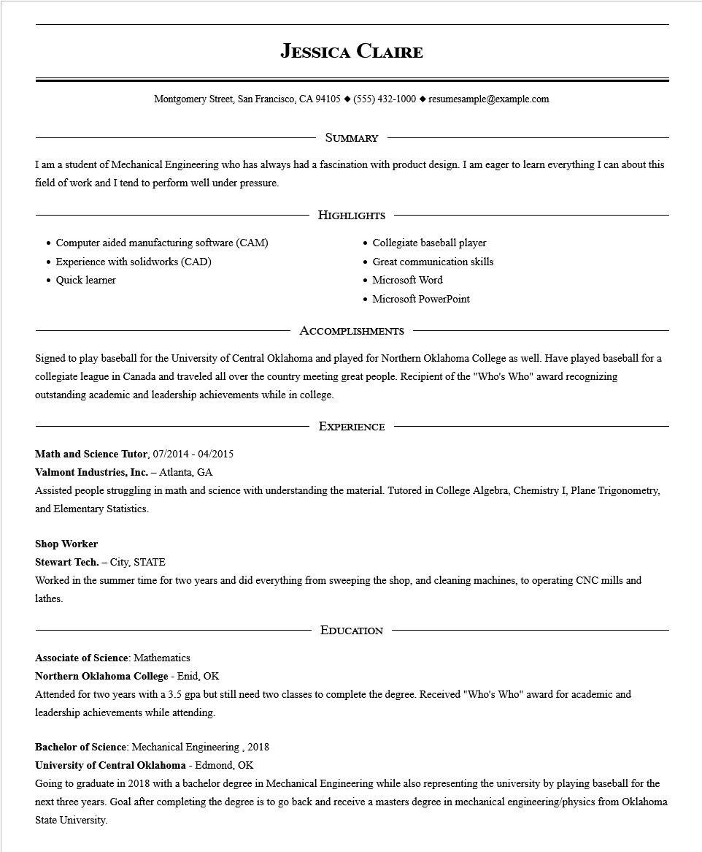

**JESSICA CLAIRE**

Montgomery Street, San Francisco, CA 94105 ♦ (555) 432-1000 resumesample@example.com

SUMMARY

I am a student of Mechanical Engineering who has always had a fascination with product design. I am eager to learn everything I can about this field of work and I tend to perform well under pressure.

Computer aided manufacturing software (CAM)

.

Experience with solidworks (CAD)

•

Quick learner

HIGHLIGHTS

Collegiate baseball player

• Great communication skills

• Microsoft Word

• Microsoft PowerPoint

ACCOMPLISHMENTS

Signed to play baseball for the University of Central Oklahoma and played for Northern Oklahoma College as well. Have played baseball for a collegiate league in Canada and traveled all over the country meeting great people. Recipient of the "Who's Who" award recognizing outstanding academic and leadership achievements while in college.

EXPERIENCE

**Math and Science Tutor, 07/2014 - 04/2015**

**Valmont Industries, Inc. - Atlanta, GA**

Assisted people struggling in math and science with understanding the material. Tutored in College Algebra, Chemistry I, Plane Trigonometry, and Elementary Statistics.

**Shop Worker**

**Stewart Tech. - City, STATE**

Worked in the summer time for two years and did everything from sweeping the shop, and cleaning machines, to operating CNC mills and lathes.

**EDUCATION**

Associate of Science: Mathematics

**Northern Oklahoma College - Enid, OK**

Attended for two years with a 3.5 gpa but still need two classes to complete the degree. Received "Who's Who" award for academic and leadership achievements while attending.

Bachelor of Science: Mechanical Engineering, 2018

**University of Central Oklahoma - Edmond, OK**

Going to graduate in 2018 with a bachelor degree in Mechanical Engineering while also representing the university by playing baseball for the

next three years. Goal after completing the degree is to go back and receive a masters degree in mechanical engineering/physics from Oklahoma State University.