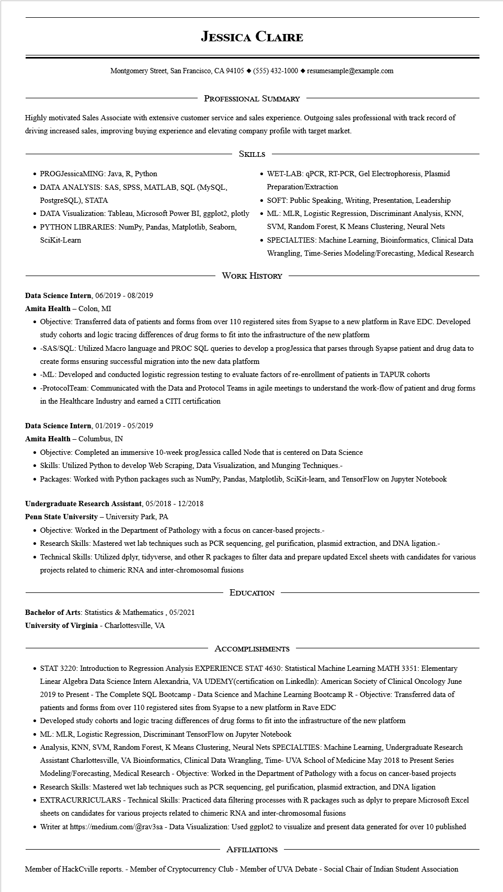

**JESSICA CLAIRE**

Montgomery Street, San Francisco, CA 94105 ♦ (555) 432-1000 resumesample@example.com

PROFESSIONAL SUMMARY

Highly motivated Sales Associate with extensive customer service and sales experience. Outgoing sales professional with track record of driving increased sales, improving buying experience and elevating company profile with target market.

• PROGJessicaMING: Java, R, Python

• DATA ANALYSIS: SAS, SPSS, MATLAB, SQL (MySQL, PostgreSQL), STATA

SKILLS

• DATA Visualization: Tableau, Microsoft Power BI, ggplot2, plotly

• PYTHON LIBRARIES: NumPy, Pandas, Matplotlib, Seaborn, Scikit-Learn

• WET-LAB: qPCR, RT-PCR, Gel Electrophoresis, Plasmid Preparation/Extraction

• SOFT: Public Speaking, Writing, Presentation, Leadership

• ML: MLR, Logistic Regression, Discriminant Analysis, KNN, SVM, Random Forest, K Means Clustering, Neural Nets

• SPECIALTIES: Machine Learning, Bioinformatics, Clinical Data Wrangling, Time-Series Modeling/Forecasting, Medical Research

WORK HISTORY

Data Science Intern, 06/2019 - 08/2019

**Amita Health - Colon, MI**

• Objective: Transferred data of patients and forms from over 110 registered sites from Syapse to a new platform in Rave EDC. Developed study cohorts and logic tracing differences of drug forms to fit into the infrastructure of the new platform

•

-SAS/SQL: Utilized Macro language and PROC SQL queries to develop a progJessica that parses through Syapse patient and drug data to create forms ensuring successful migration into the new data platform

• -ML: Developed and conducted logistic regression testing to evaluate factors of re-enrollment of patients in TAPUR cohorts

⚫ -ProtocolTeam: Communicated with the Data and Protocol Teams in agile meetings to understand the work-flow of patient and drug forms in the Healthcare Industry and earned a CITI certification

**Data Science Intern, 01/2019 - 05/2019**

**Amita Health - Columbus, IN**

• Objective: Completed an immersive 10-week progJessica called Node that is centered on Data Science

• Skills: Utilized Python to develop Web Scraping, Data Visualization, and Munging Techniques.-

• Packages: Worked with Python packages such as NumPy, Pandas, Matplotlib, Scikit-learn, and TensorFlow on Jupyter Notebook

**Undergraduate Research Assistant, 05/2018 - 12/2018**

Penn State University - University Park, PA

• Objective: Worked in the Department of Pathology with a focus on cancer-based projects.-

• Research Skills: Mastered wet lab techniques such as PCR sequencing, gel purification, plasmid extraction, and DNA ligation.-

• Technical Skills: Utilized dplyr, tidyverse, and other R packages to filter data and prepare updated Excel sheets with candidates for various projects related to chimeric RNA and inter-chromosomal fusions

Bachelor of Arts: Statistics & Mathematics, 05/2021

**University of Virginia - Charlottesville, VA**

EDUCATION

ACCOMPLISHMENTS

• STAT 3220: Introduction to Regression Analysis EXPERIENCE STAT 4630: Statistical Machine Learning MATH 3351: Elementary Linear Algebra Data Science Intern Alexandria, VA UDEMY(certification on Linkedln): American Society of Clinical Oncology June 2019 to Present - The Complete SQL Bootcamp - Data Science and Machine Learning Bootcamp R - Objective: Transferred data of patients and forms from over 110 registered sites from Syapse to a new platform in Rave EDC

• Developed study cohorts and logic tracing differences of drug forms to fit into the infrastructure of the new platform

• ML: MLR, Logistic Regression, Discriminant TensorFlow on Jupyter Notebook

• Analysis, KNN, SVM, Random Forest, K Means Clustering, Neural Nets SPECIALTIES: Machine Learning, Undergraduate Research Assistant Charlottesville, VA Bioinformatics, Clinical Data Wrangling, Time- UVA School of Medicine May 2018 to Present Series Modeling/Forecasting, Medical Research - Objective: Worked in the Department of Pathology with a focus on cancer-based projects • Research Skills: Mastered wet lab techniques such as PCR sequencing, gel purification, plasmid extraction, and DNA ligation

• EXTRACURRICULARS - Technical Skills: Practiced data filtering processes with R packages such as dplyr to prepare Microsoft Excel sheets on candidates for various projects related to chimeric RNA and inter-chromosomal fusions

• Writer at https://medium.com/@rav3sa - Data Visualization: Used ggplot2 to visualize and present data generated for over 10 published

AFFILIATIONS

Member of HackCville reports. - Member of Cryptocurrency Club - Member of UVA Debate - Social Chair of Indian Student Association