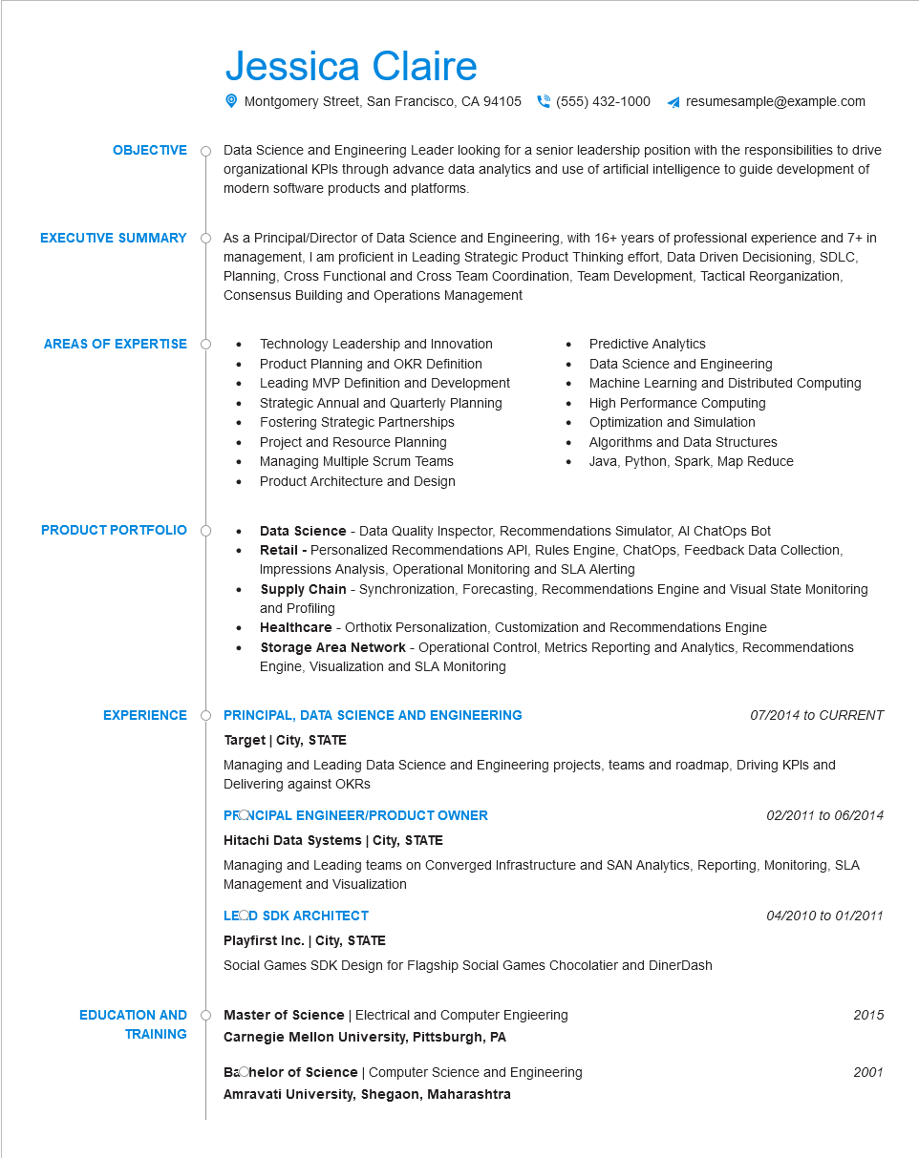

**OBJECTIVE**

**EXECUTIVE SUMMARY**

**AREAS OF EXPERTISE**

**PRODUCT PORTFOLIO**

Jessica Claire

Montgomery Street, San Francisco, CA 94105 (555) 432-1000

resumesample@example.com

Data Science and Engineering Leader looking for a senior leadership position with the responsibilities to drive organizational KPIs through advance data analytics and use of artificial intelligence to guide development of modern software products and platforms.

As a Principal/Director of Data Science and Engineering, with 16+ years of professional experience and 7+ in management, I am proficient in Leading Strategic Product Thinking effort, Data Driven Decisioning, SDLC, Planning, Cross Functional and Cross Team Coordination, Team Development, Tactical Reorganization, Consensus Building and Operations Management

• Technology Leadership and Innovation

•

Product Planning and OKR Definition

Leading MVP Definition and Development Strategic Annual and Quarterly Planning

• Fostering Strategic Partnerships

Project and Resource Planning

Managing Multiple Scrum Teams

•

•

Predictive Analytics

Data Science and Engineering

Machine Learning and Distributed Computing

High Performance Computing

Optimization and Simulation

Algorithms and Data Structures Java, Python, Spark, Map Reduce

Product Architecture and Design

Data Science - Data Quality Inspector, Recommendations Simulator, Al ChatOps Bot

· Retail - Personalized Recommendations API, Rules Engine, ChatOps, Feedback Data Collection, Impressions Analysis, Operational Monitoring and SLA Alerting

•

•

Supply Chain - Synchronization, Forecasting, Recommendations Engine and Visual State Monitoring and Profiling

Healthcare - Orthotix Personalization, Customization and Recommendations Engine

Storage Area Network - Operational Control, Metrics Reporting and Analytics, Recommendations Engine, Visualization and SLA Monitoring

**EXPERIENCE**

**PRINCIPAL, DATA SCIENCE AND ENGINEERING**

**Target City, STATE**

07/2014 to CURRENT

Managing and Leading Data Science and Engineering projects, teams and roadmap, Driving KPIs and Delivering against OKRS

**PRONCIPAL ENGINEER/PRODUCT OWNER**

**Hitachi Data Systems | City, STATE**

*02/2011 to 06/2014*

Managing and Leading teams on Converged Infrastructure and SAN Analytics, Reporting, Monitoring, SLA Management and Visualization

**LEOD SDK ARCHITECT**

**Playfirst Inc. | City, STATE**

Social Games SDK Design for Flagship Social Games Chocolatier and DinerDash

**EDUCATION AND TRAINING**

**Master of Science | Electrical and Computer Engieering Carnegie Mellon University, Pittsburgh, PA**

**Bachelor of Science | Computer Science and Engineering Amravati University, Shegaon, Maharashtra**

04/2010 to 01/2011

2015

2001