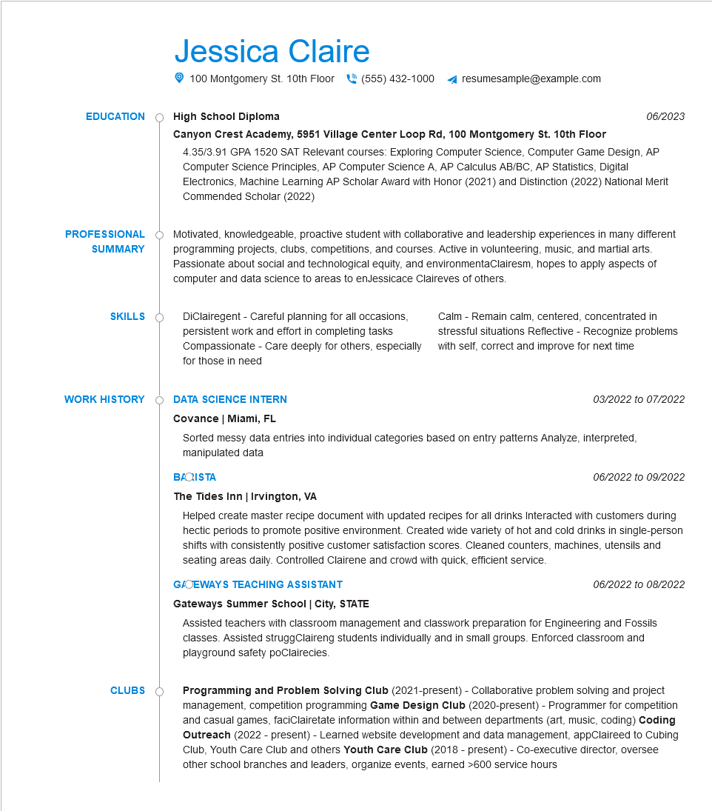

Jessica Claire

100 Montgomery St. 10th Floor (555) 432-1000

**EDUCATION**

**High School Diploma**

resumesample@example.com

*06/2023*

**PROFESSIONAL**

**SUMMARY**

**SKILLS**

**Canyon Crest Academy, 5951 Village Center Loop Rd, 100 Montgomery St. 10th Floor**

4.35/3.91 GPA 1520 SAT Relevant courses: Exploring Computer Science, Computer Game Design, AP Computer Science Principles, AP Computer Science A, AP Calculus AB/BC, AP Statistics, Digital Electronics, Machine Learning AP Scholar Award with Honor (2021) and Distinction (2022) National Merit Commended Scholar (2022)

Motivated, knowledgeable, proactive student with collaborative and leadership experiences in many different programming projects, clubs, competitions, and courses. Active in volunteering, music, and martial arts. Passionate about social and technological equity, and environmentaClairesm, hopes to apply aspects of computer and data science to areas to enJessicace Claireves of others.

DiClairegent - Careful planning for all occasions, persistent work and effort in completing tasks Compassionate - Care deeply for others, especially for those in need

Calm - Remain calm, centered, concentrated in stressful situations Reflective - Recognize problems with self, correct and improve for next time

**WORK HISTORY**

**DATA SCIENCE INTERN**

*03/2022 to 07/2022*

**CLUBS**

**Covance | Miami, FL**

Sorted messy data entries into individual categories based on entry patterns Analyze, interpreted, manipulated data

BAQISTA

**The Tides Inn | Irvington, VA**

06/2022 to 09/2022

Helped create master recipe document with updated recipes for all drinks Interacted with customers during hectic periods to promote positive environment. Created wide variety of hot and cold drinks in single-person shifts with consistently positive customer satisfaction scores. Cleaned counters, machines, utensils and seating areas daily. Controlled Clairene and crowd with quick, efficient service.

**G/OEWAYS TEACHING ASSISTANT**

**Gateways Summer School | City, STATE**

*06/2022 to 08/2022*

Assisted teachers with classroom management and classwork preparation for Engineering and Fossils classes. Assisted struggClaireng students individually and in small groups. Enforced classroom and playground safety poClairecies.

Programming and Problem Solving Club (2021-present) - Collaborative problem solving and project management, competition programming Game Design Club (2020-present) - Programmer for competition and casual games, faciClairetate information within and between departments (art, music, coding) Coding Outreach (2022 - present) - Learned website development and data management, appClaireed to Cubing Club, Youth Care Club and others Youth Care Club (2018 - present) - Co-executive director, oversee other school branches and leaders, organize events, earned >600 service hours