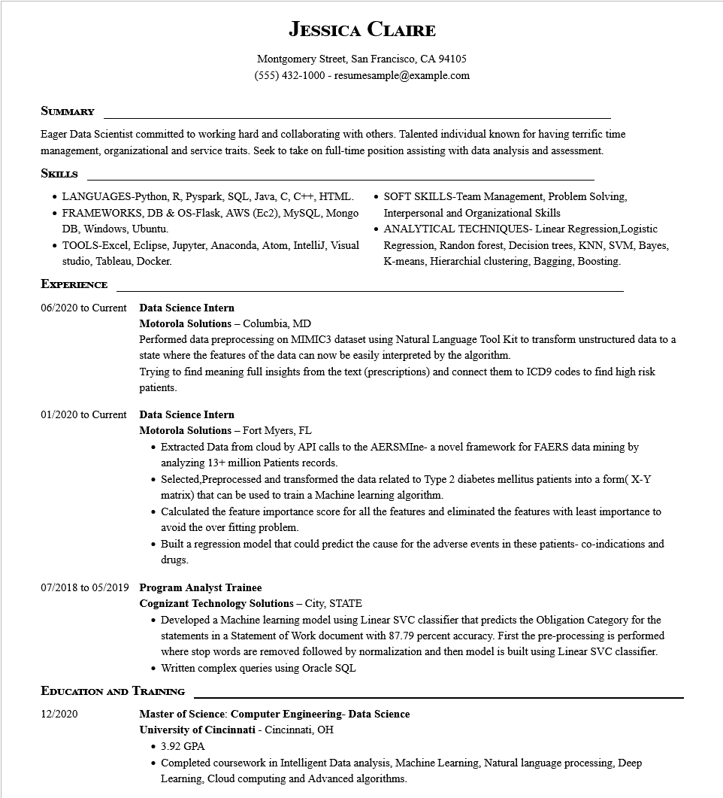

**JESSICA CLAIRE**

Montgomery Street, San Francisco, CA 94105 (555) 432-1000-resumesample@example.com

**SUMMARY**

Eager Data Scientist committed to working hard and collaborating with others. Talented individual known for having terrific time management, organizational and service traits. Seek to take on full-time position assisting with data analysis and assessment. SKILLS

• LANGUAGES-Python, R, Pyspark, SQL, Java, C, C++, HTML. • FRAMEWORKS, DB & OS-Flask, AWS (Ec2), MySQL, Mongo DB, Windows, Ubuntu.

• TOOLS-Excel, Eclipse, Jupyter, Anaconda, Atom, IntelliJ, Visual studio, Tableau, Docker.

**EXPERIENCE**

06/2020 to Current Data Science Intern

**Motorola Solutions - Columbia, MD**

• SOFT SKILLS-Team Management, Problem Solving, Interpersonal and Organizational Skills

• ANALYTICAL TECHNIQUES- Linear Regression, Logistic Regression, Randon forest, Decision trees, KNN, SVM, Bayes, K-means, Hierarchial clustering, Bagging, Boosting.

Performed data preprocessing on MIMIC3 dataset using Natural Language Tool Kit to transform unstructured data to a state where the features of the data can now be easily interpreted by the algorithm.

Trying to find meaning full insights from the text (prescriptions) and connect them to ICD9 codes to find high risk patients.

01/2020 to Current Data Science Intern

**Motorola Solutions - Fort Myers, FL**

• Extracted Data from cloud by API calls to the AERSMIne- a novel framework for FAERS data mining by analyzing 13+ million Patients records.

• Selected, Preprocessed and transformed the data related to Type 2 diabetes mellitus patients into a form(X-Y matrix) that can be used to train a Machine learning algorithm.

• Calculated the feature importance score for all the features and eliminated the features with least importance to avoid the over fitting problem.

• Built a regression model that could predict the cause for the adverse events in these patients- co-indications and drugs.

**07/2018 to 05/2019 Program Analyst Trainee**

**Cognizant Technology Solutions - City, STATE**

• Developed a Machine learning model using Linear SVC classifier that predicts the Obligation Category for the statements in a Statement of Work document with 87.79 percent accuracy. First the pre-processing is performed where stop words are removed followed by normalization and then model is built using Linear SVC classifier. • Written complex queries using Oracle SQL

**EDUCATION AND TRAINING**

12/2020

**Master of Science: Computer Engineering- Data Science**

**University of Cincinnati - Cincinnati, OH**

• 3.92 GPA

·

Completed coursework in Intelligent Data analysis, Machine Learning, Natural language processing, Deep Learning, Cloud computing and Advanced algorithms.