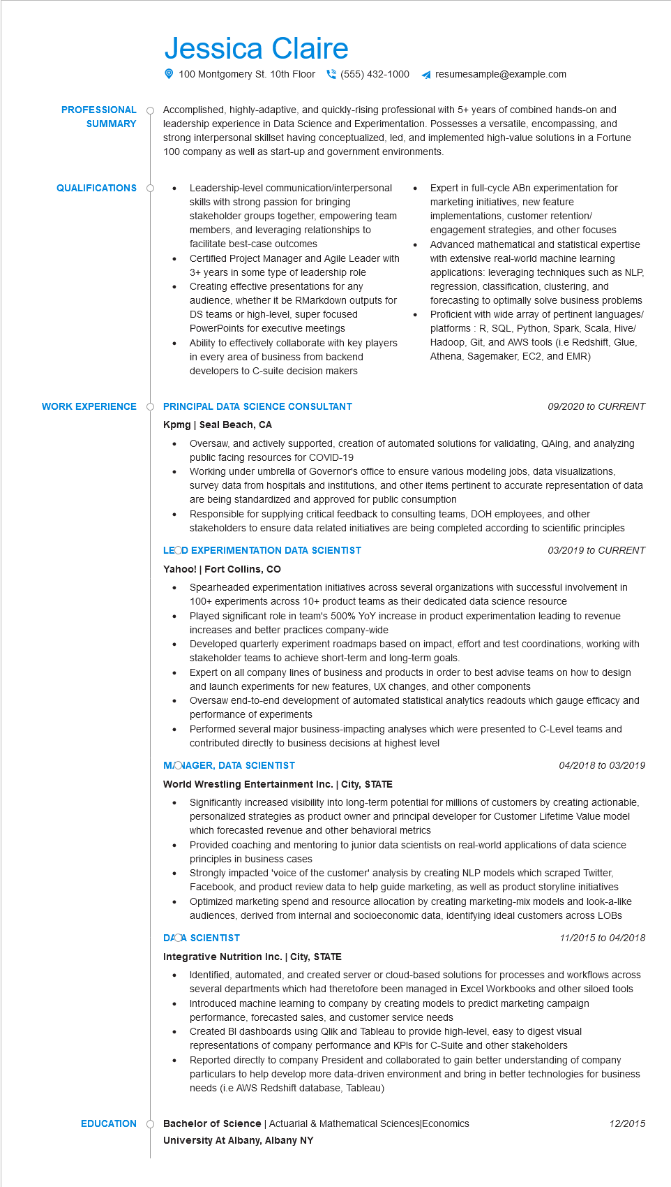

**PROFESSIONAL**

**SUMMARY**

Jessica Claire

100 Montgomery St. 10th Floor (555) 432-1000

resumesample@example.com

Accomplished, highly-adaptive, and quickly-rising professional with 5+ years of combined hands-on and leadership experience in Data Science and Experimentation. Possesses a versatile, encompassing, and strong interpersonal skillset having conceptualized, led, and implemented high-value solutions in a Fortune 100 company as well as start-up and government environments.

**QUALIFICATIONS**

•

Leadership-level communication/interpersonal

skills with strong passion for bringing stakeholder groups together, empowering team members, and leveraging relationships to facilitate best-case outcomes

Certified Project Manager and Agile Leader with 3+ years in some type of leadership role Creating effective presentations for any audience, whether it be RMarkdown outputs for DS teams or high-level, super focused PowerPoints for executive meetings

Ability to effectively collaborate with key players in every area of business from backend developers to C-suite decision makers

**WORK EXPERIENCE Ò PRINCIPAL DATA SCIENCE CONSULTANT**

**Kpmg | Seal Beach, CA**

•

Expert in full-cycle ABn experimentation for marketing initiatives, new feature implementations, customer retention/ engagement strategies, and other focuses Advanced mathematical and statistical expertise with extensive real-world machine learning applications: leveraging techniques such as NLP, regression, classification, clustering, and forecasting to optimally solve business problems Proficient with wide array of pertinent languages/ platforms: R, SQL, Python, Spark, Scala, Hive/ Hadoop, Git, and AWS tools (i.e Redshift, Glue, Athena, Sagemaker, EC2, and EMR)

*09/2020 to CURRENT*

Oversaw, and actively supported, creation of automated solutions for validating, QAing, and analyzing public facing resources for COVID-19

Working under umbrella of Governor's office to ensure various modeling jobs, data visualizations, survey data from hospitals and institutions, and other items pertinent to accurate representation of data are being standardized and approved for public consumption

Responsible for supplying critical feedback to consulting teams, DOH employees, and other stakeholders to ensure data related initiatives are being completed according to scientific principles LEOD EXPERIMENTATION DATA SCIENTIST

**Yahoo! | Fort Collins, CO**

•

•

*03/2019 to CURRENT*

Spearheaded experimentation initiatives across several organizations with successful involvement in 100+ experiments across 10+ product teams as their dedicated data science resource

Played significant role in team's 500% YoY increase in product experimentation leading to revenue increases and better practices company-wide

Developed quarterly experiment roadmaps based on impact, effort and test coordinations, working with stakeholder teams to achieve short-term and long-term goals.

• Expert on all company lines of business and products in order to best advise teams on how to design and launch experiments for new features, UX changes, and other components

•

Oversaw end-to-end development of automated statistical analytics readouts which gauge efficacy and performance of experiments

Performed several major business-impacting analyses which were presented to C-Level teams and contributed directly to business decisions at highest level

**MOJAGER, DATA SCIENTIST**

**World Wrestling Entertainment Inc. | City, STATE**

•

04/2018 to 03/2019

Significantly increased visibility into long-term potential for millions of customers by creating actionable, personalized strategies as product owner and principal developer for Customer Lifetime Value model which forecasted revenue and other behavioral metrics

Provided coaching and mentoring to junior data scientists on real-world applications of data science principles in business cases

Strongly impacted 'voice of the customer' analysis by creating NLP models which scraped Twitter, Facebook, and product review data to help guide marketing, as well as product storyline initiatives

• Optimized marketing spend and resource allocation by creating marketing-mix models and look-a-like audiences, derived from internal and socioeconomic data, identifying ideal customers across LOBS DACA SCIENTIST 11/2015 to 04/2018

**Integrative Nutrition Inc. | City, STATE**

•

.

Identified, automated, and created server or cloud-based solutions for processes and workflows across several departments which had theretofore been managed in Excel Workbooks and other siloed tools Introduced machine learning to company by creating models to predict marketing campaign performance, forecasted sales, and customer service needs

Created BI dashboards using Qlik and Tableau to provide high-level, easy to digest visual representations of company performance and KPIs for C-Suite and other stakeholders

Reported directly to company President and collaborated to gain better understanding of company

particulars to help develop more data-driven environment and bring in better technologies for business needs (i.e AWS Redshift database, Tableau)

EDUCATION

**Bachelor of Science | Actuarial & Mathematical Sciences|Economics University At Albany, Albany NY**

12/2015