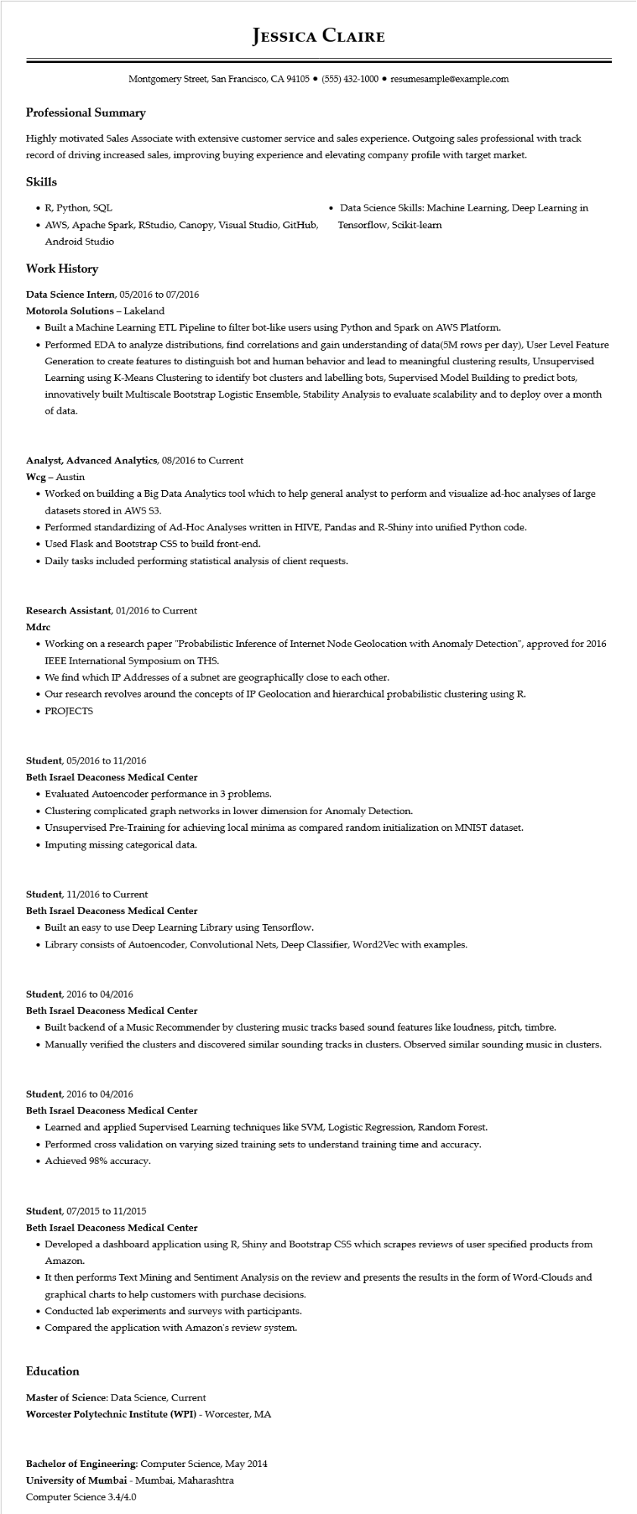

**JESSICA CLAIRE**

Montgomery Street, San Francisco, CA 94105⚫ (555) 432-1000⚫ resumesample@example.com

**Professional Summary**

Highly motivated Sales Associate with extensive customer service and sales experience. Outgoing sales professional with track record of driving increased sales, improving buying experience and elevating company profile with target market.

**Skills**

• R, Python, SQL

• AWS, Apache Spark, RStudio, Canopy, Visual Studio, GitHub, Android Studio

**Work History**

Data Science Intern, 05/2016 to 07/2016

**Motorola Solutions - Lakeland**

• Data Science Skills: Machine Learning, Deep Learning in Tensorflow, Scikit-learn

• Built a Machine Learning ETL Pipeline to filter bot-like users using Python and Spark on AWS Platform.

• Performed EDA to analyze distributions, find correlations and gain understanding of data(5M rows per day), User Level Feature Generation to create features to distinguish bot and human behavior and lead to meaningful clustering results, Unsupervised Learning using K-Means Clustering to identify bot clusters and labelling bots, Supervised Model Building to predict bots, innovatively built Multiscale Bootstrap Logistic Ensemble, Stability Analysis to evaluate scalability and to deploy over a month of data.

**Analyst, Advanced Analytics, 08/2016 to Current**

Wcg - Austin

• Worked on building a Big Data Analytics tool which to help general analyst to perform and visualize ad-hoc analyses of large datasets stored in AWS S3.

• Performed standardizing of Ad-Hoc Analyses written in HIVE, Pandas and R-Shiny into unified Python code.

• Used Flask and Bootstrap CSS to build front-end.

• Daily tasks included performing statistical analysis of client requests.

**Research Assistant, 01/2016 to Current**

Mdrc

• Working on a research paper "Probabilistic Inference of Internet Node Geolocation with Anomaly Detection", approved for 2016 IEEE International Symposium on THS.

• We find which IP Addresses of a subnet are geographically close to each other.

• Our research revolves around the concepts of IP Geolocation and hierarchical probabilistic clustering using R.

• PROJECTS

Student, 05/2016 to 11/2016

**Beth Israel Deaconess Medical Center**

• Evaluated Autoencoder performance in 3 problems.

• Clustering complicated graph networks in lower dimension for Anomaly Detection.

• Unsupervised Pre-Training for achieving local minima as compared random initialization on MNIST dataset.

• Imputing missing categorical data.

Student, 11/2016 to Current

Beth Israel Deaconess Medical Center

• Built an easy to use Deep Learning Library using Tensorflow.

• Library consists of Autoencoder, Convolutional Nets, Deep Classifier, Word2Vec with examples.

Student, 2016 to 04/2016

Beth Israel Deaconess Medical Center

• Built backend of a Music Recommender by clustering music tracks based sound features like loudness, pitch, timbre.

• Manually verified the clusters and discovered similar sounding tracks in clusters. Observed similar sounding music in clusters.

Student, 2016 to 04/2016

Beth Israel Deaconess Medical Center

• Learned and applied Supervised Learning techniques like SVM, Logistic Regression, Random Forest.

• Performed cross validation on varying sized training sets to understand training time and accuracy.

• Achieved 98% accuracy.

Student, 07/2015 to 11/2015

Beth Israel Deaconess Medical Center

• Developed a dashboard application using R, Shiny and Bootstrap CSS which scrapes reviews of user specified products from Amazon.

• It then performs Text Mining and Sentiment Analysis on the review and presents the results in the form of Word-Clouds and graphical charts to help customers with purchase decisions.

• Conducted lab experiments and surveys with participants.

• Compared the application with Amazon's review system.

**Education**

Master of Science: Data Science, Current

**Worcester Polytechnic Institute (WPI) - Worcester, MA**

**Bachelor of Engineering: Computer Science, May 2014 University of Mumbai - Mumbai, Maharashtra Computer Science 3.4/4.0**