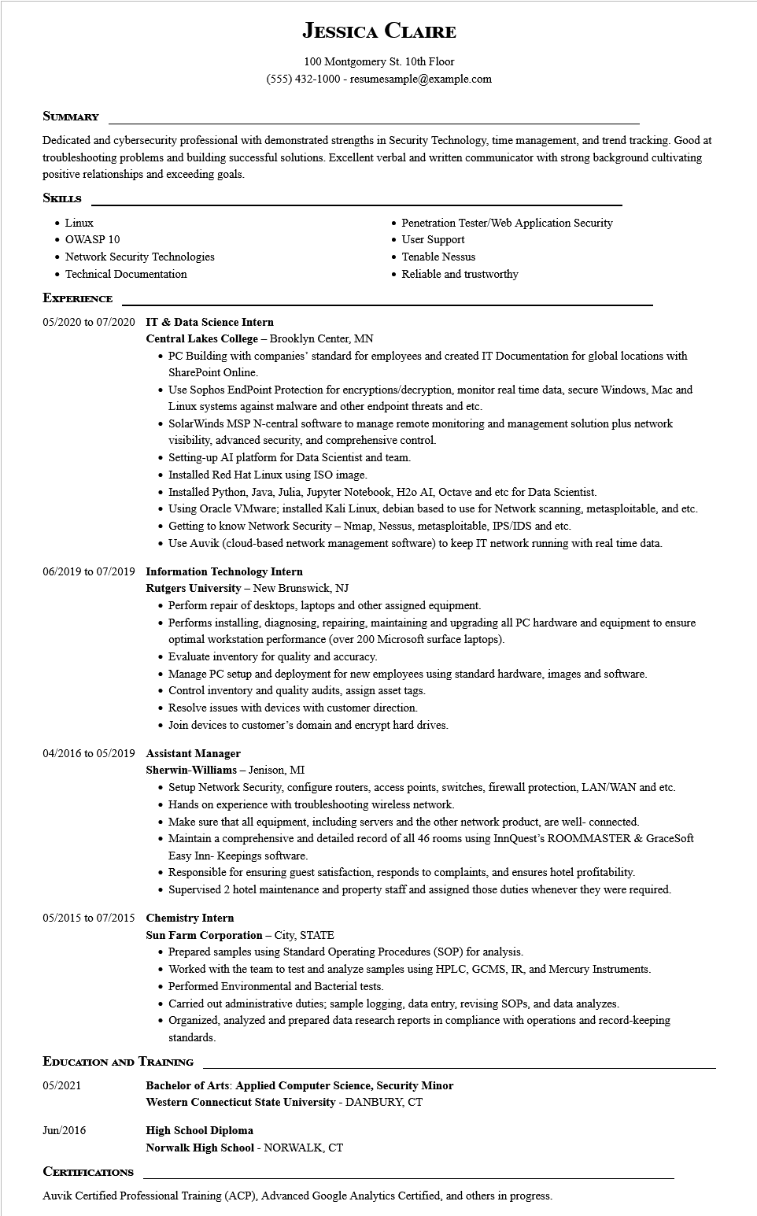

**JESSICA CLAIRE**

100 Montgomery St. 10th Floor

(555) 432-1000 - resumesample@example.com

**SUMMARY**

Dedicated and cybersecurity professional with demonstrated strengths in Security Technology, time management, and trend tracking. Good at troubleshooting problems and building successful solutions. Excellent verbal and written communicator with strong background cultivating positive relationships and exceeding goals.

**SKILLS**

• Linux

• OWASP 10

• Network Security Technologies

• Technical Documentation

**EXPERIENCE**

**05/2020 to 07/2020 IT & Data Science Intern**

**Central Lakes College - Brooklyn Center, MN**

• Penetration Tester/Web Application Security • User Support

• Tenable Nessus

• Reliable and trustworthy

• PC Building with companies' standard for employees and created IT Documentation for global locations with SharePoint Online.

• Use Sophos Endpoint Protection for encryptions/decryption, monitor real time data, secure Windows, Mac and Linux systems against malware and other endpoint threats and etc.

• SolarWinds MSP N-central software to manage remote monitoring and management solution plus network visibility, advanced security, and comprehensive control.

• Setting-up AI platform for Data Scientist and team.

• Installed Red Hat Linux using ISO image.

• Installed Python, Java, Julia, Jupyter Notebook, H20 AI, Octave and etc for Data Scientist.

• Using Oracle VMware; installed Kali Linux, debian based to use for Network scanning, metasploitable, and etc.

• Getting to know Network Security - Nmap, Nessus, metasploitable, IPS/IDS and etc.

• Use Auvik (cloud-based network management software) to keep IT network running with real time data.

**06/2019 to 07/2019 Information Technology Intern**

**Rutgers University - New Brunswick, NJ**

• Perform repair of desktops, laptops and other assigned equipment.

• Performs installing, diagnosing, repairing, maintaining and upgrading all PC hardware and equipment to ensure optimal workstation performance (over 200 Microsoft surface laptops).

• Evaluate inventory for quality and accuracy.

• Manage PC setup and deployment for new employees using standard hardware, images and software.

• Control inventory and quality audits, assign asset tags.

• Resolve issues with devices with customer direction.

• Join devices to customer's domain and encrypt hard drives.

**04/2016 to 05/2019 Assistant Manager**

**Sherwin-Williams - Jenison, MI**

• Setup Network Security, configure routers, access points, switches, firewall protection, LAN/WAN and etc. • Hands on experience with troubleshooting wireless network.

• Make sure that all equipment, including servers and the other network product, are well- connected.

• Maintain a comprehensive and detailed record of all 46 rooms using InnQuest's ROOMMASTER & GraceSoft Easy Inn-Keepings software.

• Responsible for ensuring guest satisfaction, responds to complaints, and ensures hotel profitability.

• Supervised 2 hotel maintenance and property staff and assigned those duties whenever they were required.

05/2015 to 07/2015 Chemistry Intern

**Sun Farm Corporation - City, STATE**

• Prepared samples using Standard Operating Procedures (SOP) for analysis.

• Worked with the team to test and analyze samples using HPLC, GCMS, IR, and Mercury Instruments.

• Performed Environmental and Bacterial tests.

• Carried out administrative duties; sample logging, data entry, revising SOPs, and data analyzes.

• Organized, analyzed and prepared data research reports in compliance with operations and record-keeping standards.

**EDUCATION AND TRAINING**

05/2021

Jun/2016

**CERTIFICATIONS**

**Bachelor of Arts: Applied Computer Science, Security Minor**

**Western Connecticut State University - DANBURY, CT**

**High School Diploma**

**Norwalk High School - NORWALK, CT**

Auvik Certified Professional Training (ACP), Advanced Google Analytics Certified, and others in progress.