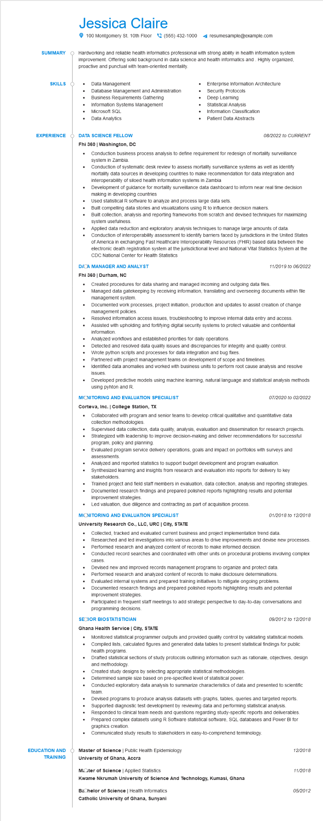

**SUMMARY**

Jessica Claire

100 Montgomery St. 10th Floor(555) 432-1000 4 resumesample@example.com

Hardworking and reliable health informatics professional with strong ability in health information system improvement. Offering solid background in data science and health informatics and. Highly organized, proactive and punctual with team-oriented mentality.

**SKILLS**

•

Data Management

Database Management and Administration

Business Requirements Gathering

Information Systems Management

Microsoft SQL

Data Analytics

**EXPERIENCE**

**DATA SCIENCE FELLOW**

Enterprise Information Architecture

Security Protocols

Deep Learning

Statistical Analysis

•

Information Classification

Patient Data Abstracts

*08/2022 to CURRENT*

Fhi 360 | Washington, DC

•

•

•

Conduction business process analysis to define requirement for redesign of mortality surveillance system in Zambia.

Conduction of systematic desk review to assess mortality surveillance systems as well as identify mortality data sources in developing countries to make recommendation for data integration and interoperability of siloed health information systems in Zambia

Development of guidance for mortality surveillance data dashboard to inform near real time decision making in developing countries

Used statistical R software to analyze and process large data sets.

Built compelling data stories and visualizations using R to influence decision makers.

Built collection, analysis and reporting frameworks from scratch and devised techniques for maximizing system usefulness.

Applied data reduction and exploratory analysis techniques to manage large amounts of data. Conduction of interoperability assessment to identify barriers faced by jurisdictions in the United States of America in exchanging Fast Healthcare Interoperability Resources (FHIR) based data between the electronic death registration system at the jurisdictional level and National Vital Statistics System at the CDC National Center for Health Statistics

**DACA MANAGER AND ANALYST**

**Fhi 360 | Durham, NC**

Created procedures for data sharing and managed incoming and outgoing data files.

11/2019 to 06/2022

Managed data gatekeeping by receiving information, translating and overseeing documents within file management system.

• Documented work processes, project initiation, production and updates to assist creation of change management policies.

•

•

Resolved information access issues, troubleshooting to improve internal data entry and access. Assisted with upholding and fortifying digital security systems to protect valuable and confidential information.

Analyzed workflows and established priorities for daily operations.

Detected and resolved data quality issues and discrepancies for integrity and quality control.

Wrote python scripts and processes for data integration and bug fixes.

Partnered with project management teams on development of scope and timelines.

Identified data anomalies and worked with business units to perform root cause analysis and resolve issues.

Developed predictive models using machine learning, natural language and statistical analysis methods using pyhton and R.

**MONITORING AND EVALUATION SPECIALIST**

**Corteva, Inc. | College Station, TX**

•

•

07/2020 to 02/2022

Collaborated with program and senior teams to develop critical qualitative and quantitative data collection methodologies.

Supervised data collection, data quality, analysis, evaluation and dissemination for research projects. Strategized with leadership to improve decision-making and deliver recommendations for successful program, policy and planning.

Evaluated program service delivery operations, goals and impact on portfolios with surveys and assessments.

•

Analyzed and reported statistics to support budget development and program evaluation. Synthesized learning and insights from research and evaluation into reports for delivery to key stakeholders.

Trained project and field staff members in evaluation, data collection, analysis and reporting strategies. Documented research findings and prepared polished reports highlighting results and potential

improvement strategies.

Led valuation, due diligence and contracting as part of acquisition process.

**MONITORING AND EVALUATION SPECIALIST**

01/2018 to 12/2018

**University Research Co., LLC, URC | City, STATE**

• Collected, tracked and evaluated current business and project implementation trend data.

Researched and led investigations into various areas to drive improvements and devise new processes. Performed research and analyzed content of records to make informed decision.

•

•

Conducted record searches and coordinated with other units on procedural problems involving complex

cases.

Devised new and improved records management programs to organize and protect data.

•

Performed research and analyzed content of records to make disclosure determinations.

Evaluated internal systems and prepared training initiatives to mitigate ongoing problems. Documented research findings and prepared polished reports highlighting results and potential improvement strategies.

Participated in frequent staff meetings to add strategic perspective to day-to-day conversations and programming decisions.

**SECIOR BIOSTATISTICIAN**

**Ghana Health Service | City, STATE**

09/2012 to 12/2018

Monitored statistical programmer outputs and provided quality control by validating statistical models. Compiled lists, calculated figures and generated data tables to present statistical findings for public health programs.

Drafted statistical sections of study protocols outlining information such as rationale, objectives, design and methodology.

Created study designs by selecting appropriate statistical methodologies. Determined sample size based on pre-specified level of statistical power.

Conducted exploratory data analysis to summarize characteristics of data and presented to scientific team.

Devised programs to produce analysis datasets with graphs, tables, queries and targeted reports • Supported diagnostic test development by reviewing data and performing statistical analysis. Responded to clinical team needs and questions regarding study-specific reports and deliverables. Prepared complex datasets using R Software statistical software, SQL databases and Power BI for graphics creation.

•

Communicated study results to stakeholders in easy-to-comprehend terminology.

**EDUCATION AND TRAINING**

Master of Science | Public Health Epidemiology

12/2018

**University of Ghana, Accra**

Moter of Science | Applied Statistics

*11/2018*

**Kwame Nkrumah University of Science And Technology, Kumasi, Ghana**

**Bachelor of Science | Health Informatics**

05/2012

**Catholic University of Ghana, Sunyani**