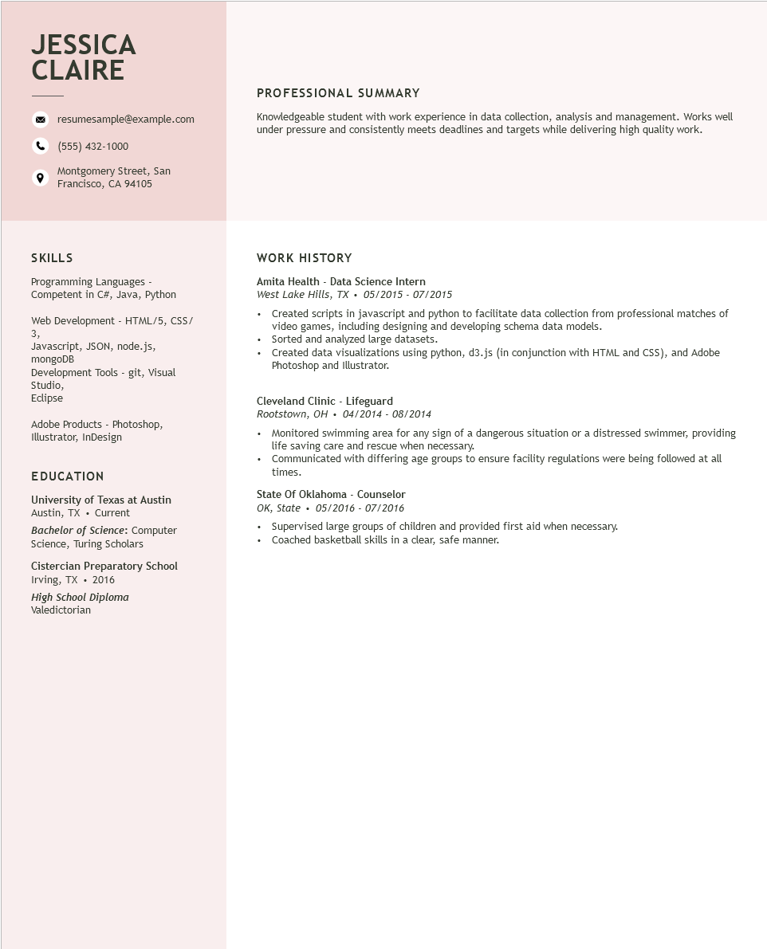

**JESSICA CLAIRE**

resumesample@example.com

(555) 432-1000

Montgomery Street, San Francisco, CA 94105

PROFESSIONAL SUMMARY

Knowledgeable student with work experience in data collection, analysis and management. Works well under pressure and consistently meets deadlines and targets while delivering high quality work.

SKILLS

Programming Languages - Competent in C#, Java, Python

Web Development - HTML/5, CSS/

3,

Javascript, JSON, node.js,

mongoDB

Development Tools - git, Visual

Studio,

Eclipse

Adobe Products - Photoshop, Illustrator, InDesign

EDUCATION

University of Texas at Austin Austin, TX. Current

Bachelor of Science: Computer Science, Turing Scholars

Cistercian Preparatory School Irving, TX. 2016

*High School Diploma*

Valedictorian

**WORK HISTORY**

Amita Health - Data Science Intern

*West Lake Hills, TX. 05/2015 07/2015*

• Created scripts in javascript and python to facilitate data collection from professional matches of video games, including designing and developing schema data models.

•

Sorted and analyzed large datasets.

•

Created data visualizations using python, d3.js (in conjunction with HTML and CSS), and Adobe Photoshop and Illustrator.

Cleveland Clinic - Lifeguard

*Rootstown, OH. 04/2014 - 08/2014*

• Monitored swimming area for any sign of a dangerous situation or a distressed swimmer, providing life saving care and rescue when necessary.

• Communicated with differing age groups to ensure facility regulations were being followed at all times.

State of Oklahoma - Counselor

*OK, State*

05/2016 - 07/2016

Supervised large groups of children and provided first aid when necessary. Coached basketball skills in a clear, safe manner.