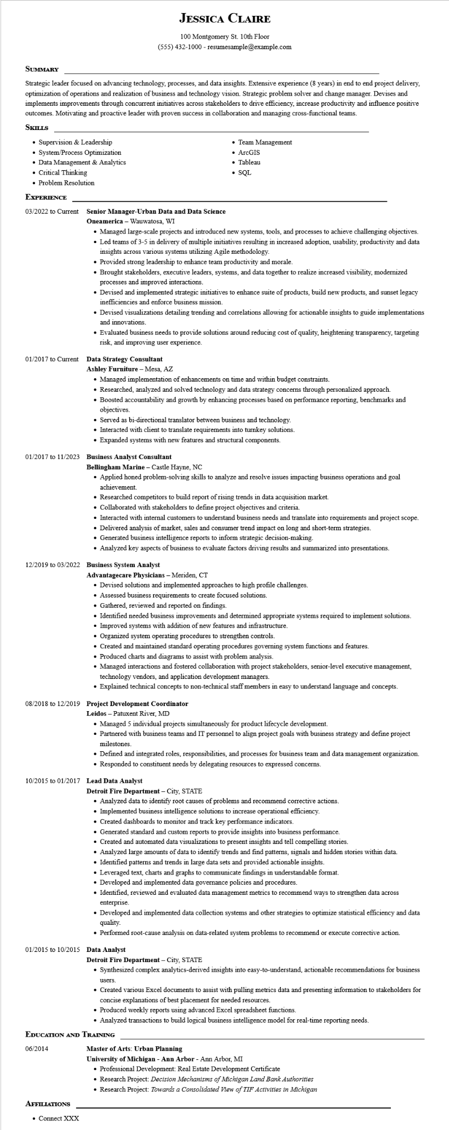

**JESSICA CLAIRE**

100 Montgomery St. 10th Floor

(555) 432-1000 - resumesample@example.com

**SUMMARY**

Strategic leader focused on advancing technology, processes, and data insights. Extensive experience (8 years) in end to end project delivery, optimization of operations and realization of business and technology vision. Strategic problem solver and change manager. Devises and implements improvements through concurrent initiatives across stakeholders to drive efficiency, increase productivity and influence positive outcomes. Motivating and proactive leader with proven success in collaboration and managing cross-functional teams.

**SKILLS**

• Supervision & Leadership

• System/Process Optimization

• Data Management & Analytics

• Critical Thinking

• Problem Resolution

**EXPERIENCE**

**03/2022 to Current Senior Manager-Urban Data and Data Science Oneamerica - Wauwatosa, WI**

01/2017 to Current

• Team Management

• ArcGIS

• Tableau

• SQL

• Managed large-scale projects and introduced new systems, tools, and processes to achieve challenging objectives.

• Led teams of 3-5 in delivery of multiple initiatives resulting in increased adoption, usability, productivity and data insights across various systems utilizing Agile methodology.

• Provided strong leadership to enhance team productivity and morale.

• Brought stakeholders, executive leaders, systems, and data together to realize increased visibility, modernized processes and improved interactions.

• Devised and implemented strategic initiatives to enhance suite of products, build new products, and sunset legacy inefficiencies and enforce business mission.

• Devised visualizations detailing trending and correlations allowing for actionable insights to guide implementations and innovations.

• Evaluated business needs to provide solutions around reducing cost of quality, heightening transparency, targeting risk, and improving user experience.

**Data Strategy Consultant**

**Ashley Furniture - Mesa, AZ**

• Managed implementation of enhancements on time and within budget constraints.

• Researched, analyzed and solved technology and data strategy concerns through personalized approach.

• Boosted accountability and growth by enhancing processes based on performance reporting, benchmarks and objectives.

• Served as bi-directional translator between business and technology.

• Interacted with client to translate requirements into turnkey solutions.

• Expanded systems with new features and structural components.

**01/2017 to 11/2023 Business Analyst Consultant**

**Bellingham Marine - Castle Hayne, NC**

• Applied honed problem-solving skills to analyze and resolve issues impacting business operations and goal achievement.

• Researched competitors to build report of rising trends in data acquisition market.

• Collaborated with stakeholders to define project objectives and criteria.

• Interacted with internal customers to understand business needs and translate into requirements and project scope.

• Delivered analysis of market, sales and consumer trend impact on long and short-term strategies.

• Generated business intelligence reports to inform strategic decision-making.

• Analyzed key aspects of business to evaluate factors driving results and summarized into presentations.

**12/2019 to 03/2022 Business System Analyst**

**Advantagecare Physicians - Meriden, CT**

• Devised solutions and implemented approaches to high profile challenges.

• Assessed business requirements to create focused solutions.

• Gathered, reviewed and reported on findings.

• Identified needed business improvements and determined appropriate systems required to implement solutions.

• Improved systems with addition of new features and infrastructure.

• Organized system operating procedures to strengthen controls.

• Created and maintained standard operating procedures governing system functions and features.

• Produced charts and diagrams to assist with problem analysis.

• Managed interactions and fostered collaboration with project stakeholders, senior-level executive management, technology vendors, and application development managers.

• Explained technical concepts to non-technical staff members in easy to understand language and concepts.

**08/2018 to 12/2019 Project Development Coordinator**

Leidos - Patuxent River, MD

• Managed 5 individual projects simultaneously for product lifecycle development.

• Partnered with business teams and IT personnel to align project goals with business strategy and define project milestones.

• Defined and integrated roles, responsibilities, and processes for business team and data management organization.

• Responded to constituent needs by delegating resources to expressed concerns.

**10/2015 to 01/2017 Lead Data Analyst**

**Detroit Fire Department - City, STATE**

• Analyzed data to identify root causes of problems and recommend corrective actions.

• Implemented business intelligence solutions to increase operational efficiency.

• Created dashboards to monitor and track key performance indicators.

• Generated standard and custom reports to provide insights into business performance.

• Created and automated data visualizations to present insights and tell compelling stories.

• Analyzed large amounts of data to identify trends and find patterns, signals and hidden stories within data.

• Identified patterns and trends in large data sets and provided actionable insights.

• Leveraged text, charts and graphs to communicate findings in understandable format.

• Developed and implemented data governance policies and procedures.

• Identified, reviewed and evaluated data management metrics to recommend ways to strengthen data across enterprise.

• Developed and implemented data collection systems and other strategies to optimize statistical efficiency and data quality.

• Performed root-cause analysis on data-related system problems to recommend or execute corrective action.

01/2015 to 10/2015

**Data Analyst**

**Detroit Fire Department - City, STATE**

• Synthesized complex analytics-derived insights into easy-to-understand, actionable recommendations for business

users.

• Created various Excel documents to assist with pulling metrics data and presenting information to stakeholders for concise explanations of best placement for needed resources.

• Produced weekly reports using advanced Excel spreadsheet functions.

• Analyzed transactions to build logical business intelligence model for real-time reporting needs.

**EDUCATION AND TRAINING**

06/2014

**AFFILIATIONS**

• Connect XXX

**Master of Arts: Urban Planning**

**University of Michigan - Ann Arbor - Ann Arbor, MI**

• Professional Development: Real Estate Development Certificate

• Research Project: Decision Mechanisms of Michigan Land Bank Authorities

• Research Project: Towards a Consolidated View of TIF Activities in Michigan