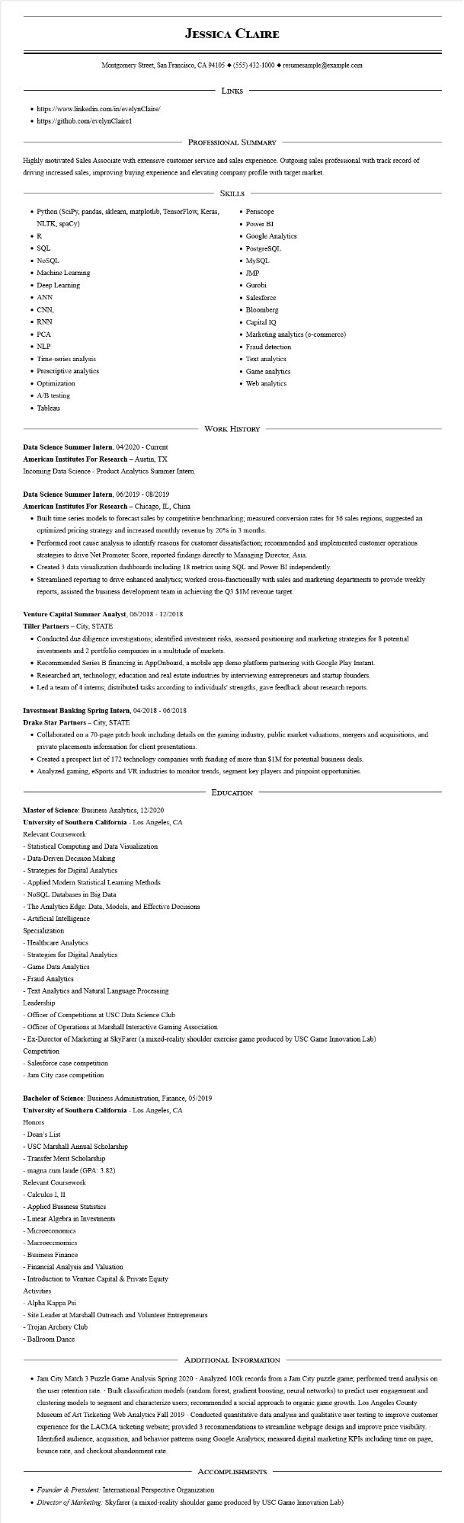

**JESSICA CLAIRE**

Montgomery Street, San Francisco, CA 94105 ♦ (555) 432-1000 resumesample@example.com

• https://www.linkedin.com/in/evelynClaire/

• https://github.com/evelynClaire1

LINKS

PROFESSIONAL SUMMARY

Highly motivated Sales Associate with extensive customer service and sales experience. Outgoing sales professional with track record of driving increased sales, improving buying experience and elevating company profile with target market.

• Periscope

SKILLS

• Python (SciPy, pandas, sklearn, matplotlib, TensorFlow, Keras,

NLTK, spaCy)

• R

• SQL

• NoSQL

• Machine Learning

• Deep Learning

• ANN

• CNN,

• RNN

• PCA

• NLP

• Time-series analysis

• Prescriptive analytics

• Optimization

• A/B testing

• Power BI

• Google Analytics

• PostgreSQL

• MySQL

• JMP

• Gurobi

• Salesforce

• Bloomberg

• Capital IQ

• Marketing analytics (e-commerce)

• Fraud detection

• Text analytics

• Game analytics

• Web analytics

• Tableau

Data Science Summer Intern, 04/2020 - Current

**American Institutes For Research - Austin, TX**

Incoming Data Science - Product Analytics Summer Intern.

WORK HISTORY

**Data Science Summer Intern, 06/2019-08/2019**

**American Institutes For Research - Chicago, IL, China**

• Built time series models to forecast sales by competitive benchmarking; measured conversion rates for 36 sales regions, suggested an optimized pricing strategy and increased monthly revenue by 20% in 3 months.

• Performed root cause analysis to identify reasons for customer dissatisfaction; recommended and implemented customer operations strategies to drive Net Promoter Score, reported findings directly to Managing Director, Asia.

• Created 3 data visualization dashboards including 18 metrics using SQL and Power BI independently.

• Streamlined reporting to drive enhanced analytics; worked cross-functionally with sales and marketing departments to provide weekly reports, assisted the business development team in achieving the Q3 $1M revenue target.

**Venture Capital Summer Analyst, 06/2018 - 12/2018**

**Tiller Partners - City, STATE**

• Conducted due diligence investigations; identified investment risks, assessed positioning and marketing strategies for 8 potential investments and 2 portfolio companies in a multitude of markets.

• Recommended Series B financing in AppOnboard, a mobile app demo platform partnering with Google Play Instant.

• Researched art, technology, education and real estate industries by interviewing entrepreneurs and startup founders.

• Led a team of 4 interns; distributed tasks according to individuals' strengths, gave feedback about research reports.

**Investment Banking Spring Intern, 04/2018 - 06/2018**

**Drake Star Partners - City, STATE**

• Collaborated on a 70-page pitch book including details on the gaming industry, public market valuations, mergers and acquisitions, and private placements information for client presentations.

• Created a prospect list of 172 technology companies with funding of more than $1M for potential business deals.

• Analyzed gaming, eSports and VR industries to monitor trends, segment key players and pinpoint opportunities.

EDUCATION

Master of Science: Business Analytics, 12/2020

**University of Southern California - Los Angeles, CA**

Relevant Coursework

- Statistical Computing and Data Visualization

-Data-Driven Decision Making

- Strategies for Digital Analytics

- Applied Modern Statistical Learning Methods

- NoSQL Databases in Big Data

- The Analytics Edge: Data, Models, and Effective Decisions

- Artificial Intelligence

Specialization

- Healthcare Analytics

- Strategies for Digital Analytics

- Game Data Analytics

- Fraud Analytics

- Text Analytics and Natural Language Processing

Leadership

- Officer of Competitions at USC Data Science Club

- Officer of Operations at Marshall Interactive Gaming Association

- Ex-Director of Marketing at SkyFarer (a mixed-reality shoulder exercise game produced by USC Game Innovation Lab)

Competition

- Salesforce case competition

- Jam City case competition

Bachelor of Science: Business Administration, Finance, 05/2019

**University of Southern California - Los Angeles, CA**

Honors

- Dean's List

- USC Marshall Annual Scholarship

- Transfer Merit Scholarship

- magna cum laude (GPA: 3.82)

Relevant Coursework

- Calculus I, II

- Applied Business Statistics

- Linear Algebra in Investments

- Microeconomics

- Macroeconomics

- Business Finance

- Financial Analysis and Valuation

- Introduction to Venture Capital & Private Equity

Activities

- Alpha Kappa Psi

-Site Leader at Marshall Outreach and Volunteer Entrepreneurs

- Trojan Archery Club

- Ballroom Dance

ADDITIONAL INFORMATION

• Jam City Match 3 Puzzle Game Analysis Spring 2020 - Analyzed 100k records from a Jam City puzzle game; performed trend analysis on the user retention rate. Built classification models (random forest, gradient boosting, neural networks) to predict user engagement and clustering models to segment and characterize users; recommended a social approach to organic game growth. Los Angeles County Museum of Art Ticketing Web Analytics Fall 2019 - Conducted quantitative data analysis and qualitative user testing to improve customer experience for the LACMA ticketing website; provided 3 recommendations to streamline webpage design and improve price visibility. - Identified audience, acquisition, and behavior patterns using Google Analytics; measured digital marketing KPIs including time on page, bounce rate, and checkout abandonment rate.

ACCOMPLISHMENTS

• Founder & President: International Perspective Organization

• Director of Marketing: Skyfarer (a mixed-reality shoulder game produced by USC Game Innovation Lab)