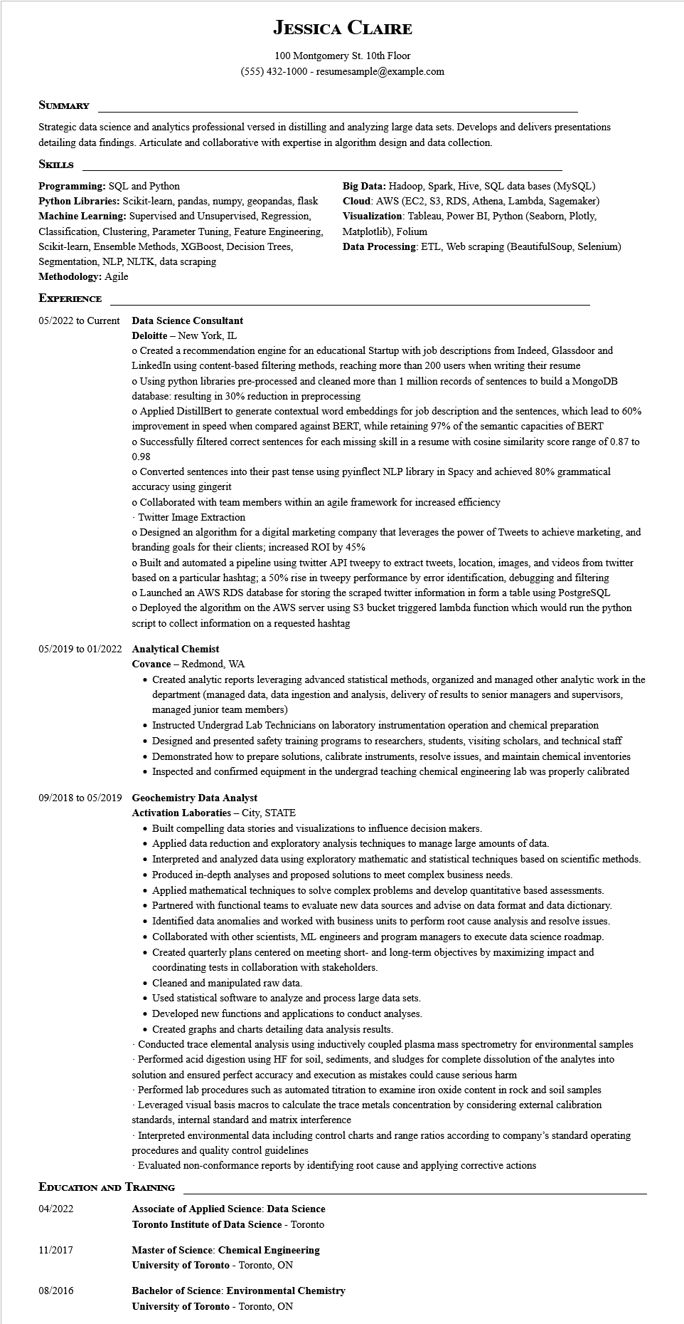

**JESSICA CLAIRE**

100 Montgomery St. 10th Floor (555) 432-1000 - resumesample@example.com

**SUMMARY**

Strategic data science and analytics professional versed in distilling and analyzing large data sets. Develops and delivers presentations detailing data findings. Articulate and collaborative with expertise in algorithm design and data collection.

**SKILLS**

**Programming: SQL and Python**

Python Libraries: Scikit-learn, pandas, numpy, geopandas, flask Machine Learning: Supervised and Unsupervised, Regression, Classification, Clustering, Parameter Tuning, Feature Engineering, Scikit-learn, Ensemble Methods, XGBoost, Decision Trees, Segmentation, NLP, NLTK, data scraping

**Methodology: Agile**

**EXPERIENCE**

Big Data: Hadoop, Spark, Hive, SQL data bases (MySQL) Cloud: AWS (EC2, S3, RDS, Athena, Lambda, Sagemaker) Visualization: Tableau, Power BI, Python (Seaborn, Plotly, Matplotlib), Folium

Data Processing: ETL, Web scraping (BeautifulSoup, Selenium)

05/2022 to Current

**Data Science Consultant**

**Deloitte - New York, IL**

o Created a recommendation engine for an educational Startup with job descriptions from Indeed, Glassdoor and LinkedIn using content-based filtering methods, reaching more than 200 users when writing their resume

o Using python libraries pre-processed and cleaned more than 1 million records of sentences to build a MongoDB database: resulting in 30% reduction in preprocessing

o Applied DistillBert to generate contextual word embeddings for job description and the sentences, which lead to 60% improvement in speed when compared against BERT, while retaining 97% of the semantic capacities of BERT

o Successfully filtered correct sentences for each missing skill in a resume with cosine similarity score range of 0.87 to 0.98

o Converted sentences into their past tense using pyinflect NLP library in Spacy and achieved 80% grammatical accuracy using gingerit

o Collaborated with team members within an agile framework for increased efficiency

-Twitter Image Extraction

o Designed an algorithm for a digital marketing company that leverages the power of Tweets to achieve marketing, and branding goals for their clients; increased ROI by 45%

o Built and automated a pipeline using twitter API tweepy to extract tweets, location, images, and videos from twitter based on a particular hashtag; a 50% rise in tweepy performance by error identification, debugging and filtering o Launched an AWS RDS database for storing the scraped twitter information in form a table using PostgreSQL

o Deployed the algorithm on the AWS server using S3 bucket triggered lambda function which would run the python script to collect information on a requested hashtag

05/2019 to 01/2022 Analytical Chemist

**Covance - Redmond, WA**

• Created analytic reports leveraging advanced statistical methods, organized and managed other analytic work in the department (managed data, data ingestion and analysis, delivery of results to senior managers and supervisors, managed junior team members)

• Instructed Undergrad Lab Technicians on laboratory instrumentation operation and chemical preparation

• Designed and presented safety training programs to researchers, students, visiting scholars, and technical staff

• Demonstrated how to prepare solutions, calibrate instruments, resolve issues, and maintain chemical inventories

• Inspected and confirmed equipment in the undergrad teaching chemical engineering lab was properly calibrated

**09/2018 to 05/2019 Geochemistry Data Analyst**

**Activation Laboraties - City, STATE**

• Built compelling data stories and visualizations to influence decision makers.

• Applied data reduction and exploratory analysis techniques to manage large amounts of data.

• Interpreted and analyzed data using exploratory mathematic and statistical techniques based on scientific methods.

• Produced in-depth analyses and proposed solutions to meet complex business needs.

• Applied mathematical techniques to solve complex problems and develop quantitative based assessments.

• Partnered with functional teams to evaluate new data sources and advise on data format and data dictionary.

• Identified data anomalies and worked with business units to perform root cause analysis and resolve issues.

• Collaborated with other scientists, ML engineers and program managers to execute data science roadmap.

• Created quarterly plans centered on meeting short- and long-term objectives by maximizing impact and coordinating tests in collaboration with stakeholders.

• Cleaned and manipulated raw data.

• Used statistical software to analyze and process large data sets.

• Developed new functions and applications to conduct analyses.

• Created graphs and charts detailing data analysis results.

Conducted trace elemental analysis using inductively coupled plasma mass spectrometry for environmental samples -Performed acid digestion using HF for soil, sediments, and sludges for complete dissolution of the analytes into solution and ensured perfect accuracy and execution as mistakes could cause serious harm

-Performed lab procedures such as automated titration to examine iron oxide content in rock and soil samples -Leveraged visual basis macros to calculate the trace metals concentration by considering external calibration standards, internal standard and matrix interference

- Interpreted environmental data including control charts and range ratios according to company's standard operating procedures and quality control guidelines

-Evaluated non-conformance reports by identifying root cause and applying corrective actions

**EDUCATION AND TRAINING**

04/2022

**Associate of Applied Science: Data Science**

**Toronto Institute of Data Science - Toronto**

11/2017

**Master of Science: Chemical Engineering**

**University of Toronto Toronto, ON**

08/2016

**Bachelor of Science: Environmental Chemistry University of Toronto - Toronto, ON**