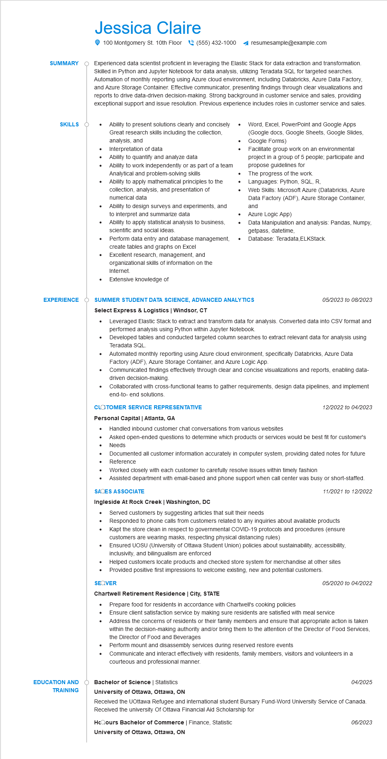

**SUMMARY**

**SKILLS O**

**EXPERIENCE**

Jessica Claire

100 Montgomery St. 10th Floor (555) 432-1000

resumesample@example.com

Experienced data scientist proficient in leveraging the Elastic Stack for data extraction and transformation. Skilled in Python and Jupyter Notebook for data analysis, utilizing Teradata SQL for targeted searches. Automation of monthly reporting using Azure cloud environment, including Databricks, Azure Data Factory, and Azure Storage Container. Effective communicator, presenting findings through clear visualizations and reports to drive data-driven decision-making. Strong background in customer service and sales, providing exceptional support and issue resolution. Previous experience includes roles in customer service and sales.

Ability to present solutions clearly and concisely Great research skills including the collection, analysis, and

Interpretation of data

Ability to quantify and analyze data

Ability to work independently or as part of a team Analytical and problem-solving skills

Ability to apply mathematical principles to the collection, analysis, and presentation of numerical data

Ability to design surveys and experiments, and to interpret and summarize data

Ability to apply statistical analysis to business, scientific and social ideas.

Perform data entry and database management,

create tables and graphs on Excel Excellent research, management, and organizational skills of information on the Internet.

• Extensive knowledge of

•

Word, Excel, PowerPoint and Google Apps (Google docs, Google Sheets, Google Slides, Google Forms)

Facilitate group work on an environmental

project in a group of 5 people; participate and propose guidelines for

The progress of the work.

Languages: Python, SQL, R,

Web Skills: Microsoft Azure (Databricks, Azure Data Factory (ADF), Azure Storage Container, and

Azure Logic App)

Data Manipulation and analysis: Pandas, Numpy, getpass, datetime,

• Database: Teradata, ELKStack.

**SUMMER STUDENT DATA SCIENCE, ADVANCED ANALYTICS**

**Select Express & Logistics | Windsor, CT**

*05/2023 to 08/2023*

• Leveraged Elastic Stack to extract and transform data for analysis. Converted data into CSV format and performed analysis using Python within Jupyter Notebook.

Developed tables and conducted targeted column searches to extract relevant data for analysis using Teradata SQL.

Automated monthly reporting using Azure cloud environment, specifically Databricks, Azure Data Factory (ADF), Azure Storage Container, and Azure Logic App.

Communicated findings effectively through clear and concise visualizations and reports, enabling data- driven decision-making.

Collaborated with cross-functional teams to gather requirements, design data pipelines, and implement end-to-end solutions.

**CLOTOMER SERVICE REPRESENTATIVE**

**Personal Capital | Atlanta, GA**

• Handled inbound customer chat conversations from various websites

•

12/2022 to 04/2023

Asked open-ended questions to determine which products or services would be best fit for customer's Needs

Documented all customer information accurately in computer system, providing dated notes for future Reference

Worked closely with each customer to carefully resolve issues within timely fashion

Assisted department with email-based and phone support when call center was busy or short-staffed.

**SACES ASSOCIATE**

**Ingleside At Rock Creek | Washington, DC**

*11/2021 to 12/2022*

•

Served customers by suggesting articles that suit their needs

• Responded to phone calls from customers related to any inquiries about available products

•

•

Kapt the store clean in respect to governmental COVID-19 protocols and procedures (ensure customers are wearing masks, respecting physical distancing rules)

Ensured UOSU (University of Ottawa Student Union) policies about sustainability, accessibility, inclusivity, and bilingualism are enforced

Helped customers locate products and checked store system for merchandise at other sites Provided positive first impressions to welcome existing, new and potential customers.

**SEQVER**

**Chartwell Retirement Residence | City, STATE**

05/2020 to 04/2022

Prepare food for residents in accordance with Chartwell's cooking policies

Ensure client satisfaction service by making sure residents are satisfied with meal service

Address the concerns of residents or their family members and ensure that appropriate action is taken

within the decision-making authority and/or bring them to the attention of the Director of Food Services, the Director of Food and Beverages

Perform mount and disassembly services during reserved restore events

Communicate and interact effectively with residents, family members, visitors and volunteers in a courteous and professional manner.

**EDUCATION AND TRAINING**

Bachelor of Science | Statistics

**University of Ottawa, Ottawa, ON**

04/2025

Received the UOttawa Refugee and international student Bursary Fund-Word University Service of Canada. Received the university Of Ottawa Financial Aid Scholarship for

**HcQours Bachelor of Commerce | Finance, Statistic**

**University of Ottawa, Ottawa, ON**

*06/2023*