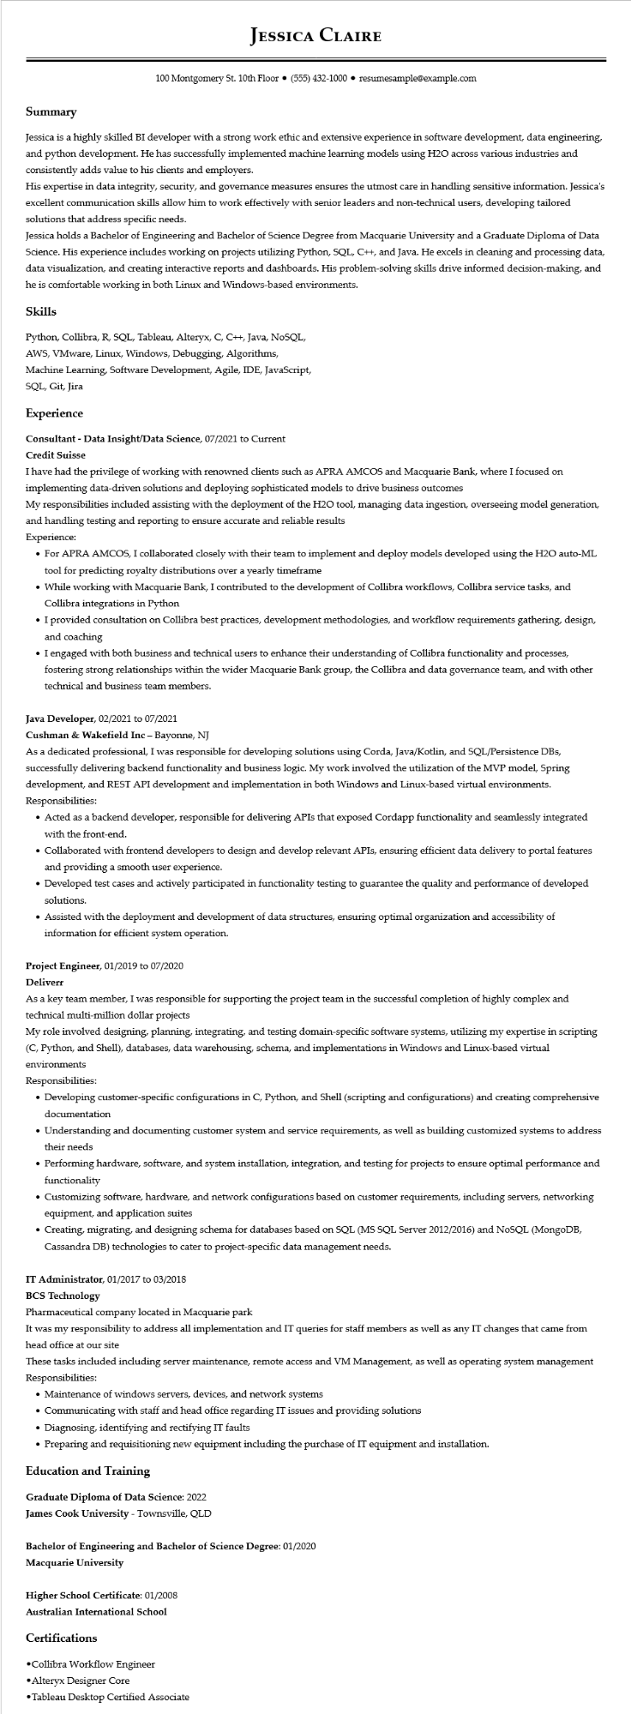

**JESSICA CLAIRE**

100 Montgomery St. 10th Floor ⚫ (555) 432-1000⚫ resumesample@example.com

Summary

Jessica is a highly skilled BI developer with a strong work ethic and extensive experience in software development, data engineering, and python development. He has successfully implemented machine learning models using H2O across various industries and consistently adds value to his clients and employers.

His expertise in data integrity, security, and governance measures ensures the utmost care in handling sensitive information. Jessica's excellent communication skills allow him to work effectively with senior leaders and non-technical users, developing tailored solutions that address specific needs.

Jessica holds a Bachelor of Engineering and Bachelor of Science Degree from Macquarie University and a Graduate Diploma of Data Science. His experience includes working on projects utilizing Python, SQL, C++, and Java. He excels in cleaning and processing data, data visualization, and creating interactive reports and dashboards. His problem-solving skills drive informed decision-making, and he is comfortable working in both Linux and Windows-based environments.

**Skills**

Python, Collibra, R, SQL, Tableau, Alteryx, C, C++, Java, NoSQL,

AWS, VMware, Linux, Windows, Debugging, Algorithms,

Machine Learning, Software Development, Agile, IDE, JavaScript, SQL, Git, Jira

**Experience**

**Consultant - Data Insight/Data Science, 07/2021 to Current**

**Credit Suisse**

I have had the privilege of working with renowned clients such as APRA AMCOS and Macquarie Bank, where I focused on implementing data-driven solutions and deploying sophisticated models to drive business outcomes

My responsibilities included assisting with the deployment of the H2O tool, managing data ingestion, overseeing model generation, and handling testing and reporting to ensure accurate and reliable results

Experience:

• For APRA AMCOS, I collaborated closely with their team to implement and deploy models developed using the H2O auto-ML tool for predicting royalty distributions over a yearly timeframe

• While working with Macquarie Bank, I contributed to the development of Collibra workflows, Collibra service tasks, and Collibra integrations in Python

• I provided consultation on Collibra best practices, development methodologies, and workflow requirements gathering, design, and coaching

• I engaged with both business and technical users to enhance their understanding of Collibra functionality and processes, fostering strong relationships within the wider Macquarie Bank group, the Collibra and data governance team, and with other technical and business team members.

Java Developer, 02/2021 to 07/2021

Cushman & Wakefield Inc - Bayonne, NJ

As a dedicated professional, I was responsible for developing solutions using Corda, Java/Kotlin, and SQL/Persistence DBs, successfully delivering backend functionality and business logic. My work involved the utilization of the MVP model, Spring development, and REST API development and implementation in both Windows and Linux-based virtual environments. Responsibilities:

• Acted as a backend developer, responsible for delivering APIs that exposed Cordapp functionality and seamlessly integrated with the front-end.

• Collaborated with frontend developers to design and develop relevant APIs, ensuring efficient data delivery to portal features and providing a smooth user experience.

• Developed test cases and actively participated in functionality testing to guarantee the quality and performance of developed solutions.

• Assisted with the deployment and development of data structures, ensuring optimal organization and accessibility of information for efficient system operation.

Project Engineer, 01/2019 to 07/2020

**Deliverr**

As a key team member, I was responsible for supporting the project team in the successful completion of highly complex and technical multi-million dollar projects

My role involved designing, planning, integrating, and testing domain-specific software systems, utilizing my expertise in scripting (C, Python, and Shell), databases, data warehousing, schema, and implementations in Windows and Linux-based virtual

environments

Responsibilities:

• Developing customer-specific configurations in C, Python, and Shell (scripting and configurations) and creating comprehensive documentation

• Understanding and documenting customer system and service requirements, as well as building customized systems to address their needs

• Performing hardware, software, and system installation, integration, and testing for projects to ensure optimal performance and functionality

• Customizing software, hardware, and network configurations based on customer requirements, including servers, networking equipment, and application suites

• Creating, migrating, and designing schema for databases based on SQL (MS SQL Server 2012/2016) and NoSQL (MongoDB, Cassandra DB) technologies to cater to project-specific data management needs.

**IT Administrator, 01/2017 to 03/2018**

BCS Technology

Pharmaceutical company located in Macquarie park

It was my responsibility to address all implementation and IT queries for staff members as well as any IT changes that came from head office at our site

These tasks included including server maintenance, remote access and VM Management, as well as operating system management Responsibilities:

• Maintenance of windows servers, devices, and network systems

• Communicating with staff and head office regarding IT issues and providing solutions

• Diagnosing, identifying and rectifying IT faults

• Preparing and requisitioning new equipment including the purchase of IT equipment and installation.

**Education and Training**

**Graduate Diploma of Data Science: 2022**

James Cook University - Townsville, QLD

**Bachelor of Engineering and Bachelor of Science Degree: 01/2020**

**Macquarie University**

**Higher School Certificate: 01/2008**

**Australian International School**

**Certifications**

•Collibra Workflow Engineer

•Alteryx Designer Core

•Tableau Desktop Certified Associate