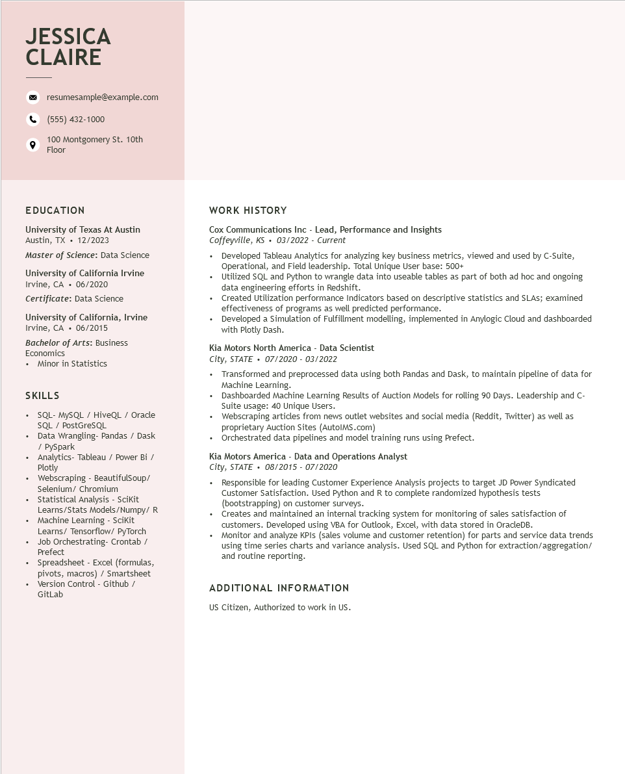

**JESSICA CLAIRE**

resumesample@example.com

(555) 432-1000

100 Montgomery St. 10th Floor

**EDUCATION**

University of Texas At Austin Austin, TX. 12/2023

Master of Science: Data Science

University of California Irvine Irvine, CA 06/2020 Certificate: Data Science

University of California, Irvine Irvine, CA. 06/2015

Bachelor of Arts: Business Economics

• Minor in Statistics

SKILLS

.

•

•

.

SQL- MySQL / HiveQL / Oracle

SQL / PostGreSQL

Data Wrangling- Pandas / Dask / PySpark

Analytics- Tableau / Power Bi / Plotly

Webscraping - BeautifulSoup/ Selenium/ Chromium

Statistical Analysis - Scikit

Learns/Stats Models/Numpy/ R

Machine Learning - Scikit

Learns/ Tensorflow/ PyTorch

• Job Orchestrating- Crontab / Prefect

Spreadsheet - Excel (formulas, pivots, macros) / Smartsheet

• Version Control - Github/ GitLab

**WORK HISTORY**

Cox Communications Inc - Lead, Performance and Insights Coffeyville, KS⚫ 03/2022 - Current

• Developed Tableau Analytics for analyzing key business metrics, viewed and used by C-Suite, Operational, and Field leadership. Total Unique User base: 500+

• Utilized SQL and Python to wrangle data into useable tables as part of both ad hoc and ongoing data engineering efforts in Redshift.

• Created Utilization performance Indicators based on descriptive statistics and SLAs; examined effectiveness of programs as well predicted performance.

• Developed a Simulation of Fulfillment modelling, implemented in Anylogic Cloud and dashboarded with Plotly Dash.

Kia Motors North America - Data Scientist

*City, STATE⚫ 07/2020 - 03/2022*

• Transformed and preprocessed data using both Pandas and Dask, to maintain pipeline of data for Machine Learning.

• Dashboarded Machine Learning Results of Auction Models for rolling 90 Days. Leadership and C- Suite usage: 40 Unique Users.

Webscraping articles from news outlet websites and social media (Reddit, Twitter) as well as proprietary Auction Sites (AutoIMS.com)

• Orchestrated data pipelines and model training runs using Prefect.

Kia Motors America - Data and Operations Analyst

*City, STATE 08/2015 - 07/2020*

• Responsible for leading Customer Experience Analysis projects to target JD Power Syndicated Customer Satisfaction. Used Python and R to complete randomized hypothesis tests (bootstrapping) on customer surveys.

Creates and maintained an internal tracking system for monitoring of sales satisfaction of customers. Developed using VBA for Outlook, Excel, with data stored in OracleDB.

• Monitor and analyze KPIs (sales volume and customer retention) for parts and service data trends using time series charts and variance analysis. Used SQL and Python for extraction/aggregation/ and routine reporting.

**ADDITIONAL INFORMATION**

US Citizen, Authorized to work in US.