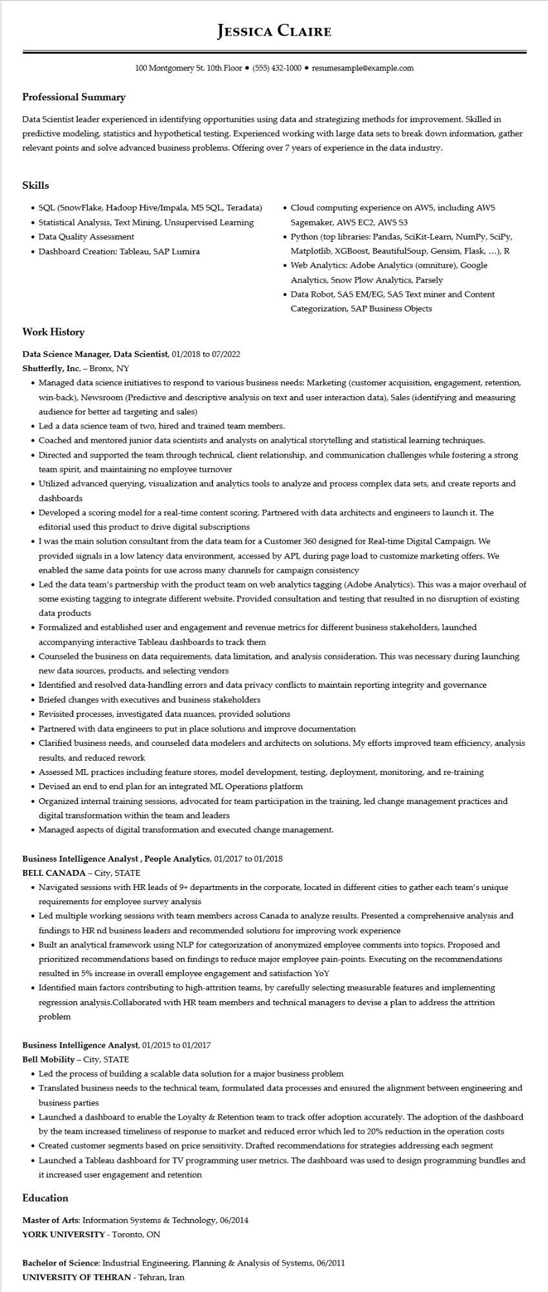

**Professional Summary**

**JESSICA CLAIRE**

100 Montgomery St. 10th Floor⚫ (555) 432-1000⚫ resumesample@example.com

Data Scientist leader experienced in identifying opportunities using data and strategizing methods for improvement. Skilled in predictive modeling, statistics and hypothetical testing. Experienced working with large data sets to break down information, gather relevant points and solve advanced business problems. Offering over 7 years of experience in the data industry.

**Skills**

• SQL (SnowFlake, Hadoop Hive/Impala, MS SQL, Teradata)

• Statistical Analysis, Text Mining, Unsupervised Learning • Data Quality Assessment

• Dashboard Creation: Tableau, SAP Lumira

• Cloud computing experience on AWS, including AWS Sagemaker, AWS EC2, AWS S3

• Python (top libraries: Pandas, Scikit-Learn, NumPy, SciPy, Matplotlib, XGBoost, BeautifulSoup, Gensim, Flask, ...), R

• Web Analytics: Adobe Analytics (omniture), Google Analytics, Snow Plow Analytics, Parsely

• Data Robot, SAS EM/EG, SAS Text miner and Content Categorization, SAP Business Objects

**Work History**

**Data Science Manager, Data Scientist, 01/2018 to 07/2022**

**Shutterfly, Inc. - Bronx, NY**

• Managed data science initiatives to respond to various business needs: Marketing (customer acquisition, engagement, retention, win-back), Newsroom (Predictive and descriptive analysis on text and user interaction data), Sales (identifying and measuring audience for better ad targeting and sales)

• Led a data science team of two, hired and trained team members.

• Coached and mentored junior data scientists and analysts on analytical storytelling and statistical learning techniques.

• Directed and supported the team through technical, client relationship, and communication challenges while fostering a strong team spirit, and maintaining no employee turnover

• Utilized advanced querying, visualization and analytics tools to analyze and process complex data sets, and create reports and dashboards

• Developed a scoring model for a real-time content scoring. Partnered with data architects and engineers to launch it. The editorial used this product to drive digital subscriptions

• I was the main solution consultant from the data team for a Customer 360 designed for Real-time Digital Campaign. We provided signals in a low latency data environment, accessed by API, during page load to customize marketing offers. We enabled the same data points for use across many channels for campaign consistency

• Led the data team's partnership with the product team on web analytics tagging (Adobe Analytics). This was a major overhaul of some existing tagging to integrate different website. Provided consultation and testing that resulted in no disruption of existing data products

• Formalized and established user and engagement and revenue metrics for different business stakeholders, launched accompanying interactive Tableau dashboards to track them

• Counseled the business on data requirements, data limitation, and analysis consideration. This was necessary during launching new data sources, products, and selecting vendors

• Identified and resolved data-handling errors and data privacy conflicts to maintain reporting integrity and governance

• Briefed changes with executives and business stakeholders

• Revisited processes, investigated data nuances, provided solutions

• Partnered with data engineers to put in place solutions and improve documentation

• Clarified business needs, and counseled data modelers and architects on solutions. My efforts improved team efficiency, analysis results, and reduced rework

• Assessed ML practices including feature stores, model development, testing, deployment, monitoring, and re-training

• Devised an end to end plan for an integrated ML Operations platform

• Organized internal training sessions, advocated for team participation in the training, led change management practices and digital transformation within the team and leaders

• Managed aspects of digital transformation and executed change management.

**Business Intelligence Analyst, People Analytics, 01/2017 to 01/2018**

**BELL CANADA - City, STATE**

• Navigated sessions with HR leads of 9+ departments in the corporate, located in different cities to gather each team's unique requirements for employee survey analysis

• Led multiple working sessions with team members across Canada to analyze results. Presented a comprehensive analysis and findings to HR nd business leaders and recommended solutions for improving work experience

• Built an analytical framework using NLP for categorization of anonymized employee comments into topics. Proposed and

prioritized recommendations based on findings to reduce major employee pain-points. Executing on the recommendations resulted in 5% increase in overall employee engagement and satisfaction YoY

• Identified main factors contributing to high-attrition teams, by carefully selecting measurable features and implementing regression analysis.Collaborated with HR team members and technical managers to devise a plan to address the attrition problem

**Business Intelligence Analyst, 01/2015 to 01/2017**

**Bell Mobility - City, STATE**

• Led the process of building a scalable data solution for a major business problem

• Translated business needs to the technical team, formulated data processes and ensured the alignment between engineering and business parties

• Launched a dashboard to enable the Loyalty & Retention team to track offer adoption accurately. The adoption of the dashboard by the team increased timeliness of response to market and reduced error which led to 20% reduction in the operation costs

• Created customer segments based on price sensitivity. Drafted recommendations for strategies addressing each segment

• Launched a Tableau dashboard for TV programming user metrics. The dashboard was used to design programming bundles and it increased user engagement and retention

**Education**

Master of Arts: Information Systems & Technology, 06/2014

**YORK UNIVERSITY - Toronto, ON**

Bachelor of Science: Industrial Engineering, Planning & Analysis of Systems, 06/2011

UNIVERSITY OF TEHRAN - Tehran, Iran