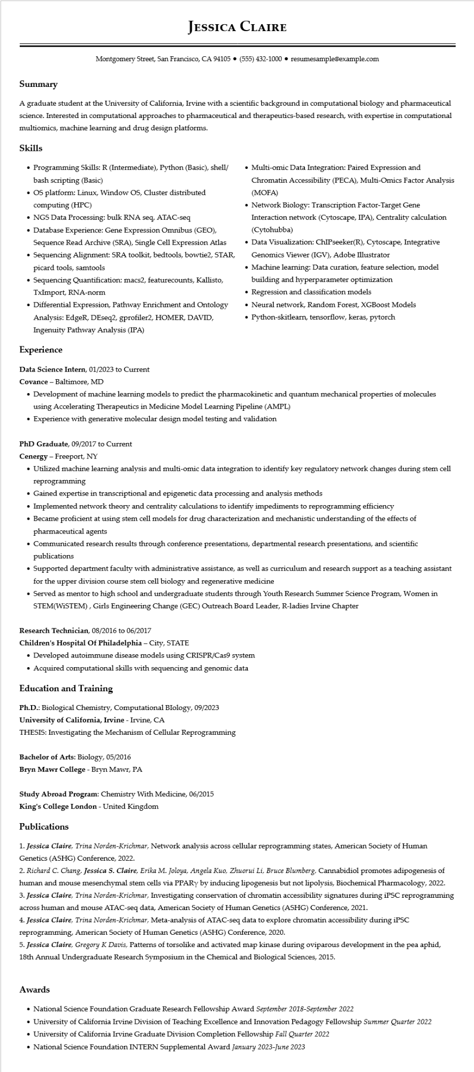

**JESSICA CLAIRE**

Montgomery Street, San Francisco, CA 94105 ⚫ (555) 432-1000⚫ resumesample@example.com

**Summary**

A graduate student at the University of California, Irvine with a scientific background in computational biology and pharmaceutical science. Interested in computational approaches to pharmaceutical and therapeutics-based research, with expertise in computational multiomics, machine learning and drug design platforms.

**Skills**

• Programming Skills: R (Intermediate), Python (Basic), shell/ bash scripting (Basic)

• OS platform: Linux, Window OS, Cluster distributed computing (HPC)

•NGS Data Processing: bulk RNA seq, ATAC-seq

• Database Experience: Gene Expression Omnibus (GEO), Sequence Read Archive (SRA), Single Cell Expression Atlas

• Sequencing Alignment: SRA toolkit, bedtools, bowtie2, STAR, picard tools, samtools

• Sequencing Quantification: macs2, featurecounts, Kallisto, TxImport, RNA-norm

• Differential Expression, Pathway Enrichment and Ontology Analysis: EdgeR, DEseq2, gprofiler2, HOMER, DAVID, Ingenuity Pathway Analysis (IPA)

**Experience**

Data Science Intern, 01/2023 to Current

Covance - Baltimore, MD

• Multi-omic Data Integration: Paired Expression and

Chromatin Accessibility (PECA), Multi-Omics Factor Analysis (MOFA)

• Network Biology: Transcription Factor-Target Gene Interaction network (Cytoscape, IPA), Centrality calculation (Cytohubba)

• Data Visualization: ChIPseeker(R), Cytoscape, Integrative Genomics Viewer (IGV), Adobe Illustrator

• Machine learning: Data curation, feature selection, model building and hyperparameter optimization

Regression and classification models

• Neural network, Random Forest, XGBoost Models

• Python-skitlearn, tensorflow, keras, pytorch

• Development of machine learning models to predict the pharmacokinetic and quantum mechanical properties of molecules using Accelerating Therapeutics in Medicine Model Learning Pipeline (AMPL)

• Experience with generative molecular design model testing and validation

PhD Graduate, 09/2017 to Current

Cenergy - Freeport, NY

• Utilized machine learning analysis and multi-omic data integration to identify key regulatory network changes during stem cell reprogramming

• Gained expertise in transcriptional and epigenetic data processing and analysis methods

• Implemented network theory and centrality calculations to identify impediments to reprogramming efficiency

• Became proficient at using stem cell models for drug characterization and mechanistic understanding of the effects of pharmaceutical agents

• Communicated research results through conference presentations, departmental research presentations, and scientific publications

• Supported department faculty with administrative assistance, as well as curriculum and research support as a teaching assistant for the upper division course stem cell biology and regenerative medicine

• Served as mentor to high school and undergraduate students through Youth Research Summer Science Program, Women in STEM(WISTEM), Girls Engineering Change (GEC) Outreach Board Leader, R-ladies Irvine Chapter

Research Technician, 08/2016 to 06/2017

**Children's Hospital Of Philadelphia - City, STATE**

• Developed autoimmune disease models using CRISPR/Cas9 system

• Acquired computational skills with sequencing and genomic data

**Education and Training**

Ph.D.: Biological Chemistry, Computational Biology, 09/2023

University of California, Irvine - Irvine, CA

THESIS: Investigating the Mechanism of Cellular Reprogramming

Bachelor of Arts: Biology, 05/2016

**Bryn Mawr College - Bryn Mawr, PA**

**Study Abroad Program: Chemistry With Medicine, 06/2015**

**King's College London - United Kingdom**

**Publications**

1. Jessica Claire, Trina Norden-Krichmar, Network analysis across cellular reprogramming states, American Society of Human Genetics (ASHG) Conference, 2022.

2. Richard C. Chang, Jessica S. Claire, Erika M. Joloya, Angela Kuo, Zhuorui Li, Bruce Blumberg, Cannabidiol promotes adipogenesis of human and mouse mesenchymal stem cells via PPARY by inducing lipogenesis but not lipolysis, Biochemical Pharmacology, 2022. 3. Jessica Claire, Trina Norden-Krichmar, Investigating conservation of chromatin accessibility signatures during iPSC reprogramming across human and mouse ATAC-seq data, American Society of Human Genetics (ASHG) Conference, 2021.

4. Jessica Claire, Trina Norden-Krichmar, Meta-analysis of ATAC-seq data to explore chromatin accessibility during iPSC reprogramming, American Society of Human Genetics (ASHG) Conference, 2020.

5. Jessica Claire, Gregory K Davis, Patterns of torsolike and activated map kinase during oviparous development in the pea aphid, 18th Annual Undergraduate Research Symposium in the Chemical and Biological Sciences, 2015.

**Awards**

• National Science Foundation Graduate Research Fellowship Award September 2018-September 2022

• University of California Irvine Division of Teaching Excellence and Innovation Pedagogy Fellowship Summer Quarter 2022

• University of California Irvine Graduate Division Completion Fellowship Fall Quarter 2022

• National Science Foundation INTERN Supplemental Award January 2023-June 2023