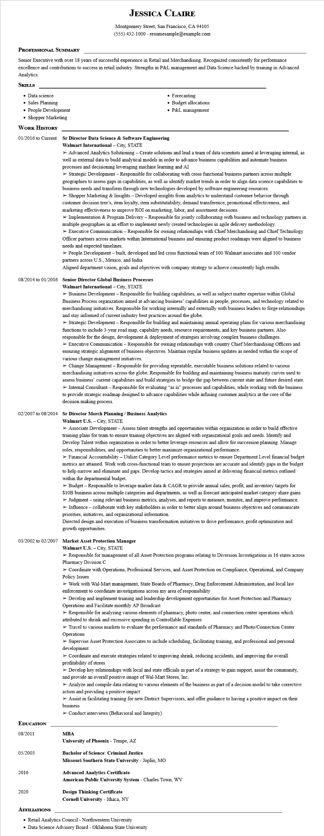

**JESSICA CLAIRE**

Montgomery Street, San Francisco, CA 94105

(555) 432-1000 - resumesample@example.com

**PROFESSIONAL SUMMARY**

Senior Executive with over 18 years of successful experience in Retail and Merchandising. Recognized consistently for performance excellence and contributions to success in retail industry. Strengths in P&L management and Data Science backed by training in Advanced Analytics.

**SKILLS**

• Data science

Sales Planning

• People Development

• Shopper Marketing

**WORK HISTORY**

• Forecasting

• Budget allocations

• P&L management

**01/2016 to Current Sr Director Data Science & Software Engineering Walmart International City, STATE**

➤ Advanced Analytics Solutioning - Create solutions and lead a team of data scientists aimed at leveraging internal, as well as external data to build analytical models in order to advance business capabilities and automate business processes and decisioning leveraging machine learning and AI

➤ Strategic Development - Responsible for collaborating with cross functional business partners across multiple geographies to assess gaps in capabilities, as well as identify market trends in order to align data science capabilities to business needs and transform through new technologies developed by software engineering resources.

➤ Shopper Marketing & Insights - Developed insights from analytics to understand customer behavior through customer decision tree's, item loyalty, item substitutability, demand transference, promotional effectiveness, and marketing effectiveness to improve ROI on marketing, labor, and assortment decisions

➤ Implementation & Program Delivery - Responsible for jointly collaborating with business and technology partners in multiple geographies in an effort to implement newly created technologies in agile delivery methodology.

> Executive Communication - Responsible for owning relationships with Chief Merchandising and Chief Technology

Officer partners across markets within International business and ensuring product roadmaps were aligned to business needs and expected timelines.

➤ People Development - built, developed and led cross functional team of 100 Walmart associates and 100 vendor partners across U.S., Mexico, and India

Aligned department vision, goals and objectives with company strategy to achieve consistently high results.

**08/2014 to 01/2016 Senior Director Global Business Processes**

**Walmart International - City, STATE**

➤ Business Development - Responsible for building capabilities, as well as subject matter expertise within Global Business Process organization aimed at advancing business' capabilities in people, processes, and technology related to merchandising initiatives. Responsible for working internally and externally with business leaders to forge relationships and stay informed of current industry best practices around the globe.

➤ Strategic Development - Responsible for building and maintaining annual operating plans for various merchandising functions to include 3-year road map, capability needs, resource requirements, and key business partners. Also responsible for the design, development & deployment of strategies involving complex business challenges.

> Executive Communication - Responsible for owning relationships with country Chief Merchandising Officers and ensuring strategic alignment of business objectives. Maintain regular business updates as needed within the scope of various change management initiatives.

➤ Change Management - Responsible for providing repeatable, executable business solutions related to various merchandising initiatives across the globe. Responsible for building and maintaining business maturity curves used to assess business' current capabilities and build strategies to bridge the gap between current state and future desired state. ➤ Internal Consultant - Responsible for evaluating "as is" processes and capabilities, while working with the business to provide strategic roadmap designed to advance capabilities while infusing customer analytics at the core of the decision making process.

**02/2007 to 08/2014 Sr Director Merch Planning/Business Analytics**

Walmart U.S. - City, STATE

➤ Associate Development - Assess talent strengths and opportunities within organization in order to build effective training plans for team to ensure training objectives are aligned with organizational goals and needs. Identify and Develop Talent within organization in order to better leverage resources and allow for succession planning. Manage roles, responsibilities, and opportunities to better maximize organizational performance.

➤ Financial Accountability - Utilize Category Level performance metrics to ensure Department Level financial budget metrics are attained. Work with cross-functional team to ensure projections are accurate and identify gaps in the budget to help narrow and eliminate and gaps. Develop tactics and strategies aimed at delivering financial metrics outlined within the departmental budget.

> Budget - Responsible to leverage market data & CAGR to provide annual sales, profit, and inventory targets for $10B business across multiple categories and departments, as well as forecast anticipated market category share gains ➤ Judgment - using relevant business metrics, analyses, and reports to measure, monitor, and improve performance. ➤ Influence - collaborate with key stakeholders in order to better align around business objectives and communicate priorities, initiatives, and organizational information.

Directed design and execution of business transformation initiatives to drive performance, profit optimization and growth opportunities.

**03/2002 to 02/2007 Market Asset Protection Manager**

**EDUCATION**

Walmart U.S.-City, STATE

> Responsible for management of all Asset Protection programs relating to Diversion Investigations in 16 states across Pharmacy Division C

> Coordinate with Operations, Professional Services, and Asset Protection on Compliance, Operational, and Company Policy Issues

➤ Work with Wal-Mart management, State Boards of Pharmacy, Drug Enforcement Administration, and local law enforcement to coordinate investigations across my area of responsibility

➤ Develop and implement training and leadership development opportunities for Asset Protection and Pharmacy Operations and Facilitate monthly AP Broadcast

> Responsible for analyzing various elements of pharmacy, photo center, and connection center operations which attributed to shrink and excessive spending in Controllable Expenses

➤ Travel to various markets to evaluate the performance and standards of Pharmacy and Photo/Connection Center Operations

➤ Supervise Asset Protection Associates to include scheduling, facilitating training, and professional and personal development

> Coordinate and execute strategies related to improving shrink, reducing accidents, and improving the overall profitability of stores

➤ Develop key relationships with local and state officials as part of a strategy to gain support, assist the community, and provide an overall positive image of Wal-Mart Stores, Inc.

➤ Analyze and compile data relating to various elements of the business as part of a decision model to take corrective action and providing a positive impact

➤ Assist in facilitating training for new District Supervisors, and offer guidance to having a positive impact on their business

➤ Conduct interviews (Behavioral and Integrity)

08/2011

**MBA**

**University of Phoenix - Tempe, AZ**

05/2003

**Bachelor of Science: Criminal Justice**

**Missouri Southern State University - Joplin, MO**

2016

**Advanced Analytics Certificate**

American Public University System - Charles Town, WV

2020

**Design Thinking Certificate**

**Cornell University - Ithaca, NY**

**AFFILIATIONS**

• Retail Analytics Council - Northwestern University

• Data Science Advisory Board - Oklahoma State University