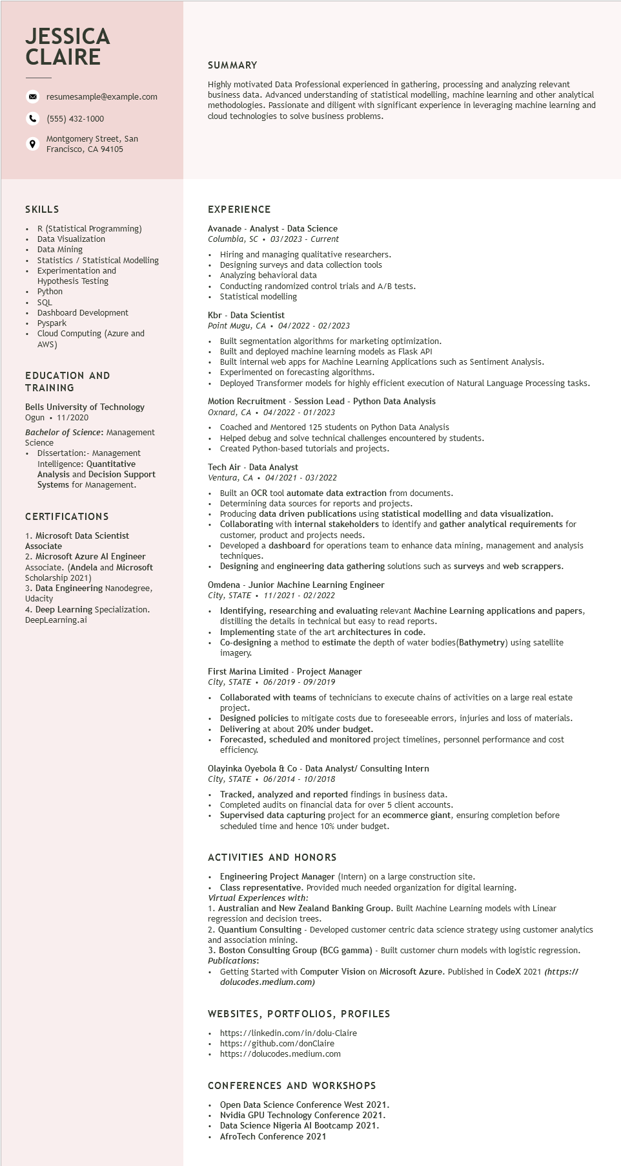

**JESSICA CLAIRE**

9

resumesample@example.com

(555) 432-1000

Montgomery Street, San Francisco, CA 94105

SUMMARY

Highly motivated Data Professional experienced in gathering, processing and analyzing relevant business data. Advanced understanding of statistical modelling, machine learning and other analytical methodologies. Passionate and diligent with significant experience in leveraging machine learning and cloud technologies to solve business problems.

**SKILLS**

R (Statistical Programming)

Data Visualization

Data Mining

Statistics / Statistical Modelling

Experimentation and

Hypothesis Testing

Python

SQL

Dashboard Development

• Pyspark

Cloud Computing (Azure and AWS)

EDUCATION AND TRAINING

Bells University of Technology Ogun. 11/2020

Bachelor of Science: Management Science

• Dissertation:- Management Intelligence: Quantitative

Analysis and Decision Support Systems for Management.

CERTIFICATIONS

1. Microsoft Data Scientist Associate

2. Microsoft Azure Al Engineer Associate. (Andela and Microsoft Scholarship 2021)

3. Data Engineering Nanodegree, Udacity

4. Deep Learning Specialization. DeepLearning.ai

EXPERIENCE

Avanade - Analyst - Data Science Columbia, SC

03/2023 - Current

• Hiring and managing qualitative researchers. Designing surveys and data collection tools Analyzing behavioral data

• Conducting randomized control trials and A/B tests. Statistical modelling

Kbr - Data Scientist

Point Mugu, CA. 04/2022- 02/2023

Built segmentation algorithms for marketing optimization.

Built and deployed machine learning models as Flask API

Built internal web apps for Machine Learning Applications such as Sentiment Analysis.

Experimented on forecasting algorithms.

Deployed Transformer models for highly efficient execution of Natural Language Processing tasks.

Motion Recruitment - Session Lead - Python Data Analysis

Oxnard, CA. 04/2022 - 01/2023

Coached and Mentored 125 students on Python Data Analysis

• Helped debug and solve technical challenges encountered by students.

Created Python-based tutorials and projects.

Tech Air - Data Analyst

Ventura, CA. 04/2021 - 03/2022

Built an OCR tool automate data extraction from documents.

• Determining data sources for reports and projects.

• Producing data driven publications using statistical modelling and data visualization.

• Collaborating with internal stakeholders to identify and gather analytical requirements for customer, product and projects needs.

Developed a dashboard for operations team to enhance data mining, management and analysis techniques.

Designing and engineering data gathering solutions such as surveys and web scrappers.

Omdena - Junior Machine Learning Engineer

*City, STATE*

*11/2021 - 02/2022*

Identifying, researching and evaluating relevant Machine Learning applications and papers, distilling the details in technical but easy read reports.

Implementing state of the art architectures in code.

Co-designing a method to estimate the depth of water bodies (Bathymetry) using satellite imagery.

First Marina Limited - Project Manager

*City, STATE. 06/2019 - 09/2019*

.

Collaborated with teams of technicians to execute chains of activities on a large real estate project.

Designed policies to mitigate costs due to foreseeable errors, injuries and loss of materials. Delivering at about 20% under budget.

Forecasted, scheduled and monitored project timelines, personnel performance and cost efficiency.

Olayinka Oyebola & Co - Data Analyst/ Consulting Intern

*City, STATE. 06/2014 - 10/2018*

Tracked, analyzed and reported findings in business data.

Completed audits on financial data for over 5 client accounts.

Supervised data capturing project for an ecommerce giant, ensuring completion before scheduled time and hence 10% under budget.

ACTIVITIES AND HONORS

• Engineering Project Manager (Intern) on a large construction site.

Class representative. Provided much needed organization for digital learning.

*Virtual Experiences with:*

1. Australian and New Zealand Banking Group. Built Machine Learning models with Linear regression and decision trees.

2. Quantium Consulting - Developed customer centric data science strategy using customer analytics and association mining.

3. Boston Consulting Group (BCG gamma) - Built customer churn models with logistic regression. Publications:

• Getting Started with Computer Vision on Microsoft Azure. Published in CodeX 2021 (https:// dolucodes.medium.com)

**WEBSITES, PORTFOLIOS, PROFILES**

https://linkedin.com/in/dolu-Claire

https://github.com/donClaire

https://dolucodes.medium.com

CONFERENCES AND WORKSHOPS

Open Data Science Conference West 2021. Nvidia GPU Technology Conference 2021. Data Science Nigeria Al Bootcamp 2021. AfroTech Conference 2021