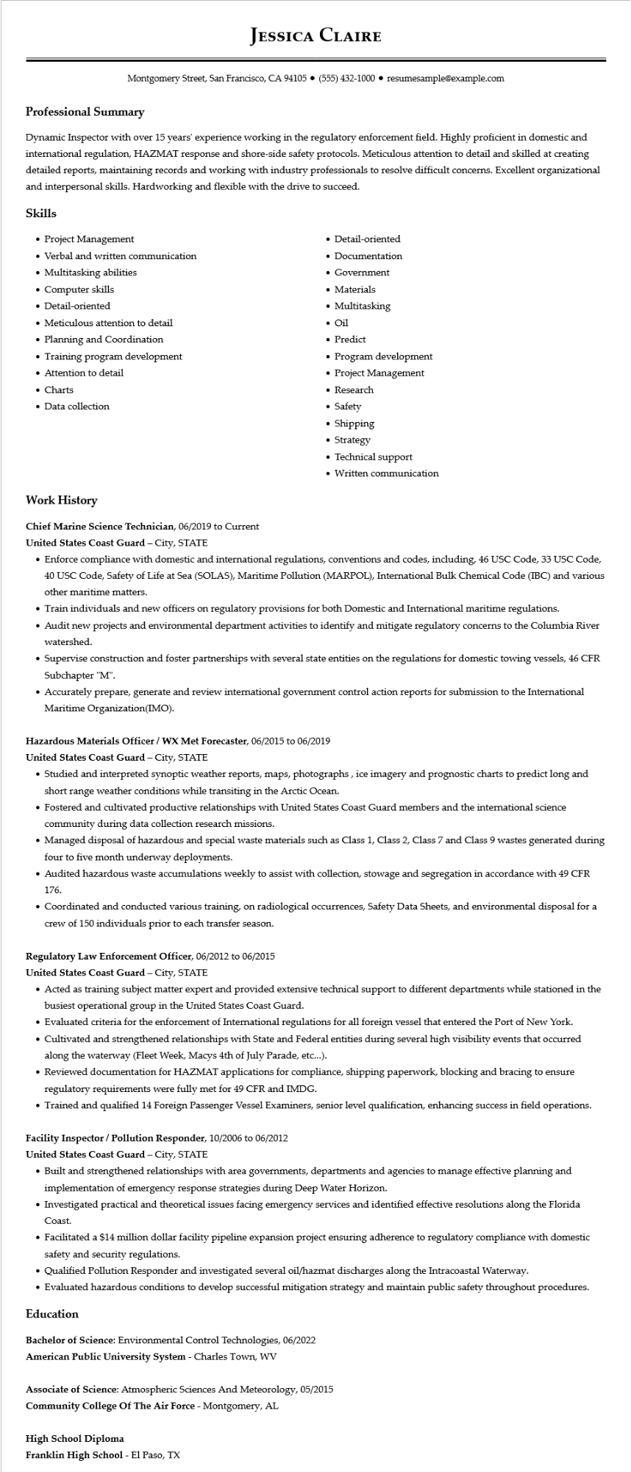

**JESSICA CLAIRE**

Montgomery Street, San Francisco, CA 94105 ⚫ (555) 432-1000⚫ resumesample@example.com

**Professional Summary**

Dynamic Inspector with over 15 years' experience working in the regulatory enforcement field. Highly proficient in domestic and international regulation, HAZMAT response and shore-side safety protocols. Meticulous attention to detail and skilled at creating detailed reports, maintaining records and working with industry professionals to resolve difficult concerns. Excellent organizational and interpersonal skills. Hardworking and flexible with the drive to succeed.

**Skills**

• Project Management

• Verbal and written communication

• Multitasking abilities

• Computer skills

• Detail-oriented

• Meticulous attention to detail

• Planning and Coordination

• Training program development

• Attention to detail

• Charts

• Data collection

• Detail-oriented

• Documentation

• Government

• Materials

• Multitasking

• Oil

• Predict

• Program development

• Project Management

• Research

• Safety

• Shipping

• Strategy

• Technical support

• Written communication

**Work History**

**Chief Marine Science Technician, 06/2019 to Current**

**United States Coast Guard - City, STATE**

• Enforce compliance with domestic and international regulations, conventions and codes, including, 46 USC Code, 33 USC Code, 40 USC Code, Safety of Life at Sea (SOLAS), Maritime Pollution (MARPOL), International Bulk Chemical Code (IBC) and various other maritime matters.

• Train individuals and new officers on regulatory provisions for both Domestic and International maritime regulations.

• Audit new projects and environmental department activities to identify and mitigate regulatory concerns to the Columbia River watershed.

• Supervise construction and foster partnerships with several state entities on the regulations for domestic towing vessels, 46 CFR Subchapter "M".

• Accurately prepare, generate and review international government control action reports for submission to the International Maritime Organization(IMO).

**Hazardous Materials Officer/WX Met Forecaster, 06/2015 to 06/2019**

United States Coast Guard - City, STATE

• Studied and interpreted synoptic weather reports, maps, photographs, ice imagery and prognostic charts to predict long and short range weather conditions while transiting in the Arctic Ocean.

• Fostered and cultivated productive relationships with United States Coast Guard members and the international science community during data collection research missions.

• Managed disposal of hazardous and special waste materials such as Class 1, Class 2, Class 7 and Class 9 wastes generated during four to five month underway deployments.

• Audited hazardous waste accumulations weekly to assist with collection, stowage and segregation in accordance with 49 CFR 176.

• Coordinated and conducted various training, on radiological occurrences, Safety Data Sheets, and environmental disposal for a crew of 150 individuals prior to each transfer season.

**Regulatory Law Enforcement Officer, 06/2012 to 06/2015**

United States Coast Guard - City, STATE

• Acted as training subject matter expert and provided extensive technical support to different departments while stationed in the busiest operational group in the United States Coast Guard.

• Evaluated criteria for the enforcement of International regulations for all foreign vessel that entered the Port of New York.

• Cultivated and strengthened relationships with State and Federal entities during several high visibility events that occurred along the waterway (Fleet Week, Macys 4th of July Parade, etc...).

• Reviewed documentation for HAZMAT applications for compliance, shipping paperwork, blocking and bracing to ensure regulatory requirements were fully met for 49 CFR and IMDG.

• Trained and qualified 14 Foreign Passenger Vessel Examiners, senior level qualification, enhancing success in field operations.

**Facility Inspector / Pollution Responder, 10/2006 to 06/2012**

**United States Coast Guard - City, STATE**

• Built and strengthened relationships with area governments, departments and agencies to manage effective planning and implementation of emergency response strategies during Deep Water Horizon.

• Investigated practical and theoretical issues facing emergency services and identified effective resolutions along the Florida Coast.

• Facilitated a $14 million dollar facility pipeline expansion project ensuring adherence to regulatory compliance with domestic safety and security regulations.

• Qualified Pollution Responder and investigated several oil/hazmat discharges along the Intracoastal Waterway.

• Evaluated hazardous conditions to develop successful mitigation strategy and maintain public safety throughout procedures.

**Education**

Bachelor of Science: Environmental Control Technologies, 06/2022

**American Public University System - Charles Town, WV**

Associate of Science: Atmospheric Sciences And Meteorology, 05/2015

**Community College Of The Air Force - Montgomery, AL**

**High School Diploma**

**Franklin High School - El Paso, TX**