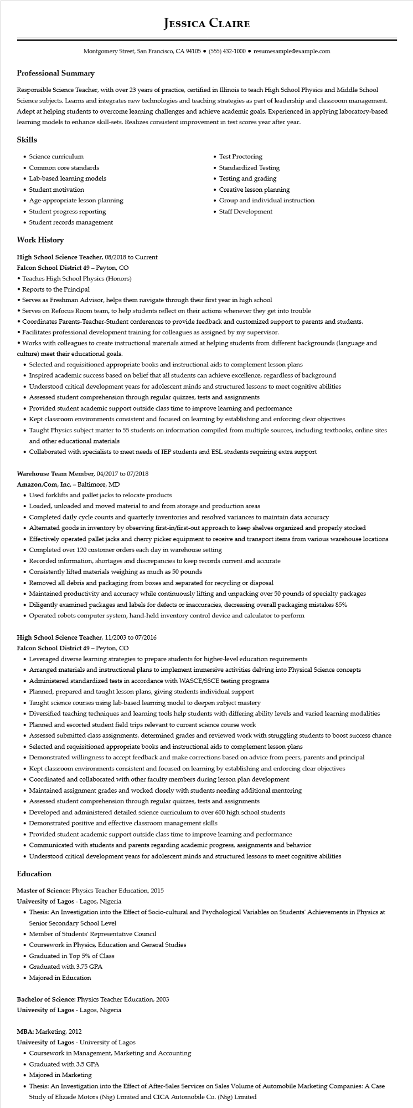

**JESSICA CLAIRE**

Montgomery Street, San Francisco, CA 94105⚫ (555) 432-1000⚫ resumesample@example.com

**Professional Summary**

Responsible Science Teacher, with over 23 years of practice, certified in Illinois to teach High School Physics and Middle School Science subjects. Learns and integrates new technologies and teaching strategies as part of leadership and classroom management. Adept at helping students to overcome learning challenges and achieve academic goals. Experienced in applying laboratory-based learning models to enhance skill-sets. Realizes consistent improvement in test scores year after year.

**Skills**

• Science curriculum

• Common core standards

• Lab-based learning models

• Student motivation

• Age-appropriate lesson planning

• Student progress reporting

• Student records management

**Work History**

High School Science Teacher, 08/2018 to Current

Falcon School District 49 - Peyton, CO

• Teaches High School Physics (Honors)

• Reports to the Principal

• Test Proctoring

• Standardized Testing

• Testing and grading

• Creative lesson planning

• Group and individual instruction

• Staff Development

• Serves as Freshman Advisor, helps them navigate through their first year in high school

• Serves on Refocus Room team, to help students reflect on their actions whenever they get into trouble

• Coordinates Parents-Teacher-Student conferences to provide feedback and customized support to parents and students.

• Facilitates professional development training for colleagues as assigned by my supervisor.

• Works with colleagues to create instructional materials aimed at helping students from different backgrounds (language and culture) meet their educational goals.

• Selected and requisitioned appropriate books and instructional aids to complement lesson plans

• Inspired academic success based on belief that all students can achieve excellence, regardless of background

• Understood critical development years for adolescent minds and structured lessons to meet cognitive abilities

• Assessed student comprehension through regular quizzes, tests and assignments

• Provided student academic support outside class time to improve learning and performance

• Kept classroom environments consistent and focused on learning by establishing and enforcing clear objectives

• Taught Physics subject matter to 55 students on information compiled from multiple sources, including textbooks, online sites and other educational materials

• Collaborated with specialists to meet needs of IEP students and ESL students requiring extra support

Warehouse Team Member, 04/2017 to 07/2018

Amazon.com, Inc. - Baltimore, MD

• Used forklifts and pallet jacks to relocate products

• Loaded, unloaded and moved material to and from storage and production areas

• Completed daily cycle counts and quarterly inventories and resolved variances to maintain data accuracy

• Alternated goods in inventory by observing first-in/first-out approach to keep shelves organized and properly stocked

• Effectively operated pallet jacks and cherry picker equipment to receive and transport items from various warehouse locations

·

Completed over 120 customer orders each day in warehouse setting

• Recorded information, shortages and discrepancies to keep records current and accurate

• Consistently lifted materials weighing as much as 50 pounds

• Removed all debris and packaging from boxes and separated for recycling or disposal

• Maintained productivity and accuracy while continuously lifting and unpacking over 50 pounds of specialty packages

• Diligently examined packages and labels for defects or inaccuracies, decreasing overall packaging mistakes 85%

Operated robots computer system, hand-held inventory control device and calculator to perform

High School Science Teacher, 11/2003 to 07/2016

Falcon School District 49 - Peyton, CO

• Leveraged diverse learning strategies to prepare students for higher-level education requirements

• Arranged materials and instructional plans to implement immersive activities delving into Physical Science concepts

• Administered standardized tests in accordance with WASCE/SSCE testing programs

• Planned, prepared and taught lesson plans, giving students individual support

• Taught science courses using lab-based learning model to deepen subject mastery

• Diversified teaching techniques and learning tools help students with differing ability levels and varied learning modalities

• Planned and escorted student field trips relevant to current science course work

• Assessed submitted class assignments, determined grades and reviewed work with struggling students to boost success chance

• Selected and requisitioned appropriate books and instructional aids to complement lesson plans

• Demonstrated willingness to accept feedback and make corrections based on advice from peers, parents and principal

• Kept classroom environments consistent and focused on learning by establishing and enforcing clear objectives

• Coordinated and collaborated with other faculty members during lesson plan development

• Maintained assignment grades and worked closely with students needing additional mentoring

• Assessed student comprehension through regular quizzes, tests and assignments

• Developed and administered detailed science curriculum to over 600 high school students

• Demonstrated positive and effective classroom management skills

• Provided student academic support outside class time to improve learning and performance

• Communicated with students and parents regarding academic progress, assignments and behavior

• Understood critical development years for adolescent minds and structured lessons to meet cognitive abilities

**Education**

Master of Science: Physics Teacher Education, 2015

**University of Lagos Lagos, Nigeria**

• Thesis: An Investigation into the Effect of Socio-cultural and Psychological Variables on Students' Achievements in Physics at Senior Secondary School Level

• Member of Students' Representative Council

• Coursework in Physics, Education and General Studies

• Graduated in Top 5% of Class

• Graduated with 3.75 GPA

• Majored in Education

Bachelor of Science: Physics Teacher Education, 2003

University of Lagos - Lagos, Nigeria

MBA: Marketing, 2012

**University of Lagos - University of Lagos**

• Coursework in Management, Marketing and Accounting

• Graduated with 3.5 GPA

• Majored in Marketing

• Thesis: An Investigation into the Effect of After-Sales Services on Sales Volume of Automobile Marketing Companies: A Case Study of Elizade Motors (Nig) Limited and CICA Automobile Co. (Nig) Limited