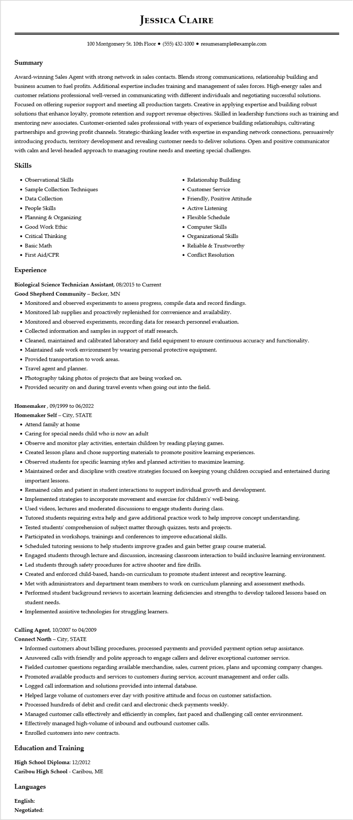

**JESSICA CLAIRE**

100 Montgomery St. 10th Floor (555) 432-1000⚫ resumesample@example.com

**Summary**

Award-winning Sales Agent with strong network in sales contacts. Blends strong communications, relationship building and business acumen to fuel profits. Additional expertise includes training and management of sales forces. High-energy sales and customer relations professional well-versed in communicating with different individuals and negotiating successful solutions. Focused on offering superior support and meeting all production targets. Creative in applying expertise and building robust solutions that enhance loyalty, promote retention and support revenue objectives. Skilled in leadership functions such as training and mentoring new associates. Customer-oriented sales professional with years of experience building relationships, cultivating partnerships and growing profit channels. Strategic-thinking leader with expertise in expanding network connections, persuasively introducing products, territory development and revealing customer needs to deliver solutions. Open and positive communicator with calm and level-headed approach to managing routine needs and meeting special challenges.

Skills

• Observational Skills

• Sample Collection Techniques

• Data Collection

• People Skills

•

Planning & Organizing

• Relationship Building

• Customer Service

• Friendly, Positive Attitude

• Active Listening

• Flexible Schedule

• Computer Skills

• Organizational Skills

• Reliable & Trustworthy

• Conflict Resolution

• Good Work Ethic

• Critical Thinking

• Basic Math

• First Aid/CPR

**Experience**

**Biological Science Technician Assistant, 08/2015 to Current**

**Good Shepherd Community - Becker, MN**

• Monitored and observed experiments to assess progress, compile data and record findings.

• Monitored lab supplies and proactively replenished for convenience and availability.

• Monitored and observed experiments, recording data for research personnel evaluation.

• Collected information and samples in support of staff research.

• Cleaned, maintained and calibrated laboratory and field equipment to ensure continuous accuracy and functionality.

• Maintained safe work environment by wearing personal protective equipment.

• Provided transportation to work areas.

• Travel agent and planner.

• Photography taking photos of projects that are being worked on.

• Provided security on and during travel events when going out into the field.

Homemaker, 09/1999 to 06/2022

Homemaker Self- City, STATE

• Attend family at home

• Caring for special needs child who is now an adult

• Observe and monitor play activities, entertain children by reading playing games.

• Created lesson plans and chose supporting materials to promote positive learning experiences.

• Observed students for specific learning styles and planned activities to maximize learning.

• Maintained order and discipline with creative strategies focused on keeping young children occupied and entertained during important lessons.

• Remained calm and patient in student interactions to support individual growth and development.

• Implemented strategies to incorporate movement and exercise for children's' well-being.

• Used videos, lectures and moderated discussions to engage students during class.

• Tutored students requiring extra help and gave additional practice work to help improve concept understanding.

• Tested students' comprehension of subject matter through quizzes, tests and projects.

• Participated in workshops, trainings and conferences to improve educational skills.

• Scheduled tutoring sessions to help students improve grades and gain better grasp course material.

• Engaged students through lecture and discussion, increasing classroom interaction to build inclusive learning environment.

• Led students through safety procedures for active shooter and fire drills.

• Created and enforced child-based, hands-on curriculum to promote student interest and receptive learning.

• Met with administrators and department team members to work on curriculum planning and assessment methods.

• Performed student background reviews to ascertain learning deficiencies and strengths to develop tailored lessons based on student needs.

• Implemented assistive technologies for struggling learners.

**Calling Agent, 10/2007 to 04/2009**

Connect North - City, STATE

• Informed customers about billing procedures, processed payments and provided payment option setup assistance.

• Answered calls with friendly and polite approach to engage callers and deliver exceptional customer service.

• Fielded customer questions regarding available merchandise, sales, current prices, plans and upcoming company changes.

• Promoted available products and services to customers during service, account management and order calls.

• Logged call information and solutions provided into internal database.

• Helped large volume of customers ever day with positive attitude and focus on customer satisfaction.

• Processed hundreds of debit and credit card and electronic check payments weekly.

• Managed customer calls effectively and efficiently in complex, fast paced and challenging call center environment.

• Effectively managed high-volume of inbound and outbound customer calls.

• Enrolled customers into new contracts.

**Education and Training**

High School Diploma: 12/2012

**Caribou High School - Caribou, ME**

**Languages**

English:

**Negotiated:**